**APRIL/MAY BIRTHDAYS & ANNIVERSERIES**

April 19 Allan/Alicia Hartong (A)

April 20 George/Shirley Barrett (A)

April 21 Ed Phillips (B)

April 27 Mark/Pauline Fischer (A)

April 30 Bob Sudduth (B)

May 1 Mark & Deanna Bragg (A)

May 2 Alan Lair (B)

*Welcome to* ***GRAND HEIGHTS***

**We are having a Service on April 19th – RAIN or SHINE! In compliance with current safe distancing we are having a Drive-In Service. Dr. Mark Smith, a Cedarville University Professor, will be delivering the message. You need to have a vehicle with a working FM radio. A packet of information is available upon arrival. Several men will direct you to park. Please do not allow anyone to leave their vehicle. The building is closed to the public as we cannot make arrangements to keep everyone safe. Arrive at 10:15 to allow time to park. Service is scheduled to begin at 10:30. This Drive-in service will allow those in our fellowship with health issues to safely come and worship together. You can find the Order of Service Packet on the Church Web Site. Go to Grand Heights Baptist Church Fairborn Ohio and print a copy of this Packet. If you have a problem, please contact Allan Hartong @ (937-718-0533).**

**PULPIT COMMITTEE REPORT**

The Comimittee continues its search for a pastoral candidate to bring before the church. We had expected to conduct an interview but we were prevented from doing so because of restrictions due to the virus. At the moment we have two applicants that we are pursuing, one from Kentucky and one from Michigan. We expect to have them speak at a later date. Please continue to pray for wisdom for the committee and for an end to the coronavirus.

***Our Mission: We exist to glorify God as we help people move closer to Jesus in their spiritual journey.***

***Our Mission: We exist to glorify God as we help people move closer to Jesus in their spiritual journey.***

 ***Mission: We exist to glorify God as we help people move closer to Jesus in their spiritual journey.***

MISSIONARY FOR THE MONTH OF APRIL 2020

Dan and Valerie Woods

Jewish work in Sao Paulo, Brazil

We have supported them since 1992. They have seven children ranging in ages from 20 to 7 years old. The Woods continue to have serious financial issues (needing an additional $2300 a month).

**Their plans are to be in the U.S. in June & July. We plan to have them speak when they are here. They need a six passenger VAN or RV. Do you have any options ?**

***“So we, being many, are one body in Christ, and every one members one of another..” Romans 12:5***

**\* OTHER MINISTRY UPDATES \***

1. **McDonald’s** 7 year old granddaughter has been diagnosed wih leukemia. They live in the Seattle area.
2. **Russells** – Pray for their work and the many missionaries they oversee in Latin America. Because of Coronavirus they are working on line and very busy with crisis management.

***“I have set the LORD always before me. Because He is at my right hand, I will not be shaken.” Psalm 16:8***

1. **Dyes** – Social distancing in Columbus. Planning to return to Berlin in August where Steve will assume the role of Rgional Director of the Middle East & North Africa.
2. **Casey Kuang** is ministering online. Pray for the Chinese Students as the Chinese government has told the students to stay away from Chrisitan meetings.



ALL FOLLOWING ACTIVITES ARE PUT ON HOLD AT THIS TIME BECAUSE OF THE

CORONAVIRUS – IF YOUR FAMILY IS IN NEED IN ANY WAY, PLEASE CONTACT YOUR DEACON OR THE CHURCH OFFICE.

YOUTH ACTIVITIES

May 2nd or May 9th Spring Activity

Movie and/or Games

MEN’S ACTIVITIES

Men’s Retreat at Skyview Ranch – April 23rd-25th

Shooting Range, Corn Hole, Lawn Mower Races, Hiking and much more. A special work day

is April 23rd. See Allan Hartong for details!

ALL CHURCH SERVICES

April 19th @ 10:30 – Morning Drive-In Service

Arrive by 10:15 a.m.

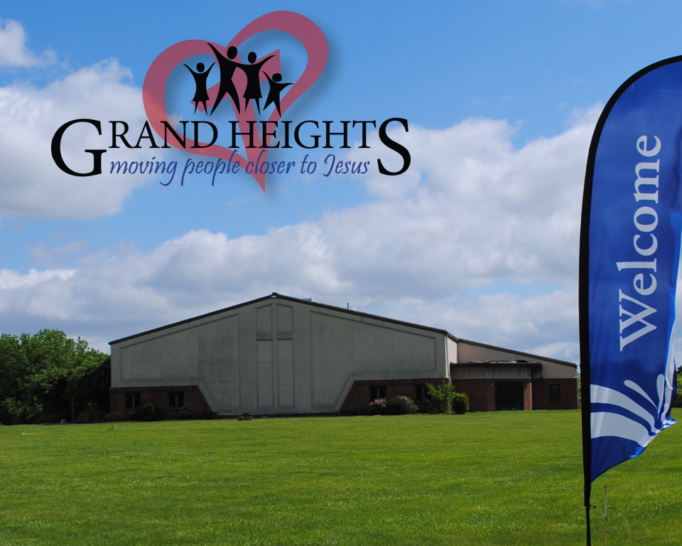

DR. MARK SMITH

Dr. Smith teaches courses in American politics, constitutional law, and research methodology/data analysis. He has authored numerous refereed journal articles, book chapters, and other publications. His primary research interest is in the field of religion and American politics. He is often seen on TV as a political analyst.

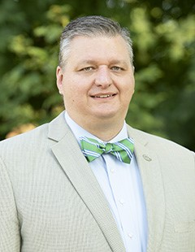

**Grand Heights Baptist Church**

**1611 Armstrong Road**

**Fairborn, OH 45324**

**(937)878-7971**

**E-mail: ghbcnet@grandheights.org**

April 19, 2020