

Executive Director for Latin America and the Caribbean

**2021 Annual Election Meeting / Nominating Committee**

The Annual Election will be in May. A Nominating Committee has been appointed and they are: Alan Lair, Committee Chairman; Allan Hartong; Brendon Dierker; Beth Hetzel; & Kathy Rudy. The committee will be seeking candidates for several positions.

**Missionaries for the Month of April**

**LEAD & WAR INT’L**

**PHIL & REBECCA McDONALD**

**Theme for 2021 - “OUT WITH THE OLD, IN WITH THE NEW”**

**PRAYER REQUESTS**

* **Wisdom on travel plans**
* **Fund requests for organizations**
* **Wisdom on hiring individuals**
* **Time to complete work that is needed**

**DR. JASON LEE**

**INTERIM PASTOR**

**Easter Service**

**April 4th**

**at**

**10:30**

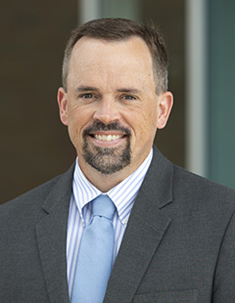

**LADIES BIBLE STUDY - Mondays @ 7:00 P.M.**

**A Bible Study by Kay Arthur & Pete DeLacy “TRUSTING GOD IN TIMES OF ADVERSITY”**

**You must wear a face mask and**

**seating is in compliance with current safe distancing!**

***WELCOME TO******GRAND HEIGHTS***

**Welcome to our Sunday Service Today – RAIN or SHINE! In compliance with current safe distancing AND wearing face masks, we are having our indoor/outdoor service. You have the option of coming into the church or staying in your car in the church parking lot for the church message. It will be broadcasted on the 88.7 FM station.**

**An Order Of Service packet is available upon arrival. Arrive at 10:15 to allow time to park. Service is scheduled to begin at 10:30.**

**APRIL BIRTHDAYS and ANNIVERSARIES**

**Apr 4 Greg Dierker (B) Apr 10 Scott/Becky Stark (A)**

**Apr 5 George Barrett (B) Apr 19 Allan/Alicia Hartong (A)**

**Apr 15 Joel Pensworth (B) Apr 20 George/Shirley Barrett (A)**

**Apr 30 Bob Sudduth (B)**

**Apr 20 George/Shirley Barrett**

**WELCOME CENTER** If you are visiting with us today for the first time, please stop by our Welcome Center to register.



**ADULT SUNDAY MORNING BIBLE FELLOWSHIP**

**Gospel of Mark (Chapter One) – Sunday @ 9:15 a.m.**

**Room 301– Alan Lair - Teacher**

**MISSIONARY FOR THE MONTH OF APRIL**

***Our Mission: We exist to glorify God as we help people move***

***Closer to Jesus in their spiritual journey.***

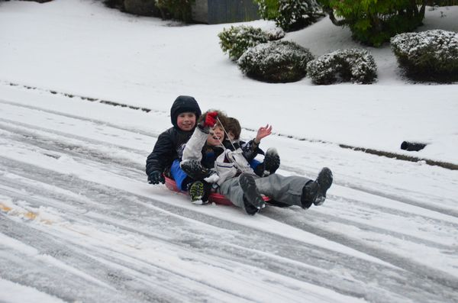

APRIL 4, 2021

IF YOUR FAMILY IS IN NEED IN ANY WAY, PLEASE CONTACT YOUR DEACON OR THE CHURCH OFFICE.

CALENDAR EVENTS

Tues – 9:30 am - Ladies Prayer Mtg.

Sun – Apr 4 Easter Sunday–Continental Breakfast – 9:00

Sun – April 4– Sunday School @ 9:15 a.m.

Sun - April 4 – NO Teens Night @ 5:30 p.m.

Sun – April 4 – NO Awana

Mon – April 5 – Ladies Bible Study 7:00 p.m.

Wed – April 7 – Prayer Meeting @ 7:00 pm

Thur – April 8 – Men’s Small Group Mtg @ 7:00 pm

Wed – April 21 – Church Board Meeting @ 7:30 pm

Sun – April 25 – Communion – Morning Service

EASTER SUNDAY

He Has Risen!

Mark 16:5-7: "As they entered the tomb, they saw a young man dressed in a white robe sitting on the right side, and they were alarmed. 'Don't be alarmed,' he said. 'You are looking for Jesus the Nazarene, who was crucified. He has risen! He is not here. See the place where they laid him. But go, tell his disciples and Peter, "He is going ahead of you into Galilee. There you will see him, just as he told you."

**NO AWANA TONIGHT**



**Pre K – 6th Grades**

**AWANA Clubs of GHBC**

**THE AWANA CLUBS OF GRAND HEIGHTS BAPTIST CHURCH**

**Meets on Sunday Nights**

**@ 5:30 p.m.**



**Grand Heights Baptist Church**

**1611 Armstrong Road**

Fairborn, OH 45324

**(937)878-7971**

**E-mail: ghbcnet@grandheights.org**