**APRIL & MAY Birthdays and Anniversaries**

**Apr 30 Bob Sudduth (B) May 1 Mark & Deanna Bragg (A)**

**May 2 Alan Lair (B) May 15 Dave & Teresa Burk (A)**

**May 20 Brendon Dierker(B) May 21 Drake Pensworth (B)**

**May 22 Mark Fischer (B) May 26 Braden Hetzel (B)**

**Apr 20 George/Shirley Barrett**

***WELCOME TO******GRAND HEIGHTS***

**Welcome to our Sunday Service Today – RAIN or SHINE! In compliance with current safe distancing AND wearing face masks, we are having our indoor/outdoor service. You have the option of coming into the church or staying in your car in the church parking lot for the church message. It will be broadcasted on the 88.7 FM station.**

**An Order Of Service packet is available upon arrival. Arrive at 10:15 to allow time to park. Service is scheduled to begin at 10:30.**

**If you are visiting with us today for the first time and you are inside, please register at our Welcome Center.**

**Pulpit Committee Report**

**The committee continues to seek a pastoral candidate to bring before the church. Please pray for discernment for the committee as it carries out this most important work.**





Executive Director for Latin America and the Caribbean

**2021 Annual Election Meeting / Nominating Committee**

The Annual Election will be in May. A Nominating Committee has been appointed and they are: Alan Lair, Committee Chairman; Allan Hartong; Brendon Dierker; Beth Hetzel; & Kathy Rudy. The committee will be seeking candidates for several positions.

**Missionaries for the Month of April**

**LEAD & WAR INT’L**

**PHIL & REBECCA McDONALD**

**Theme for 2021 - “OUT WITH THE OLD, IN WITH THE NEW”**

**PRAYER REQUESTS**

* **Wisdom on travel plans**
* **Fund requests for organizations**
* **Wisdom on hiring individuals**
* **Time to complete work that is needed**

**DR. JASON LEE**

**INTERIM PASTOR**

**Sunday Morning Service**

**April 11th at**

**10:30 A.M.**

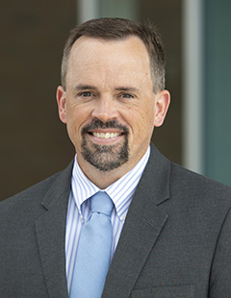

**LADIES BIBLE STUDY - Mondays @ 7:00 P.M.**

**A Bible Study by Kay Arthur & Pete DeLacy “TRUSTING GOD IN TIMES OF ADVERSITY”**

**You must wear a face mask and**

**seating is in compliance with current safe distancing!**

**ADULT SUNDAY MORNING BIBLE FELLOWSHIP**

**Gospel of Mark (Chapter One) – Sunday @ 9:15 a.m.**

**Room 301– Alan Lair - Teacher**

**MISSIONARY FOR THE MONTH OF APRIL**

***Our Mission: We exist to glorify God as we help people move***

***Closer to Jesus in their spiritual journey.***

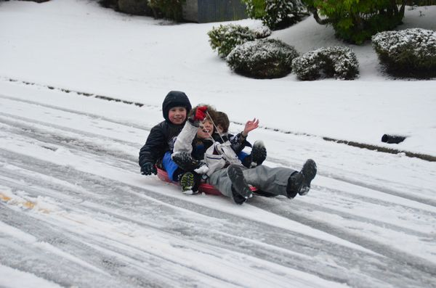

APRIL 25, 2021

IF YOUR FAMILY IS IN NEED IN ANY WAY, PLEASE CONTACT YOUR DEACON OR THE CHURCH OFFICE.

CALENDAR EVENTS

Tues – 9:30 am - Ladies Prayer Mtg.

Sun – April 25– Sunday School @ 9:15 a.m.

Sun – April 25 – Sunday Morning Worship Service @ 10:30

Sun - April 25 – Teens Night @ 5:30 p.m.

Sun – April 25 – Awana @ 5:30 p.m.

Mon – April 26 – Ladies Bible Study @ 7:00 p.m.

Wed – April 28 – Prayer Meeting @ 7:00 pm

Thur – April 29 – Men’s Small Group Mtg @ 7:00 pm

Sun – May 9 – Mother’s Day

Wed – May 12 – Church Board Meeting @ 7:30 pm

Wed – May 19 – Congregational Quarterly @ 7:00 pm

Annual Election Meeting



**RISE UP** - **A Praise Celebration**

**Today guest worship leader, Jeff Beste, will join with the Grand Heights praise team to lead us in a time of celebrating Christ’s resurrection. Our songs and sermon are focused on how Christ’s resurrection should result in praise for our Savior and in hope for our own resurrection. We hope that you have had an opportunity to invite your friends for this special celebration and worship time.**

**NEXT WEEK IS THE LAST WEEK FOR THIS YEARS AWANA! IT IS AWARDS NIGHT.**

**SEPTEMBER 12TH IS THE FALL OPENER!**



**THE AWANA CLUBS OF GRAND HEIGHTS BAPTIST CHURCH**

**Meets on Sunday Nights**

**@ 5:30 p.m.**

**Pre K – 6th Grades**

**AWANA Clubs of GHBC**

**Grand Heights Baptist Church**

**1611 Armstrong Road**

Fairborn, OH 45324

**(937)878-7971**

**E-mail: ghbcnet@grandheights.org**