**Pulpit Committee Report**

**The committee continues to seek a pastoral candidate to bring before the church. Please pray for discernment for the committee as it carries out this most important work.**

***WELCOME TO******GRAND HEIGHTS***

**Welcome to our Sunday Service Today – RAIN or SHINE! In compliance with current safe distancing AND wearing face masks, we are having our indoor/outdoor service. You have the option of coming into the church or staying in your car in the church parking lot for the church message. It will be broadcasted on the 88.7 FM station.**

**An Order Of Service packet is available upon arrival. Arrive at 10:15 to allow time to park. Service is scheduled to begin at 10:30.**

**If you are visiting with us today for the first time and you are inside, please register at our Welcome Center.**



**APRIL BIRTHDAYS and ANNIVERSARIES**

**Apr 15 Joel Pensworth (B) Apr 19 Allan/Alicia Hartong (A)**

**Apr 30 Bob Sudduth (B) Apr 20 George/Shirley Barrett (A)**

**Apr 20 George/Shirley Barrett**



Executive Director for Latin America and the Caribbean

**2021 Annual Election Meeting / Nominating Committee**

The Annual Election will be in May. A Nominating Committee has been appointed and they are: Alan Lair, Committee Chairman; Allan Hartong; Brendon Dierker; Beth Hetzel; & Kathy Rudy. The committee will be seeking candidates for several positions.

**Missionaries for the Month of April**

**LEAD & WAR INT’L**

**PHIL & REBECCA McDONALD**

**Theme for 2021 - “OUT WITH THE OLD, IN WITH THE NEW”**

**PRAYER REQUESTS**

* **Wisdom on travel plans**
* **Fund requests for organizations**
* **Wisdom on hiring individuals**
* **Time to complete work that is needed**

**DR. JASON LEE**

**INTERIM PASTOR**

**Sunday Morning Service**

**April 11th at**

**10:30 A.M.**

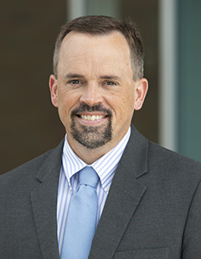

**LADIES BIBLE STUDY - Mondays @ 7:00 P.M.**

**A Bible Study by Kay Arthur & Pete DeLacy “TRUSTING GOD IN TIMES OF ADVERSITY”**

**You must wear a face mask and**

**seating is in compliance with current safe distancing!**

**ADULT SUNDAY MORNING BIBLE FELLOWSHIP**

**Gospel of Mark (Chapter One) – Sunday @ 9:15 a.m.**

**Room 301– Alan Lair - Teacher**

**MISSIONARY FOR THE MONTH OF APRIL**

***Our Mission: We exist to glorify God as we help people move***

***Closer to Jesus in their spiritual journey.***

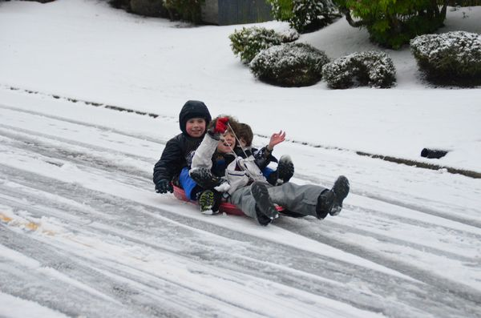

APRIL 11, 2021

IF YOUR FAMILY IS IN NEED IN ANY WAY, PLEASE CONTACT YOUR DEACON OR THE CHURCH OFFICE.

CALENDAR EVENTS

Tues – 9:30 am - Ladies Prayer Mtg.

Sun – April 11– Sunday School @ 9:15 a.m.

Sun - April 11 – Teens Night @ 5:30 p.m.

Sun – April 11 – Awana @ 5:30 p.m.

Mon – April 12 – Ladies Bible Study @ 7:00 p.m.

Wed – April 14 – Prayer Meeting @ 7:00 pm

Thur – April 15 – Men’s Small Group Mtg @ 7:00 pm

Wed – April 21 – Church Board Meeting @ 7:30 pm

Sun – April 25 – RISE UP praise celebration @ 10:30 a.m. with Jeff Beste

Sun – April 25 – Communion – Morning Service



Join us on Sunday, April 25, for RISE UP, a praise celebration. Guest worship leader, Jeff Beste, will join with the Grand Heights praise team to lead us in a time celebrating Christ’s resurrection. Our songs and sermon will focus on how Christ’s resurrection should result in praise for our Savior and in hope for our own resurrection. Feel free to invite your friends and family to join us at 10:30 A.M. in the worship center for this time of celebration and worship.



**THE AWANA CLUBS OF GRAND HEIGHTS BAPTIST CHURCH**

**Meets on Sunday Nights**

**@ 5:30 p.m.**

**Pre K – 6th Grades**

**AWANA Clubs of GHBC**

**Grand Heights Baptist Church**

**1611 Armstrong Road**

Fairborn, OH 45324

**(937)878-7971**

**E-mail: ghbcnet@grandheights.org**