**LADIES BIBLE STUDY – Mon @ 7:00**

**A Bible Study by Kay Arthur & Pete DeLacy**

**“TRUSTING GOD IN TIMES OF ADVERSITY”**

**You must wear a face mask and**

**seating is compliance with current safe distancing!**

**WELCOME CENTER** If you are visiting with us today for the first time, please stop by our Welcome Center to register.



**ADULT SUNDAY MORNING BIBLE FELLOWSHIP**

**“OR-DI-NARY” by MICHAEL HORTON**

**Sustainable faith in a radical restless world – Sunday @ 9:15**

**Room 301– Alan Lair - Teacher**

**MISSIONARY FOR THE MONTH OF MARCH**

**DAN & VALERIE WOODS**

* **Prayers for the sick with the CoVid Virus**
* **Pray for the weekend and mid-week meetings, Bible studies and prayer meetings.**
* **Pray for financial needs of ones that have lost their income during this time**
* **Support & need of a newer car**

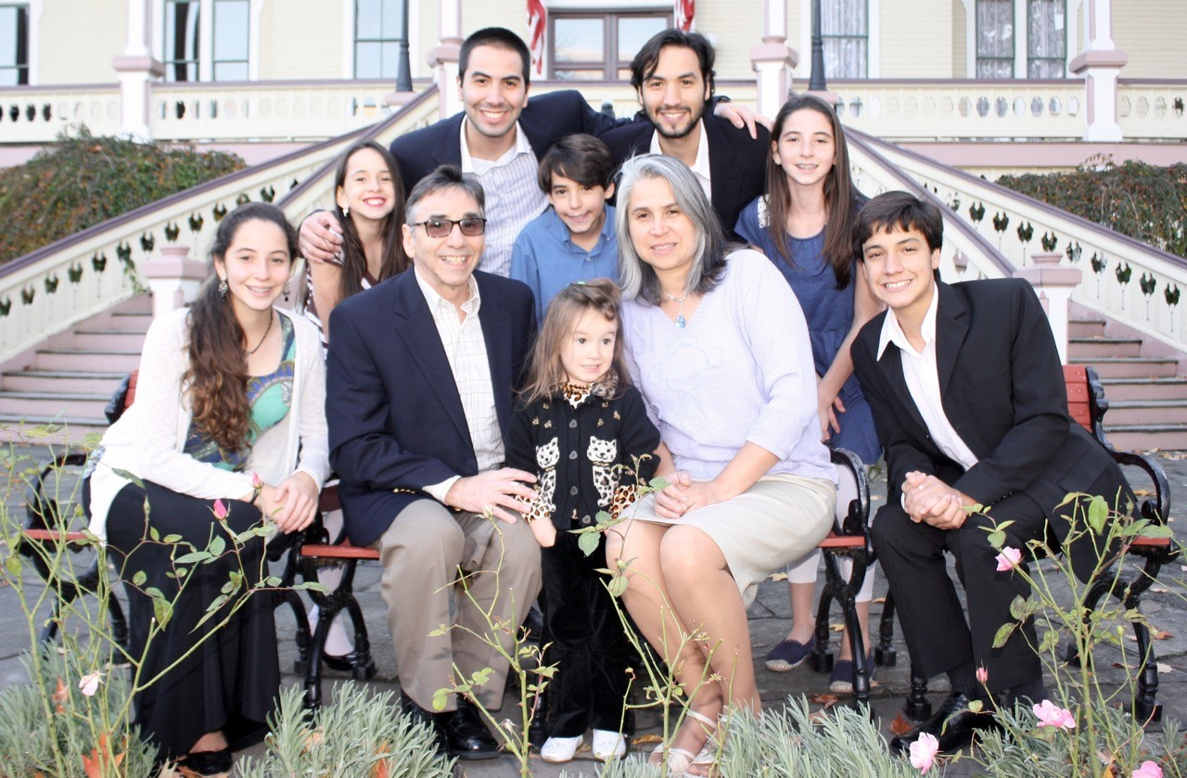

Executive Director for Latin America and the Caribbean

**INTERIM PASTOR**

**Dr. Jason Lee**

**Has agreed to another three months while the Pulpit Committee continues their search for a Sr. Pastor.**

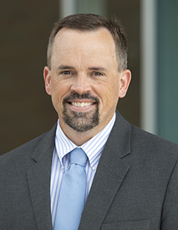

RESULTS OF SPECIAL ELECTION MEETING

1)Melinda Dierker – New Pulpit Committee member.

2)George Barrett to finish Trustee Position thru June 2021.

3)Reaffirmation of Dr. Jason Lee as our Interim Pastor

***WELCOME TO******GRAND HEIGHTS***

**Welcome to our Sunday Service Today – RAIN or SHINE! In compliance with current safe distancing AND wearing face masks, we are having our indoor/outdoor service. You have the option of coming into the church or staying in your car in the church parking lot for the church message. It will be broadcasted on the 88.7 FM station.**

**An Order Of Service packet is available upon arrival. Arrive at 10:15 to allow time to park. Service is scheduled to begin at 10:30.**

**FEBRUARY/MARCH BIRTHDAYS**

**Mar 13 Kris Dierker (B) Mar 14 Ashton Fischer (B)**

**Mar 16 Alicia Hartong (B)**

**Mar 19 Dave Pensworth (B)**

**Mar 20 Ken Hulbert (B) Mar 24 Teresa Burk (B)**

***Our Mission: We exist to glorify God as we help people move***

***Closer to Jesus in their spiritual journey.***

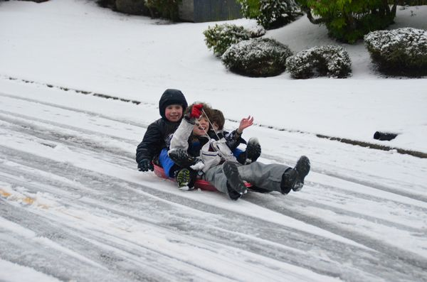

March 7, 2021

IF YOUR FAMILY IS IN NEED IN ANY WAY, PLEASE CONTACT YOUR DEACON OR THE CHURCH OFFICE.

CALENDAR EVENTS

Tues – 9:30 a.m. - Ladies Prayer Mtg.

Sun – March 7– Sunday School @ 9:15 a.m.

Sun - March 7 – Teens Night @ 5:30 p.m.

Sun – March 7 – Awana @ 5:30 p.m.

Mon – March 8 – Ladies Bible Study 7:00 p.m.

Wed – March 10 – Prayer Meeting @ 7:00 pm

Sun. – March 14 – Trustee Meeting @ 3:00 pm

Wed – March 24 – Church Board Meeting – 7:30 pm

Sun – March 28 – Communion during morning service

2021 Annual Election Meeting / Nominating Committee

The Annual Election will be in May. A Nominating Committee has been appointed and they are: Alan Lair, Committee Chairman; Allan Hartong; Brendon Dierker; Beth Hetzel; & Kathy Rudy. The committee will be seeking candidates for several positions.

**FOR MORE INFORMATION (please contact)**

**Grand Heights Baptist Church**

**937-878-7971 or www.grandheights.org**

**Pre K – 6th Grades**

**AWANA Clubs of GHBC**

**THE AWANA CLUBS OF GRAND HEIGHTS BAPTIST CHURCH**

**Meets on Sunday Nights**

**@ 5:30 p.m.**





**Grand Heights Baptist Church**

**1611 Armstrong Road**

Fairborn, OH 45324

**(937)878-7971**

**E-mail: ghbcnet@grandheights.org**