**DR. JASON LEE**

**INTERIM PASTOR**

**Easter Service, April 4th at 10:30. There will be**

**Grab-and-Go Continental Breakfast (food & drinks) for everyone before Sunday School to take to Class.**

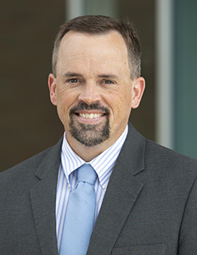

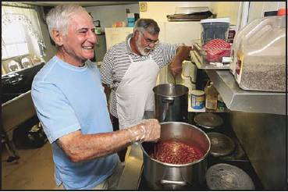

**DAYTON GOSPEL MISSIONS**

**Men can you help serve dinner on Tuesday, March 30th. Meet at the church to carpool and leave**

**the church at 5:00 p.m. Contact**

**Alan Hartong if you are available to go.**

**LADIES BIBLE STUDY - Mondays @ 7:00**

**A Bible Study by Kay Arthur & Pete DeLacy “TRUSTING GOD IN TIMES OF ADVERSITY”**

**You must wear a face mask and**

**seating is in compliance with current safe distancing!**

***WELCOME TO******GRAND HEIGHTS***

**Welcome to our Sunday Service Today – RAIN or SHINE! In compliance with current safe distancing AND wearing face masks, we are having our indoor/outdoor service. You have the option of coming into the church or staying in your car in the church parking lot for the church message. It will be broadcasted on the 88.7 FM station.**

**An Order Of Service packet is available upon arrival. Arrive at 10:15 to allow time to park. Service is scheduled to begin at 10:30.**

**APRIL BIRTHDAYS and ANNIVERSARIES**

**Apr 4 Greg Dierker (B) Apr 10 Scott/Becky Stark (A)**

**Apr 5 George Barrett (B) Apr 19 Allan/Alicia Hartong (A)**

**Apr 15 Joel Pensworth (B) Apr 20 George/Shirley Barrett (A)**

**Apr 30 Bob Sudduth (B)**

**Apr 20 George/Shirley Barrett**

**WELCOME CENTER** If you are visiting with us today for the first time, please stop by our Welcome Center to register.



**ADULT SUNDAY MORNING BIBLE FELLOWSHIP**

**Gospel of Mark (Chapter One) – Sunday @ 9:15 a.m.**

**Room 301– Alan Lair - Teacher**

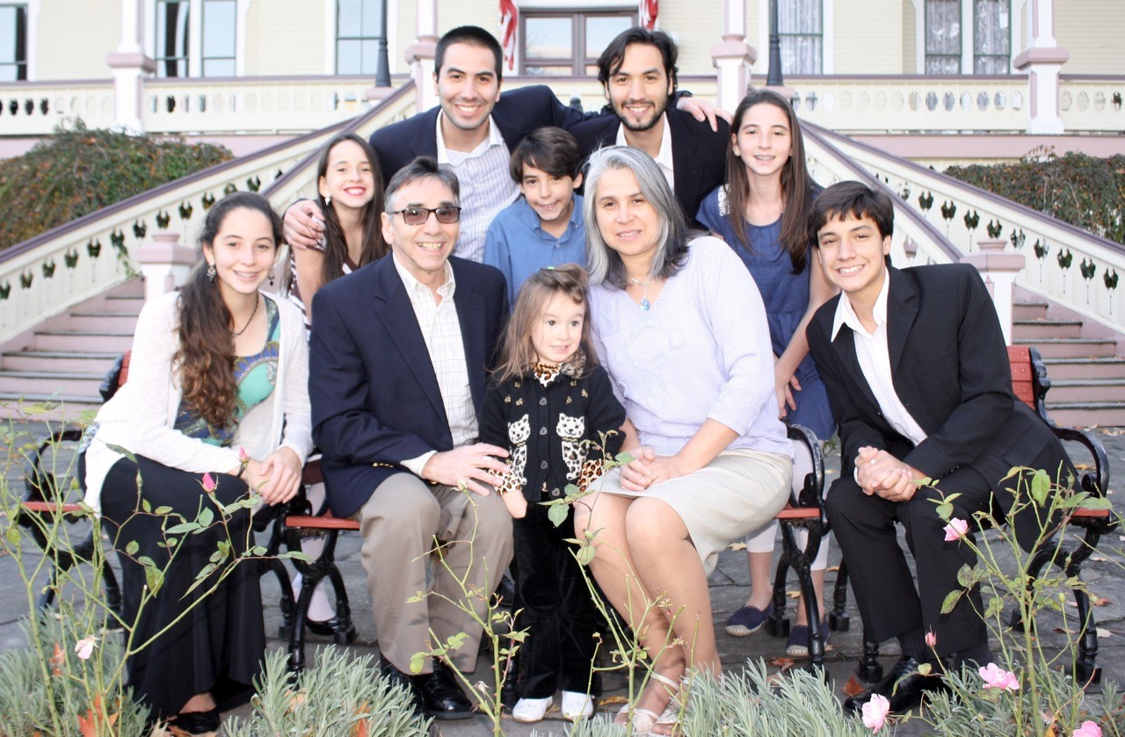

Executive Director for Latin America and the Caribbean

**DAN & VALERIE WOODS**

* **Prayers for the sick with the CoVid Virus**
* **Pray for the weekend and mid-week meetings, Bible studies and prayer meetings.**
* **Pray for financial needs of ones that have lost their income during this time**
* **Support & need of a newer car**

**MISSIONARY FOR THE MONTH OF MARCH**

***Our Mission: We exist to glorify God as we help people move***

***Closer to Jesus in their spiritual journey.***



March 28, 2021

IF YOUR FAMILY IS IN NEED IN ANY WAY, PLEASE CONTACT YOUR DEACON OR THE CHURCH OFFICE.

CALENDAR EVENTS

Tues – 9:30 am - Ladies Prayer Mtg.

Sun – March 28– Sunday School @ 9:15 a.m.

Sun - March 28 – Teens Night @ 5:30 p.m.

Sun – March 28 – Awana @ 5:30 p.m.

Mon – March 29 – Ladies Bible Study 7:00 p.m.

Tue – March 30 – Men Serving at Gospel Mission @ 5:00

Wed – March 31 – Prayer Meeting @ 7:00 pm

Sun – March 28 – Communion – Morning Service

Thur – April 1 – Men’s Small Group Mtg @ 7:00 pm

Sun – Apr 4 Easter Sunday–Continental Breakfast – 9:00

**Pre K – 6th Grades**

**AWANA Clubs of GHBC**

**Membership Meeting to Vote (Today)**

Congregational meeting to vote on Kyle Upshaw’s application for membership and Rich Marvin membership status.

**2021 Annual Election Meeting / Nominating Committee**

The Annual Election will be in May. A Nominating Committee has been appointed and they are: Alan Lair, Committee Chairman; Allan Hartong; Brendon Dierker; Beth Hetzel; & Kathy Rudy. The committee will be seeking candidates for several positions.

**FOR MORE INFORMATION (please contact)**

**Grand Heights Baptist Church**

**937-878-7971 or www.grandheights.org**

**THE AWANA CLUBS OF GRAND HEIGHTS BAPTIST CHURCH**

**Meets on Sunday Nights**

**@ 5:30 p.m.**





**Grand Heights Baptist Church**

**1611 Armstrong Road**

Fairborn, OH 45324

**(937)878-7971**

**E-mail: ghbcnet@grandheights.org**