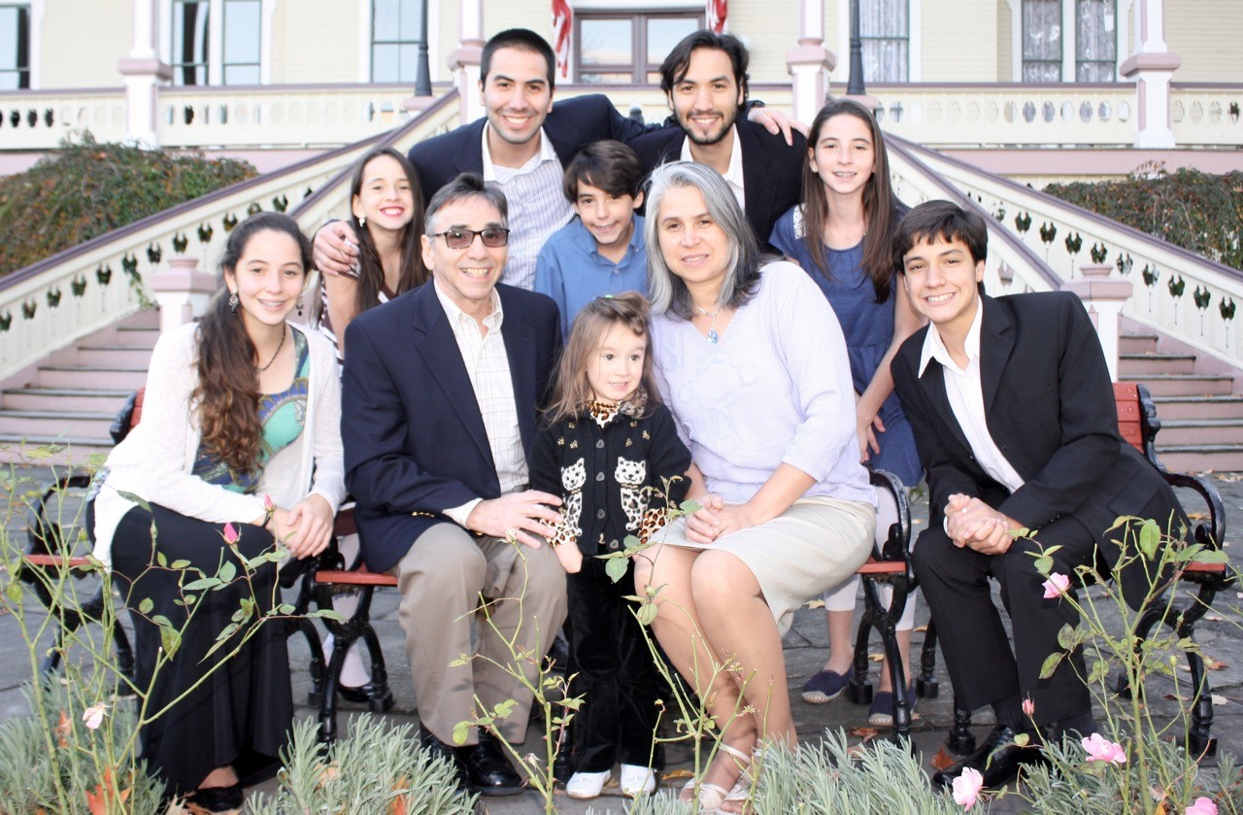

Executive Director for Latin America and the Caribbean

**DAN & VALERIE WOODS**

* **Prayers for the sick with the CoVid Virus**
* **Pray for the weekend and mid-week meetings, Bible studies and prayer meetings.**
* **Pray for financial needs of ones that have lost their income during this time**
* **Support & need of a newer car**

**DAYTON GOSPEL MISSIONS**

**Can you help serve dinner on Tuesday, March 30th. Meet at church and leave church at 5:00 p.m.**

**Contact Cindy Sudduth**

**LADIES BIBLE STUDY**

**Mondays @ 7:00**

**A Bible Study by Kay Arthur & Pete DeLacy “TRUSTING GOD IN TIMES OF ADVERSITY”**

**You must wear a face mask and**

**seating is compliance with current safe distancing!**

**WELCOME CENTER** If you are visiting with us today for the first time, please stop by our Welcome Center to register.



**ADULT SUNDAY MORNING BIBLE FELLOWSHIP**

**“OR-DI-NARY” by MICHAEL HORTON**

**Sustainable faith in a radical restless world – Sunday @ 9:15**

**Room 301– Alan Lair - Teacher**

**MISSIONARY FOR THE MONTH OF MARCH**

***Our Mission: We exist to glorify God as we help people move***

***Closer to Jesus in their spiritual journey.***

AWANA GRAND PRIX

TODAY @ 5:30 P.M.

BECAUSE OF COVID RULINGS THERE WILL BE NO FOOD

**RACE DAY**

***WELCOME TO******GRAND HEIGHTS***

**Welcome to our Sunday Service Today – RAIN or SHINE! In compliance with current safe distancing AND wearing face masks, we are having our indoor/outdoor service. You have the option of coming into the church or staying in your car in the church parking lot for the church message. It will be broadcasted on the 88.7 FM station.**

**An Order Of Service packet is available upon arrival. Arrive at 10:15 to allow time to park. Service is scheduled to begin at 10:30.**

**DR. JASON LEE**

**INTERIM PASTOR**

**DURING THE NEXT SEVERAL WEEKS SERMONS WILL BE TAKEN FROM**

**PASSAGES IN MATTHEW**

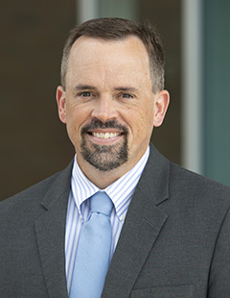

**MARCH/APRIL BIRTHDAYS and ANNIVERSARIES**

**Mar 24 Teresa Burk (B) Apr 10 Scott/Becky Stark (A)**

**Apr 4 Greg Dierker (B) Apr 19 Allan/Alicia Hartong (A)**

**Apr 5 George Barrett (B) Apr 20 George/Shirley Barrett (A)**

**Apr 15 Joel Pensworth (B) Apr 27 Mark/Pauline Fischer (A)**

**Apr 30 Bob Sudduth (B)**

**Apr 20 George/Shirley Barrett**

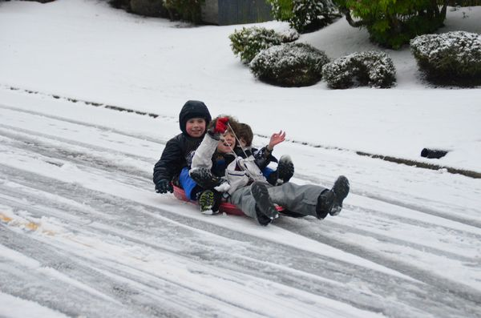

March 21, 2021

IF YOUR FAMILY IS IN NEED IN ANY WAY, PLEASE CONTACT YOUR DEACON OR THE CHURCH OFFICE.

CALENDAR EVENTS

Tues – 9:30 am - Ladies Prayer Mtg.

Sun – March 21– Sunday School @ 9:15 a.m.

Sun - March 21 – Teens Night @ 5:30 p.m.

Sun – March 21 – Awana GRAND PRIX @ 5:30 p.m.

Mon – March 22 – Ladies Bible Study 7:00 p.m.

Wed – March 24 – Prayer Meeting @ 7:00 pm

Wed – March 24 – Church Board Meeting – 7:30 pm

Thur – March 25 – Men’s Small Group Mtg @ 7:00 pm

Sun – March 28 – Communion – Morning Service

Sun – Apr 4 – Easter Sunday

**2021 Annual Election Meeting / Nominating Committee**

The Annual Election will be in May. A Nominating Committee has been appointed and they are: Alan Lair, Committee Chairman; Allan Hartong; Brendon Dierker; Beth Hetzel; & Kathy Rudy. The committee will be seeking candidates for several positions.

**FOR MORE INFORMATION (please contact)**

**Grand Heights Baptist Church**

**937-878-7971 or www.grandheights.org**

**Pre K – 6th Grades**

**AWANA Clubs of GHBC**

**THE AWANA CLUBS OF GRAND HEIGHTS BAPTIST CHURCH**

**Meets on Sunday Nights**

**@ 5:30 p.m.**



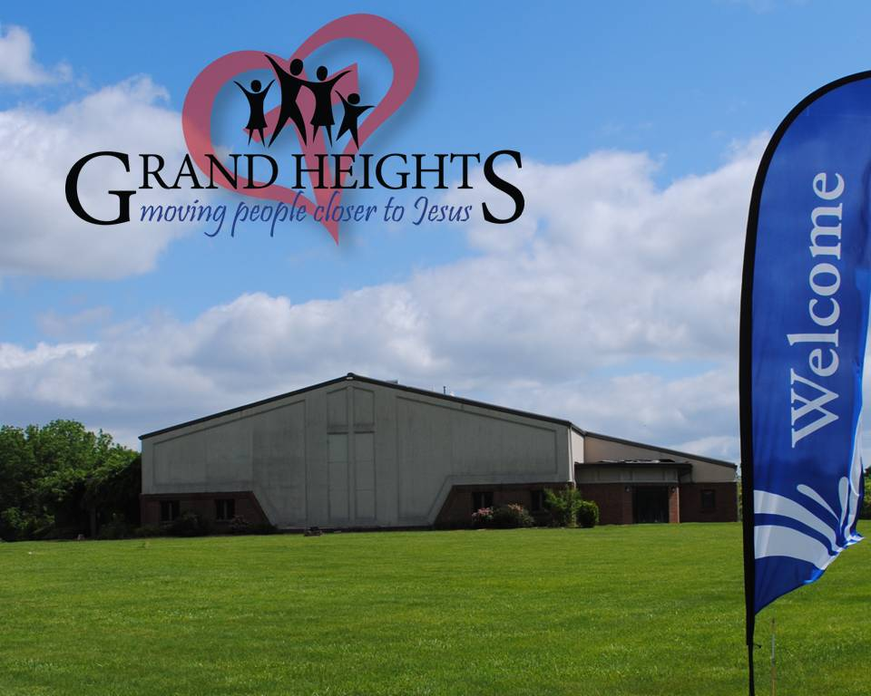

**Grand Heights Baptist Church**

**1611 Armstrong Road**

Fairborn, OH 45324

**(937)878-7971**

**E-mail: ghbcnet@grandheights.org**