A picture containing clipart

Description generated with very high confidence

**Grand Heights**

**Men’s 2018**

**Retreat Group**

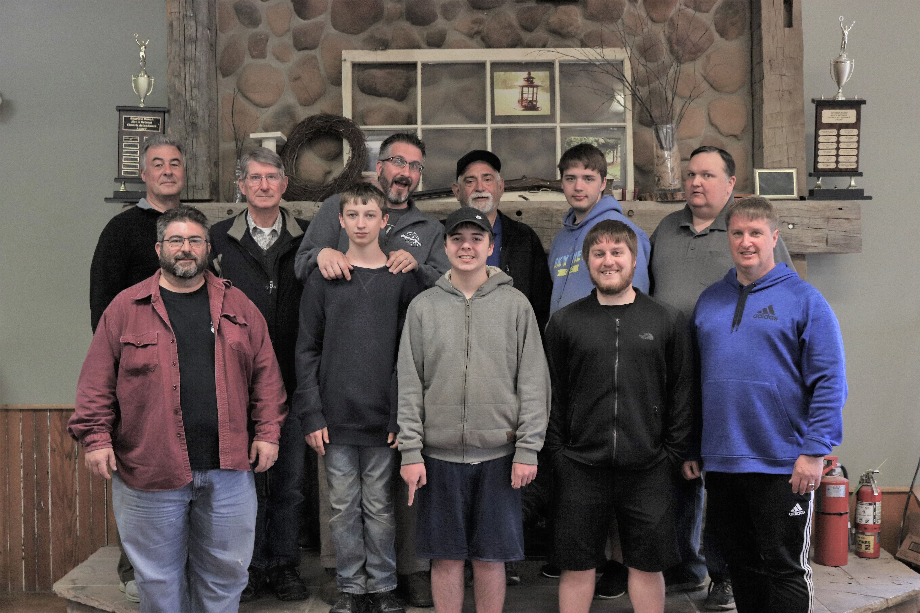

**MEN** our annual Spring Skyview Retreat is less than three months away

(April 25-27).

Be sure to sign-up at skyviewranch.org

and on the Bulletin Board so we can know who is planning on attending.



VBS is coming and will be here sooner than we think (June 10-14). Be thinking about where

you would like to help as we

strive to reach Kids for Christ.

Skyview Ranch will be celebrating its 50th Anniversary on May 25th. That’s 50 years of impacting lives for Christ. Please be in prayer for this ministry as they gear up for another year of ministry!

Are you involved in one of our

SMALL GROUP STUDIES?

COUPLES – Thursday p.m.

LADIES – Sunday p.m. or Tuesday a.m.

MEN – Sunday & Thursday p.m. & Tuesday a.m.

BE SURE TO CONNECT WITH ONE TODAY!



Operation Sub-Zero

(Skyview Winter Retreat)

Is scheduled for

March 1st thru 3rd

See Mark Fischer for details - Register

@ skyviewranch.org

GROW

Paul continues his instruction on submission as he illustrates in a number of relationships the application of the principle to life. He continues by discussing the relationship a husband is to have for his wife. We will be examing Ephesians 5:25-33 this morning.

SERVE

Our Nursery is now open each week and

helpers are needed to staff it.

Please see Kathy Rudy for details

and to volunteer!

CONNECT

A tree in the middle of a field

Description generated with high confidence

FEBRUARY MISSIONS OF THE MONTH

SKYVIEW RANCH

CALLING ALL JUNIORS



LEAD

*Welcome to* ***GRAND HEIGHTS***

We are so glad you are here! You will find Grand Heights to be a diverse community of people dedicated to impacting our community and the world with the Gospel of Jesus Christ!

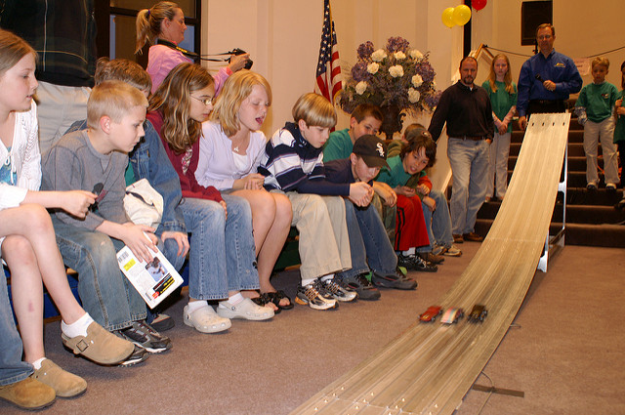

The AWANA

GRAND PRIX DERBY

March 10th at 5:00 p.m.

Everyone can participate.

See Dave Burk for car kits,

pizza will be provided!



**MARCH/APRIL CALENDAR**

Mar 1-31 FISH – Donating unperishable Food

Mar 1-3 Sub-Zero Junior Retreat 4th-6th grade

Mar 2 Men’s Devotional Breakfast

Mar 3 Deacon Stand-up Meeting

Mar 10 Awana Grand Prix

Mar 23 Teen Cedarmania @ Cedarville University

Mar 29 Ladies Game Night

Apr 3 Deacon Meeting

Apr 15 Ladies Craft Night (Card Making)

Apr 21 Easter Buffet Breakfast

TEENS! Cedarmania Is Coming

Who – All Junior and Senior High Schoolers

What – High energy action packed event

When – March 23rd - 10:00 a.m. – 4:00 p.m.

Where – Cedarville University

Cost - $30 per person (includes T-Shirt)

REGISTER BY MARCH 15TH

BIRTHDAYS/ANNIVERSARIES

Feb 17 Rick Pensworth (B)

Feb 22 Eva Suter (B)

Pastor Waldo is reducing his library.

Books are free, donations are accepted.

**WHO AM I?**

**I AM A HUSBAND**

**Grand Heights Baptist Church**

1611 Armstrong Road

Fairborn, OH 45324

(937)878-7971

E-mail: ghbcnet@grandheights.org

February 17, 2019