**FEBRUARY BIRTHDAYS**

**Feb 11 Laura Pensworth (B) Feb 17 Rick Pensworth (B)**

**Feb 22 Eva Suter (B) Feb 26 Sharon Quiggle (B)**

**Feb 29 Maggie Hartong (B)**

FEBRUARY MISSIONARY FOR THE MONTH   
Executive Director for Latin America and the Caribbean

Scott & Nikki Russell

* Pray for safety in travels to Chili, Brazil, Cuba
* Effectiveness of Ministry to Missionaries
* Fruit from preaching and teaching
* Helping out during this

Covid 19 need for finances and medical supplies!

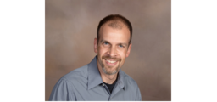

***PASTOR ERIC PUFF***

**Today we welcome Pastor Eric Puff to our pulpit. Eric is an Associate Pastor at Northfield Baptist Church in Northfield, OH. He received a Bachelor’s Degree from Clarks Summit University in 1996 and a Master’s of Divinity degree in 2002 from Baptist Bible Seminary in Clarks Summit, PA. He also serves as an Online Adjunct Faculty member at Clarks Summit University. Joining him are his wife, Carrie, and their four children - Alex, Tori, Will, and Olivia.**

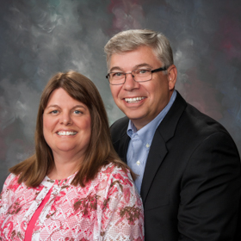

**ADULT BIBLE FELLOWSHIP**

**“OR-DI-NARY” by MICHAEL HORTON**

**Sustainable faith in a radical restless world – Sunday @ 9:15**

**Room 301– Alan Lair - Teacher**

**2021 ADDRESS & PHONE DIRECTORIES ARE READY.You can find them located on the table next to the Media/Sound Desk.**

**COME AND ENJOY THIS STUDY**

**A Bible Study by**

**Kay Arthur & Pete DeLacy**

“**TRUSTING GOD IN TIMES**

**OF ADVERSITY”**

**You must wear a face mask and in the room it is compliance with current safe distancing!**



**We are still taking food items for Fairborn Fish. Because of the weather, we have extended the food drive until this Tuesday. There is still time for you to bring in your food items.**



***Our Mission: We exist to glorify God as we help people move***

***Closer to Jesus in their spiritual journey.***

***Welcome to******GRAND HEIGHTS***

**Welcome to our Sunday Service Today – RAIN or SHINE! In compliance with current safe distancing AND wearing face masks, we are having our indoor/outdoor service. You have the option of coming into the church or staying in your car in the church parking lot for the church message. It will be broadcasted on the 88.7 FM station.**

**An Order Of Service packet is available upon arrival. Arrive at 10:15 to allow time to park. Service is scheduled to begin at 10:30. This Indoor/Outdoor service will allow those in our fellowship with health issues to safely come and worship the way they would be most comfortable.**

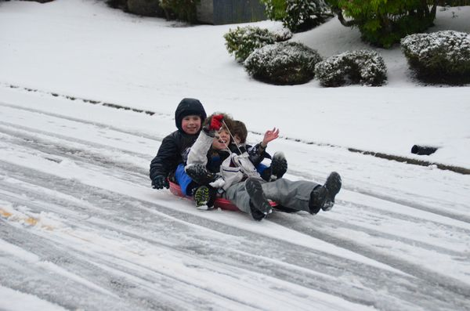

February 7, 2021

IF YOUR FAMILY IS IN NEED IN ANY WAY, PLEASE CONTACT YOUR DEACON OR THE CHURCH OFFICE.

A MESSAGE FROM OUR TREASURER

Your 2020 Offeratory Gift Statement has been completed. Bob Sudduth has passed out or mailed them. If you have not received yours contact Bob.

CALENDAR EVENTS

Tues – 9:30 a.m. - Ladies Prayer Mtg.

Sun – February 7 – Sunday School @ 9:15 a.m.

Sun - February 7 – Teens Night @ 5:30 p.m.

Sun – February 7 – Awana @ 5:30 p.m.

Sun – February 7–Brief meeting prior to morning service

Sun – February 7 – Vote prior to Morning Service on

Church Financial Secretary

Wed – February 8 – Ladies Bible Study 7:00 p.m.

Wed – February 10 – Missions Prayer Meeting @ 7:00 pm

Wed – February 24 – Church Board Meeting – 7:30 pm

Sun – February 28 – Communion during morning service

This morning we will be voting

on approval of Josh Burk

as Financial Secretary for 2020 – May 2021

Grand Heights Baptist Church Financial Year.

All active church members will be voting.



**Pre K – 6th Grades**

**AWANA Clubs of GHBC**

**THE AWANA CLUBS OF GRAND HEIGHTS BAPTIST CHURCH**

**Meets on Sunday Nights**

**@ 5:30 p.m.**

**FOR MORE INFORMATION (please contact)**

**Grand Heights Baptist Church**

**937-878-7971 or www.grandheights.org**



**Grand Heights Baptist Church**

**1611 Armstrong Road**

Fairborn, OH 45324

**(937)878-7971**

**E-mail: ghbcnet@grandheights.org**