CHURCH OFFICERS MEETINGS

**Deacon Stand-up Mtg, Feb 2nd, 12:00 pm**

**Board Mtg – Feb 5, 7:30 pm/Trustee Mtg – Feb 16, 4:00 pm**

SUPER BOWL BASH

TONIGHT at 6:00 pm

Come cheer on your favorite team. If you are not a football fan, come make it a game and fellowship night. Bring your most tasty snacks to share.

Invite your friends and neighbors.



**DR. RANDY McKINION**

**Speaker for TODAY**

Dr. Randy McKinion's academic preparation focused on the study of the Pentateuch and particularly the study of biblical narrative in the story of Joseph. Dr. McKinion desires to help the Church teach the Old Testament more effectively and faithfully.

Subzero, Jr. Age - Feb 28 - March 1

To Register: Skyviewranch.org

**SUBZERO**

**AT**

**SKYVIEW**

**RANCH**



**SKYVIEW RANCH (Missions for February)**

**Fire destroyed their Administrative Office on**

**November 11th, 2019. They are continuing the events and activities that are scheduled. Continue to pray for the camp!**

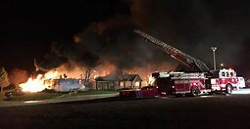

**FEBRUARY/MARCH EVENTS**

Feb 2 Deacon Stand-up Meeting 12:00 pm

Feb 2 Super Bowl Bash @ 6:00 pm

Feb 5 Board Meeting – 7:30 pm

Feb 16 Trustee Meeting 4:00 pm

Feb 18 Ladies Dinner – Cherry House 6:00 pm

Feb 28-Mar 1 Jr. Subzero – Skyview Ranch

Mar 1-31 FISH – Donated Non-perishable Food

Mar 4 Deacon Meeting 7:45 pm

Mar 7 Men’s Breakfast 7:30 am

Mar 8 Daylight Savings Time Begins

Mar 14 Bridal Shower for Bethany–2:00 p.m.

Mar 15 Awana Grand Prix – 5:30 p.m.

G

***Our Mission: We exist to glorify God as we help people move closer to Jesus in their spiritual journey.***

***Our Mission: We exist to glorify God as we help people move closer to Jesus in their spiritual journey.***

 ***Mission: We exist to glorify God as we help people move closer to Jesus in their spiritual journey.***

BIRTHDAYS/ANNIVERSARIES

Feb 3 Mark Foster (B)

Feb 3 Brian Hulbert (B)

SUBZERO

AT

SKYVIEW

RANCH

*Welcome to* ***GRAND HEIGHTS***

We are so glad you are here! You will find Grand Heights to be a diverse community of people dedicated to impacting our community and the world with the Gospel of Jesus Christ!

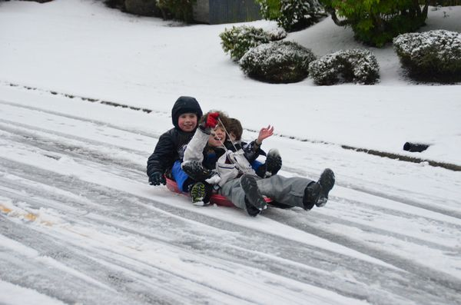

**Hot Dog Roast**

**July 22 @ 6:00 p.m.**

SPECIAL ACTIVITY COLUMN

LET THE OFFICE KNOW WHAT ACTIVITIES

YOUR GROUP HAS PLANNED!

LADIES ACTIVITIES

Please return your Ladies Response

Conference Form. Cindy needs your

feedback on what conference

you would be interested in attending.

February 18th Ladies Dinner Out

At Cherry House in Beavercreek

March 14th @ 2:00 p.m.

Bridal Shower for Tiffany at the Hulbert’s.

April 18th Greeting Card Craft

Bring Snacks to Share

YOUTH ACTIVITIES

January 31st-February 2nd

Winter Blast @ Skyview

March 21st Cedarmania

April 18th Spring Cleaning at the Church

Followed by movie and/or games

May 2nd or May 9th Spring Activity

Movie and/or Game

MEN’S ACTIVITIES

February 1st, March 7th, and April 4th – 7:30 am

Saturday morning Men’s Breakfasts!

Plan this morning and invite friends & neighbors.

Men’s Retreat at Skyview Ranch – April 23rd-25th

Shooting Range, Corn Hole, Lawn Mower Races, Hiking and much more. A special work day

is April 23rd. See Allan Hartong for details

**Grand Heights Baptist Church**

**1611 Armstrong Road**

**Fairborn, OH 45324**

**(937)878-7971**

**E-mail: ghbcnet@grandheights.org**

February 2, 2020

LADIES UPCOMING EVENTS

Dec 2 Girl’s Night Out @ Ellie’s

Dec 31 Gospel Mission/Lunch