**WELCOME CENTER** If you are visiting with us today for the first time, please stop by our Welcome Center to register.

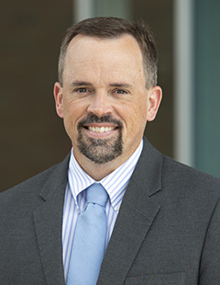

**Interim Pastor**

**Dr. Jason Lee**

**Messages are on studies from the Bible in Matthew. He is presently teaching in Matthew.**

***Welcome to******GRAND HEIGHTS***

**Welcome to our Sunday Service Today – RAIN or SHINE! In compliance with current safe distancing AND wearing face masks, we are having our indoor/outdoor service. You have the option of coming into the church or staying in your car in the church parking lot for the church message. It will be broadcasted on the 88.7 FM station.**

**An Order Of Service packet is available upon arrival. Arrive at 10:15 to allow time to park. Service is scheduled to begin at 10:30. This Indoor/Outdoor service will allow those in our fellowship with health issues to safely come and worship the way they would be most comfortable.**

**FEBRUARY/MARCH BIRTHDAYS**

**Feb 29 Maggie Hartong (B) Mar 3 Mark Coleman (B)**

**Mar 13 Kris Dierker (B) Mar 14 Ashton Fischer (B)**

**Mar 16 Alicia Hartong (B)**

**Mar 19 Dave Pensworth (B)**

**Mar 20 Ken Hulbert (B) Mar 24 Teresa Burk (B)**

**ADULT SUNDAY MORNING BIBLE FELLOWSHIP**

**“OR-DI-NARY” by MICHAEL HORTON**

**Sustainable faith in a radical restless world – Sunday @ 9:15**

**Room 301– Alan Lair - Teacher**

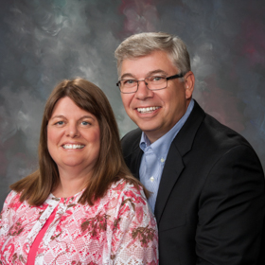

Executive Director for Latin America and the Caribbean

**Scott & Nikki Russell - Executive Director**

**For Latin America & Caribbean**

* Pray for safety in travels to Chili, Brazil,Cuba
* Effectiveness of Ministry to Missionaeies
* Fruit from preaching and teaching
* Helping out during Covid19 w/medical and finances



**LADIES BIBLE STUDY – Mon @ 7:00**

**A Bible Study by Kay Arthur & Pete DeLacy**

**“TRUSTING GOD IN TIMES OF ADVERSITY”**

**You must wear a face mask and**

**seating is compliance with current safe distancing!**

***Our Mission: We exist to glorify God as we help people move***

***Closer to Jesus in their spiritual journey.***

**MISSIONARY FOR THE MONTH OF FEBRUARY**

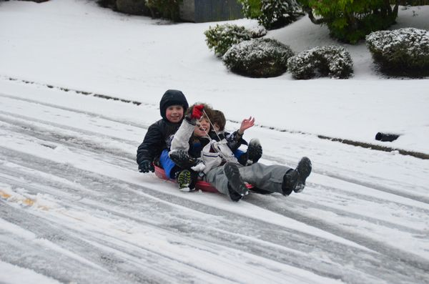

February 28, 2021

IF YOUR FAMILY IS IN NEED IN ANY WAY, PLEASE CONTACT YOUR DEACON OR THE CHURCH OFFICE.

CALENDAR EVENTS

Tues – 9:30 a.m. - Ladies Prayer Mtg.

Sun – February 28– Sunday School @ 9:15 a.m.

Sun - February 28 – Teens Night @ 5:30 p.m.

Sun – February 28 – Awana @ 5:30 p.m.

Sun – February 28 – Communion during morning service

Mon – March 1 – Ladies Bible Study 7:00 p.m.

Wed – March 3 – Missions Prayer Meeting @ 7:00 pm

Wed – March 24 – Church Board Meeting – 7:30 pm

A MESSAGE FROM OUR DEACONS

SPECIAL ELECTION MEETING THIS MORNING BEFORE SERVICE THE MEETING WILL BE AT 10:30 A.M.

1)Pulpit Committee member to replace Susan Coleman (resigned) – Nominee is Melinda Dierker

2)Trustee to replace Steve Bachowski (resigned) - nominee is George Barrett and will serve thru June 2021.

3)Reaffirmation of Dr. Jason Lee as our Interim Pastor

The annual election will be in May. A Nominating Committee has been appointed and they are: Alan Lair, Committee Chairman; Allan Hartong; Brendon Dierker; Beth Hetzel; & Kathy Rudy. The committee will be seeking candidates for several positions

**FOR MORE INFORMATION (please contact)**

**Grand Heights Baptist Church**

**937-878-7971 or www.grandheights.org**

**Pre K – 6th Grades**

**AWANA Clubs of GHBC**

**THE AWANA CLUBS OF GRAND HEIGHTS BAPTIST CHURCH**

**Meets on Sunday Nights**

**@ 5:30 p.m.**





**Grand Heights Baptist Church**

**1611 Armstrong Road**

Fairborn, OH 45324

**(937)878-7971**

**E-mail: ghbcnet@grandheights.org**