**WELCOME CENTER**

If you are visiting with us today for the first time, please stop by our Welcome Center to register.

**LADIES BIBLE STUDY – Mon @ 7:00**

**A Bible Study by Kay Arthur & Pete DeLacy**

**“TRUSTING GOD IN TIMES OF ADVERSITY”**

**You must wear a face mask and**

**seating is compliance with current safe distancing!**

**2021 ADDRESS & PHONE DIRECTORIES ARE READY. You can find them located at the Entrance doors when you come in and Exit doors as you leave.**

**Interim Pastor**

**Dr. Jason Lee**

**Messages are on studies from the Bible in Matthew. He is presently teaching in Matthew.**

**Scott & Nikki Russell - Executive Director**

**For Latin America & Caribbean**

* Pray for safety in travels to Chili, Brazil,Cuba
* Effectiveness of Ministry to Missionaeies
* Fruit from preaching and teaching
* Helping out during Covid19 w/medical and finances

***Our Mission: We exist to glorify God as we help people move***

***Closer to Jesus in their spiritual journey.***

**FEBRUARY BIRTHDAYS**

**Feb 22 Eva Suter (B) Feb 26 Sharon Quiggle (B)**

**Feb 29 Maggie Hartong (B)**



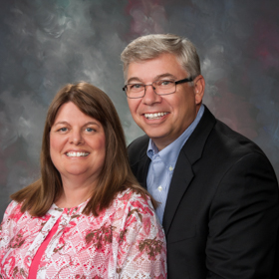

Executive Director for Latin America and the Caribbean

**MISSIONARY FOR THE MONTH OF FEBRUARY**

**ADULT SUNDAY MORNING BIBLE FELLOWSHIP**

**“OR-DI-NARY” by MICHAEL HORTON**

**Sustainable faith in a radical restless world – Sunday @ 9:15**

**Room 301– Alan Lair - Teacher**

***Welcome to******GRAND HEIGHTS***

**Welcome to our Sunday Service Today – RAIN or SHINE! In compliance with current safe distancing AND wearing face masks, we are having our indoor/outdoor service. You have the option of coming into the church or staying in your car in the church parking lot for the church message. It will be broadcasted on the 88.7 FM station.**

**An Order Of Service packet is available upon arrival. Arrive at 10:15 to allow time to park. Service is scheduled to begin at 10:30. This Indoor/Outdoor service will allow those in our fellowship with health issues to safely come and worship the way they would be most comfortable.**

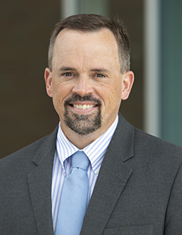

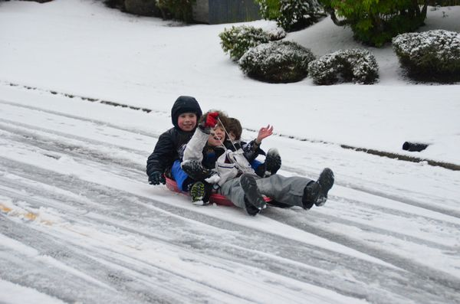

February 21, 2021

IF YOUR FAMILY IS IN NEED IN ANY WAY, PLEASE CONTACT YOUR DEACON OR THE CHURCH OFFICE.

A MESSAGE FROM OUR DEACONS

The annual election will be in May. A Nominating Committee has been appointed and they are: Allan Hartong; Brendon Dierker; Beth Hetzel; Kathy Rudy; and Alan Lair, Chairman for the committee. The committee will be seeking candidates for several positions

What we need is love that will last, love that goes deep, love that’s expressed by action. What we really need is God’s unconditional love. Apostle John said: “This is love: not that we loved God, but that He loved us and sent His Son as an atoning sacrifice for our sins”

(1 John 4:10)

CALENDAR EVENTS

Tues – 9:30 a.m. - Ladies Prayer Mtg.

Sun – February 21– Sunday School @ 9:15 a.m.

Sun - February 21 – Teens Night @ 5:30 p.m.

Sun – February 21 – Awana @ 5:30 p.m.

Mon – February 22 – Ladies Bible Study 7:00 p.m.

Wed – February 24 – Missions Prayer Meeting @ 7:00 pm

Wed – February 24 – Church Board Meeting – 7:30 pm

Sun – February 28 – Communion during morning service

**FOR MORE INFORMATION (please contact)**

**Grand Heights Baptist Church**

**937-878-7971 or www.grandheights.org**

**Pre K – 6th Grades**

**AWANA Clubs of GHBC**

**THE AWANA CLUBS OF GRAND HEIGHTS BAPTIST CHURCH**

**Meets on Sunday Nights**

**@ 5:30 p.m.**





**Grand Heights Baptist Church**

**1611 Armstrong Road**

Fairborn, OH 45324

**(937)878-7971**

**E-mail: ghbcnet@grandheights.org**