**LADIES ARE YOU INTERESTED?**

**A Bible Study by**

**Kay Arthur & Pete DeLacy**

“**TRUSTING GOD IN TIMES**

**OF ADVERSITY”**

**Study begins February 1st.**

**Contact Rachele for information!**

**This is the last Sunday in January. If you have not been able to get your non-perishable food items prior to today, you still have this evening and early Tuesday morning. These items can help a family in need.**

**FEBRUARY ANNIVERSARIES & BIRTHDAYS**

**Feb 1 Rich & Sandy Henry (A)**

**Feb 3 Brian Hulbert (B) Feb 11 Laura Pensworth (B)**

**Feb 17 Rick Pensworth (B) Feb 22 Eva Suter (B)**

**Feb 26 Sharon Quiggle (B) Feb 29 Maggie Hartong (B)**

**Interim Pastor – Dr. Jason Lee**

Dr Lee’s messages are on studies from the Bible in Matthew. He is presently teaching in Matthew Chapter 10.

**ADULT BIBLE FELLOWSHIP**

**“OR-DI-NARY” by MICHAEL HORTON**

**Sustainable faith in a radical restless world – Sunday @ 9:15 – Room 301– Alan Lair - Teacher**







**2021 ADDRESS & PHONE DIRECTORIES ARE READY.**

**You can find them located on the table**

**next to the Media/Sound Desk.**

*May God bless you with love, joy and peace this 2021. Wishing you a year of faith and strength and courage through the Pandemic illnesses*

*The Kuang Family*

With love,

MISSIONARY FOR THE MONTH OF JANUARY  
CHINA OUTREACH MINISTRIES

Kuang Family

Thomas-Casey-Xinai-Joshua-Caleb-Thomas Jr

***Our Mission: We exist to glorify God as we help people move***

***Closer to Jesus in their spiritual journey.***



***Welcome to******GRAND HEIGHTS***

**Welcome to our Sunday Service Today – RAIN or SHINE! In compliance with current safe distancing AND wearing face masks, we are having our indoor/outdoor service. You have the option of coming into the church or staying in your car in the church parking lot for the church message. It will be broadcasted on the 88.7 FM station.**

**An Order Of Service packet is available upon arrival. Arrive at 10:15 to allow time to park. Service is scheduled to begin at 10:30. This Indoor/Outdoor service will allow those in our fellowship with health issues to safely come and worship the way they would be most comfortable.**

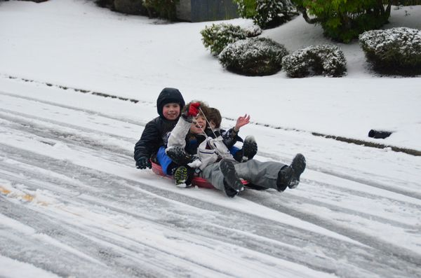

JANUARY 31, 2021

IF YOUR FAMILY IS IN NEED IN ANY WAY, PLEASE CONTACT YOUR DEACON OR THE CHURCH OFFICE.

A MESSAGE FROM OUR TREASURER

Your 2020 Offeratory Gift Statement has been completed. Bob Sudduth has passed out or mailed them. If you have not received yours contact Bob.

CALENDAR EVENTS

Tues. – 9:30 a.m. - Ladies Prayer Mtg.

Sun. – January 31 – Sunday School @ 9:15 a.m.

Sun. - January 31 – Teens Night @ 5:30 p.m.

Sun. – January 31 – Awana @ 5:30 p.m.

Sun. – January 31–Brief meeting prior to morning service

Sun. – January 31 – Communion during morning service

Sun. – January 31 – Youth Leadership Meeting @ 4:00 pm

Wed – February 1 – Ladies Bible Study 7:00 p.m.

Wed. – February 3 – Missions Prayer Meeting @ 7:00 p.m.

Sun. – February 7 – Vote prior to Morning Service on

Church Financial Secretary

YOUTH LEADERSHIP MEETING

Sunday, January 31 at 4:00 pm

Please come if you are involved or interested in helping with our Grand Heights youth ministry. If you have questions, talk with Cindy or Titus.



**Pre K – 6th Grades**

**AWANA Clubs of GHBC**

**THE AWANA CLUBS OF GRAND HEIGHTS BAPTIST CHURCH**

**Meets on Sunday Nights**

**@ 5:30 p.m.**

**FOR MORE INFORMATION (please contact)**

**Grand Heights Baptist Church**

**937-878-7971 or www.grandheights.org**



**Grand Heights Baptist Church**

**1611 Armstrong Road**

Fairborn, OH 45324

**(937)878-7971**

**E-mail: ghbcnet@grandheights.org**