**ANNUAL CHURCH BUSINESS MEETING**

Wednesday, January 27th @ 7:00 p.m.

SAVE THE DATE AND PLAN TO BE HERE!

**Interim Pastor – Dr. Jason Lee**

Dr Lee’s messages are on studies from the Bible in Matthew. He is presently teaching Matthew Chapter 10.

**LADIES ARE YOU INTERESTED?**

**A Bible Study by**

**Kay Arthur & Pete DeLacy**

“**TRUSTING GOD IN TIMES**

**OF ADVERSITY”**

**Study will begin in February.**

**Contact Rachele for information!**





**JANUARY BIRTHDAYS**

**Jan. 25 Zak Hartong (B) Jan. 26 Rachael Hartong (B)**

**ADULT BIBLE FELLOWSHIP “OR-DI-NARY” by MICHAEL HORTON**

**Sustainable faith in a radical restless world**

**Sunday @ 9:15 a.m. Room 301 Alan Lair – Teacher**



*May God bless you with love, joy and peace this 2021. Wishing you a year of faith and strength and courage through the Pandemic illnesses*

*The Kuang Family*

With love,

MISSIONARY FOR THE MONTH OF JANUARY  
CHINA OUTREACH MINISTRIES

Kuang Family

Thomas-Casey-Xinai-Joshua-Caleb-Thomas Jr

***Our Mission: We exist to glorify God as we help people move***

***Closer to Jesus in their spiritual journey.***



***Welcome to******GRAND HEIGHTS***

**Welcome to our Sunday Service Today – RAIN or SHINE! In compliance with current safe distancing AND wearing face masks, we are having our indoor/outdoor service. You have the option of coming into the church or staying in your car in the church parking lot for the church message. It will be broadcasted on the 88.7 FM station.**

**An Order Of Service packet is available upon arrival. Arrive at 10:15 to allow time to park. Service is scheduled to begin at 10:30. This Indoor/Outdoor service will allow those in our fellowship with health issues to safely come and worship the way they would be most comfortable.**

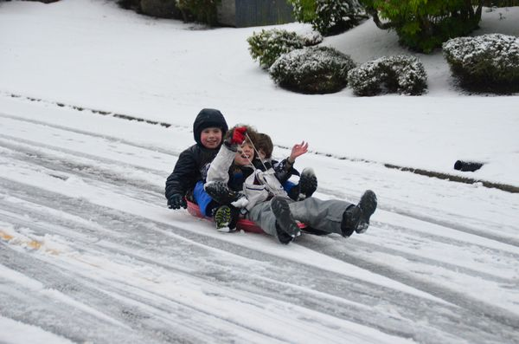

JANUARY 24, 2021

IF YOUR FAMILY IS IN NEED IN ANY WAY, PLEASE CONTACT YOUR DEACON OR THE CHURCH OFFICE.

A MESSAGE FROM OUR TREASURER

Your 2020 Offeratory Gift Statement has been completed and Bob Sudduth passed out their letter to the people who were at church – others will receive them in the mail!

CALENDAR EVENTS

Tues. – 9:30 a.m. - Ladies Prayer Mtg.

Sun. – January 24 – Sunday School @ 9:15 a.m.

Sun. - January 24 – Teens Night @ 5:30 p.m.

Sun. – January 24 – Awana @ 5:30 p.m.

Wed. – January 27 – Prayer Meeting @ 7:00 p.m.

Wed. – January 27 – Annual Church Business Meeting

SAVE THE DATE FOR THE BUSINESS MEETING

Sun. – January 31 – Communion during morning service

Sun. – January 31 – Youth Leadership Meeting @ 4:00 pm

YOUTH LEADERSHIP MEETING

Sunday, January 31 at 4:00 pm

Any who are interested in learning what our teens study here at Grand Heights and what opportunities that they participate in helping them grow in their faith, please attend. If you have questions, talk with Cindy or Titus.



**Pre K – 6th Grades**

**AWANA Clubs of GHBC**

**THE AWANA CLUBS OF GRAND HEIGHTS BAPTIST CHURCH**

**Meets on Sunday Nights**

**@ 5:30 p.m.**

**FOR MORE INFORMATION (please contact)**

**Grand Heights Baptist Church**

**937-878-7971 or www.grandheights.org**



**Grand Heights Baptist Church**

**1611 Armstrong Road**

Fairborn, OH 45324

**(937)878-7971**

**E-mail: ghbcnet@grandheights.org**