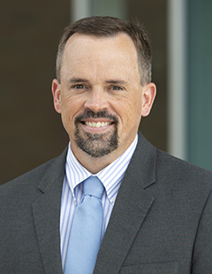

**Interim Pastor – Dr. Jason Lee**

Dr. Lee’s full time position at Cedarville University is serving as the Dean of the School of Biblical and Theological Studies. On the past three Sundays, here at Grand Heights Baptist Church, Dr Lee’s messages have been on studies from Matthew. Question From last week can you answer it? How are you recognizing Jesus’ authority in your life?

*May God bless you with love, joy and peace this 2021. Wishing you a year of faith and strength and courage through the Pandemic illnesses*

*The Kuang Family*

With love,

MISSIONARY FOR THE MONTH OF JANUARY  
CHINA OUTREACH MINISTRIES



**ADULT BIBLE FELLOWSHIP “OR-DI-NARY” by MICHAEL HORTON**

**Sustainable faith in a radical restless world**

**Sunday @ 9:15 a.m. Room 301 Alan Lair – Teacher**

**JANUARY BIRTHDAYS**

**Jan. 21 Ann Tate (B) Jan. 22 Jean MacLeod (B)**

**Jan. 23 Scott Stark (B) Jan. 25 Zak Hartong (B)**

**Jan. 26 Rachael Hartong (B)**



**LADIES ARE YOU INTERESTED?**

**A Bible Study by**

**Kay Arthur & Pete DeLacy**

“**TRUSTING GOD IN TIMES**

**OF ADVERSITY”**

**Study will begin in February.**

**Contact Rachele for information!**

Kuang Family

Thomas-Casey-Xinai-Joshua-Caleb-Thomas Jr

***Our Mission: We exist to glorify God as we help people move***

***Closer to Jesus in their spiritual journey.***

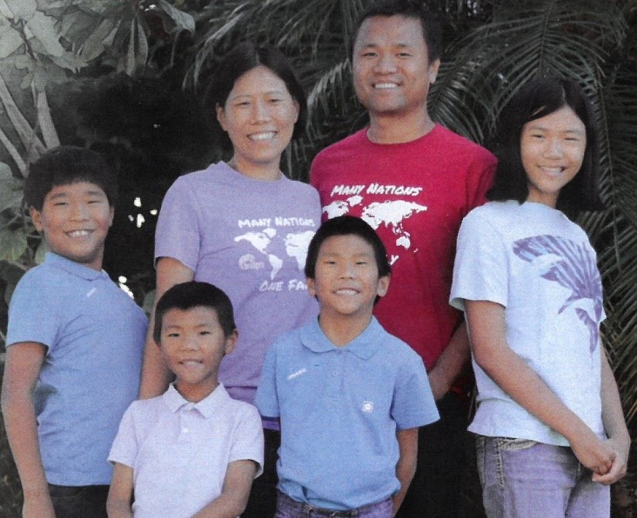

***Welcome to******GRAND HEIGHTS***

**Welcome to our Sunday Service Today – RAIN or SHINE! In compliance with current safe distancing AND wearing face masks, we are having our indoor/outdoor service. You have the option of coming into the church or staying in your car in the church parking lot for the church message. It will be broadcasted on the 88.7 FM station.**

**An Order Of Service packet is available upon arrival. Arrive at 10:15 to allow time to park. Service is scheduled to begin at 10:30. This Indoor/Outdoor service will allow those in our fellowship with health issues to safely come and worship the way they would be most comfortable.**

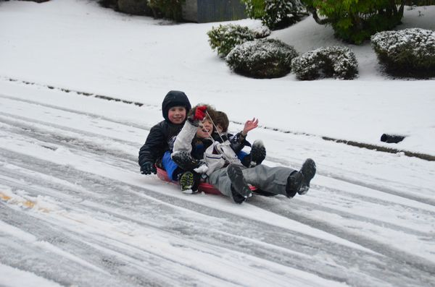

JANUARY 17, 2021

IF YOUR FAMILY IS IN NEED IN ANY WAY, PLEASE CONTACT YOUR DEACON OR THE CHURCH OFFICE.

A MESSAGE FROM OUR TREASURER

Your 2020 Offeratory Gift Statement will

be prepared by our treasurer this year

and handed/or mailed out in January!

CALENDAR EVENTS

Tues. – 9:30 a.m. - Ladies Prayer Mtg.

Sun. – January 17 – Sunday School @ 9:15 a.m.

Sun. - January 17 – Teens Night

Sun. – January 17 – Awana

Wed. – January 20 – Prayer Meeting @ 7:00 p.m.

Wed. – January 20 – Church Board Meeting @ 7:30 p.m.

Wed. – January 27 – Annual Church Business Meeting

SAVE THE DATE FOR THE BUSINESS MEETING

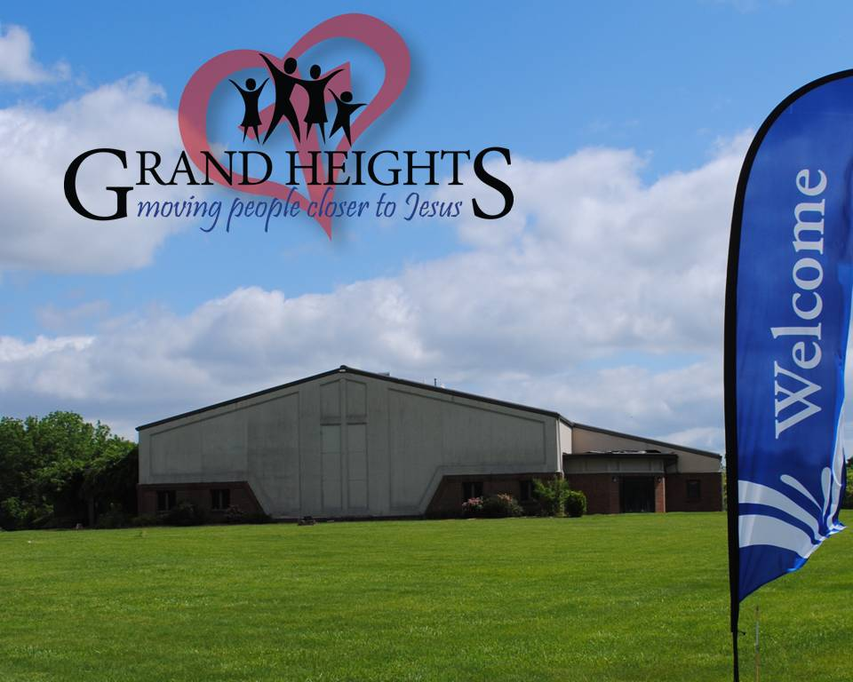

**Pre K – 6th Grades**

**AWANA Clubs of GHBC**

**THE AWANA CLUBS OF GRAND HEIGHTS BAPTIST CHURCH**

**Meets on Sunday Nights**

**@ 5:30 p.m.**



The Church Address & Phone Directory is being updated and plans are working toward having it completed in January. Your help is needed. Please turn in your family information – such as cell phone numbers and present addresses. Also we would like your anniversary dates and birthday dates of you and your children. If you want something kept confidential, we will do that.

**FOR MORE INFORMATION (please contact)**

**Grand Heights Baptist Church**

**937-878-7971 or www.grandheights.org**

**Grand Heights Baptist Church**

**1611 Armstrong Road**

Fairborn, OH 45324

**(937)878-7971**

**E-mail: ghbcnet@grandheights.org**