Dr. Lee was back with us last Sunday and has agreed to continue serving as Interim Pastor until a Senior Pastor has been called to fill that position. Dr. Lee was quaranteed with COVID-19 for a couple of weeks but is back now and seems to be fully recovered. We are very thankful to have him back with us.



**DECEMBER/JANUARY BIRTHDAYS**

**Dec. 29 Shirley Barrett (B) Dec. 30 Dominic Dierker (B)**

**Dec. 31 Isabelle Fischer (B) Jan. 2 Tom Waldo (B)**

**Jan. 2 Warren Tate (B)**

**“In this world you will have trouble. But take heart! I have overcome the world.”**

**John 3:16**



**COMMUNION**

**SUNDAY, DECEMBER 27TH**

**@ 10:30 A.M. SERVICE**

**INSIDE OR OUTSIDE**

**IN YOUR CAR**

*Welcome to* ***GRAND HEIGHTS***

**Welcome to our Sunday Service Today – RAIN or SHINE! In compliance with current safe distancing AND wearing face masks, we are having our indoor/outdoor service. You have the option of coming into the church or staying in your car in the church parking lot for the church message. It will be broadcasted on the 88.7 FM station.**

**An Order Of Service packet is available upon arrival. Arrive at 10:15 to allow time to park. Service is scheduled to begin at 10:30. This Indoor/Outdoor service will allow those in our fellowship with health issues to safely come and worship the way they would be most comfortable.**

THE BULLETIN BOARD IN THE EXIT FOYER IS WHERE CHRISTMAS GREETING CARDS ARE BEING POSTED. SHARE YOUR FAMILIES CARD AND PASS ON YOUR DONATION TO A MISSION THE CHURCHSUPPORTS.



MISSIONARY FOR THE MONTH OF DECEMBER  
WORD OF LIFE MINISTRIES  
Horst Family: Dustan – Beth – Peter – Anna - Emmett

THE HORST NEWSLETTER

* Wrote 4 Olympian Children’s lessons for Word of Life
* Preached at two churches
* Started working with four additional churches
* Trained ministry leaders
* Worked with other WOL Missionaries on virtual Conference



*Our Mission: We exist to glorify God as we help people move closer to Jesus in their spiritual journey.*

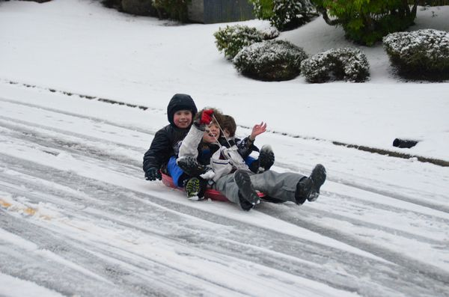

DECEMBER 27, 2020

IF YOUR FAMILY IS IN NEED IN ANY WAY, PLEASE CONTACT YOUR DEACON OR THE CHURCH OFFICE.

A MESSAGE FROM OUR TREASURER!

Remember, as we approach the end of the tax year, we want to remind you that gifts to the church must be received (or postmarked) by December 31st

to receive a tax credit for this calendar year.

**NO AWANA ON**

**DECEMBER 27 & JANUARY 3**

**Pre K – 6th Grades**

**AWANA Clubs of GHBC**

CALENDAR EVENTS

Tues. – 9:30 a.m. - Ladies Prayer Mtg.

Sun. – December 27 – NO Sunday School

Sun. - December 27 –NO Teens Night

Sun. – December 27 & January 3 – No Awana

December 27 – Communion at Sunday Morning Service

December – 29, 30, 31, January 1 – Church Office Closed

The Church Address & Phone Directory is being updated and plans are working toward having it completed in January. Your help is needed. Please turn in your family information – such as cell phone numbers and present addresses. Also we would like your anniversary dates and birthday dates of you and your children. If you want something kept confidential, we will do that.



**FOR MORE INFORMATION (please contact)**

**Grand Heights Baptist Church**

**937-878-7971 or www.grandheights.org**



**Grand Heights Baptist Church**

**1611 Armstrong Road**

Fairborn, OH 45324

**(937)878-7971**

**E-mail: ghbcnet@grandheights.org**