THE BULLETIN BOARD IN THE EXIT FOYER IS WHERE CHRISTMAS GREETING CARDS ARE BEING POSTED. SHARE YOUR FAMILIES CARD AND PASS ON YOUR DONATION TO A MISSION THE CHURCHSUPPORTS.



**WELCOME - PATRICK BAIN**

**He will be filling in for Dr. Lee today and will provide the scriptural message in our morning service. Presently he is pursuing his Masters in Divinity at Cedarville University. Upon completion of his M.Div., Patrick desires to pursue his Ph.D. in Biblical Theology.**

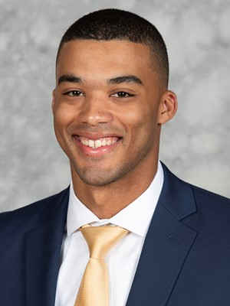

**DR. JASON LEE**

**Tested positive last Sunday for COVID 19! He will be quarantined for a period of time. The congregation voted to continue having Dr. Lee as the Interim Pastor for December thru February 28th.**

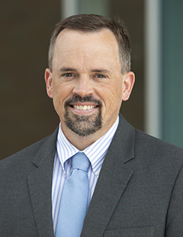

**GHBC DEACONS UPDATE – DECEMBER 13**

MISSIONARY FOR THE MONTH OF DECEMBER  
WORD OF LIFE MINISTRIES  
Horst Family: Dustan – Beth – Peter – Anna - Emmett

THE HORST NEWSLETTER

* Wrote 4 Olympian Children’s lessons for Word of Life
* Preached at two churches
* Started working with four additional churches
* Trained ministry leaders
* Worked with other WOL Missionaries on virtual Conference



***DECEMBER BIRTHDAYS***

**Dec. 15 Daniel Pensworth (B) Dec. 29 Shirley Barrett (B)**

**Dec. 30 Dominic Dierker (B) Dec. 31 Isabelle Fischer (B)**

*Our Mission: We exist to glorify God as we help people move closer to Jesus in their spiritual journey.*

*Welcome to* ***GRAND HEIGHTS***

**Welcome to our Sunday Service Today – RAIN or SHINE! In compliance with current safe distancing AND wearing face masks, we are having our indoor/outdoor service. You have the option of coming into the church or staying in your car in the church parking lot for the church message. It will be broadcasted on the 88.7 FM station.**

**An Order Of Service packet is available upon arrival. Arrive at 10:15 to allow time to park. Service is scheduled to begin at 10:30. This Indoor/Outdoor service will allow those in our fellowship with health issues to safely come and worship the way they would be most comfortable. The Order of Service can also be found on the Church Web Site.**

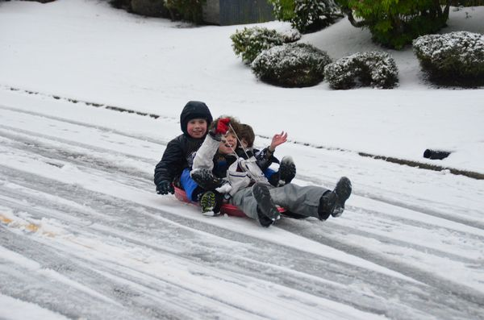

DECEMBER 13, 2020

IF YOUR FAMILY IS IN NEED IN ANY WAY, PLEASE CONTACT YOUR DEACON OR THE CHURCH OFFICE.

Thank you for coming to the meeting on the 9th. The following are the business issues that passed. Pulpit Committee – Brian Hetzel; Interim Pastor – Dr. Lee; Removal of the Jones family as they transferred to another church; 2021 Church budget passed; Discontinued mission support for Beth Trimble (remarried); Financial Secretary – still not filled!



CALENDAR EVENTS

Tues. – 9:30 a.m. - Ladies Prayer Mtg.

Sun. – December – Adults, Teens and Children Sunday School Classes (9:15 A.M.)

Sun. - December 13 –Teens Night – 5:30 p.m.

Sun. – December 13 –Awana Clubs tonight - 5:30 p.m.

Wed. – December 16 - Prayer Meeting - 7:00 p.m

Wed. – December 23 – Christmas Eve Eve Service

December – 24 & 25 – Church Office Closed – Holiday

December – 29, 30, 31, January 1 – Church Office Closed

**The Church Address & Phone Directory is being updated and plans are working toward having it completed by January. Your help is needed. Please turn in your family information – such as cell phone numbers and present addresses. Also we would like your anniversary dates and birthday dates of you and your children. If you want something kept confidential, we will do that.**

**THE AWANA CLUBS OF GRAND HEIGHTS BAPTIST CHURCH**

**Meets Sunday Nights**

**@ 5:30 p.m.**



**Pre K – 6th Grades**

**AWANA Clubs of GHBC**

**FOR MORE INFORMATION (please contact)**

**Grand Heights Baptist Church**

**937-878-7971 or www.grandheights.org**

**Grand Heights Baptist Church**

**1611 Armstrong Road**

Fairborn, OH 45324

**(937)878-7971**

**E-mail: ghbcnet@grandheights.org**