**Pamphlets and shoeboxes**

**are available in the Foyer**

**Area as you exit.**

COLLECTION WEEK – NOV. 16

How to pack your shoebox – select a quality toy (doll, soccer ball with pump, stuffed animal). Fill with other, hygiene items & school supplies. Most importantly,

**PRAY FOR THE CHILD WHO**

**WILL RECEIVE YOUR GIFT. INCLUDE A PERSONAL NOTE AND PHOTO.**

MISSIONS FOR THE MONTH OF NOVEMBER

Operation Christmas Child

**NOVEMBER BIRTHDAYS & ANNIVERSARIES**

**Nov 8 Vicki Smith (B) Nov 8 Megan Suter (B)**

**Nov 17 Vicki Lair (B) Nov 21 Matthew Coleman (B)**

**Nov 22 Dave Imes (B) Nov 22 Rich & Ruth Marvin (A)**

**GHBC DEACONS UPDATE FOR THE HINES - November 8**

**"Pastor Eric Hines will not be starting his ministry at Grand Heights for several more weeks.  He is working through some problems concerning a staff member at his former church. With his announced departure, the matter became public and caused unforeseen stress for him and his family even though Eric is not at fault. The Michigan GARBC state representative (Pastor to the Pastors) Ken Floyd has been working with the Hines family and their former church. We have been and will continue to work with Ken as we all pull together to help. Ken also observed that a two-week transition from one church to a new one was not typical, especially when the churches are located hundreds of miles apart.  On top of this additional emotional stress, Eric has the normal stress of having to sell his home in Michigan, buy a home in Fairborn, and then make the move here.  At the moment it is uncertain when exactly he will be joining us, but it is unlikely to be before December. In the meantime, however, we will continue to enjoy the pastoral ministry of Dr. Jason Lee since his status as our interim pastor has been renewed. Please pray for Eric and his family in this trying time. If you have questions or concerns please contact any of us or Dr. Jason Lee.”**

*Our Mission: We exist to glorify God as we help people move closer to Jesus in their spiritual journey.*

***The Dayton Gospel Mission is looking for volunteers to serve the Thanksgiving Buffet which is on Friday November 27 from*** ***10-2. This could be a family project. If interested, contact*** ***Ken Clarkston  937-223-4513***

**NEW PHONE DIRECTORIES WILL BE COMING OUT BY THE BEGINNING OF 2021. IF YOU HAVE CHANGES PLEASE LET THE OFFICE KNOW!**



*Welcome to* ***GRAND HEIGHTS***

**Welcome to our Sunday Service Today – RAIN or SHINE! In compliance with current safe distancing AND wearing face masks, we are having our indoor/outdoor service. You have the option of coming into the church or staying in your car in the church parking lot for the church message. It will be broadcasted on the 88.7 FM station.**

**An Order Of Service packet is available upon arrival. Arrive at 10:15 to allow time to park. Service is scheduled to begin at 10:30. This Indoor/Outdoor service will allow those in our fellowship with health issues to safely come and worship the way they would be most comfortable. The Order of Service can also be found on the Church Web Site.**

**IF YOU HAVE ANY QUESTIONS OR NEED MORE SUPPLIES FOR YOUR SHOEBOX, PLEASE CONTACT BRENDON DIERKER! We need you to bring in your filled boxes by November 16. Make out your check to Grand Heights Baptist Church and put it in the Offering Plate on that Sunday.**

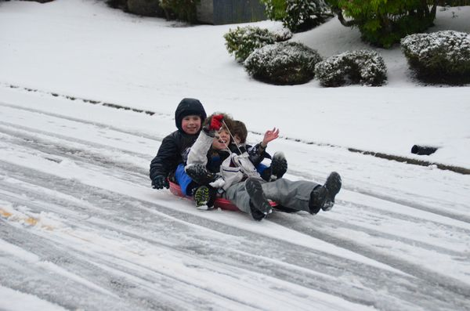

NOVEMBER 8, 2020

IF YOUR FAMILY IS IN NEED IN ANY WAY, PLEASE CONTACT YOUR DEACON OR THE CHURCH OFFICE.

WELCOME

Dr. Jason Lee, Interim Pastor

**NOVEMBER HAS FIVE SUNDAYS FOR FISH DONATIONS**

**NON-PERISHABLE FOODS AND SUPPLIES ONLY**

***THANK YOU!***

***Sandy Hazelbaker says thank you to the church for***

***the baby gifts, prayers and support***

***for her and baby Jayden.***



**THE AWANA CLUBS OF GRAND HEIGHTS BAPTIST CHURCH**

**Meets Sunday Nights**

**@ 5:30 p.m.**

**FOR MORE INFORMATION (please contact)**

**Grand Heights Baptist Church**

**937-878-7971 or www.grandheights.org**

**Pre K – 6th Grades**

**AWANA Clubs of GHBC**

CALENDAR EVENTS

Tues. – 9:30 a.m. - Ladies Prayer Mtg.

Wed. – 7:00 p.m. – All Church Prayer Time

Sun. – November – Adults, Teens, and Children Sunday School Classes (9:15 A.M.)

Wed. – November 4 – Missions Prayer Meeting – 7:00 p.m.

Sun. - November 8 – Awana & Teens Night – 5:30 p.m.

Wed. – November 11 – Congregation Budget Mtg–7:00 pm

Thur. – November 26 – Thanksgiving – Office Closed

Fri. – November 27–Thanksgiving Holiday – Office Closed

**Grand Heights Baptist Church**

**1611 Armstrong Road**

Fairborn, OH 45324

**(937)878-7971**

**E-mail: ghbcnet@grandheights.org**