**GHBC DEACONS UPDATE - NOVEMBER 29**

Patrick Bain, a Cedarville University graduate student will be filling in for Dr. Lee, today and he will provide the scriptural message in our morning service. Presently he is pursuing his Masters in Divinity at Cedarville. Upon completion of his M.Div., Patrick desires to pursue his Ph.D. in Biblical Theology. Other activites that he is involved in at this time is a Graduate-Assistant with the Men’s Basketball Program plus he also works in the Global Outreach Department.

**WELCOME**

**PATRICK**

**BAIN**

**THIRTY-ONE**

**SHOEBOXES**

**WERE DELIVERED**

**MONDAY, NOV. 23**

***DECEMBER BIRTHDAYS & NO ANNIVERSARIES***

**Dec. 2 Melinda Dierker (B) Dec. 15 Daniel Pensworth (B)**

**Dec. 29 Shirley Barrett (B) Dec. 30 Dominic Dierker (B)**

**Dec. 31 Isabelle Fischer (B)**

THANKS FOR EVERYONE’S SHOEBOX DONATION

**If you are giving cash instead of shoeboxes please make out your checks to Grand Heights Baptist Church and put them** **in the Offering Plate today. This money is to pay for shipping the Shoeboxes.**



*Our Mission: We exist to glorify God as we help people move closer to Jesus in their spiritual journey.*

MISSIONS FOR THE MONTH OF NOVEMBER

Operation Christmas Child

*Welcome to* ***GRAND HEIGHTS***

**Welcome to our Sunday Service Today – RAIN or SHINE! In compliance with current safe distancing AND wearing face masks, we are having our indoor/outdoor service. You have the option of coming into the church or staying in your car in the church parking lot for the church message. It will be broadcasted on the 88.7 FM station.**

**An Order Of Service packet is available upon arrival. Arrive at 10:15 to allow time to park. Service is scheduled to begin at 10:30. This Indoor/Outdoor service will allow those in our fellowship with health issues to safely come and worship the way they would be most comfortable. The Order of Service can also be found on the Church Web Site.**

**NEW PHONE DIRECTORIES WILL BE COMING OUT BY THE BEGINNING OF 2021. IF YOU HAVE CHANGES PLEASE LET THE OFFICE KNOW!**



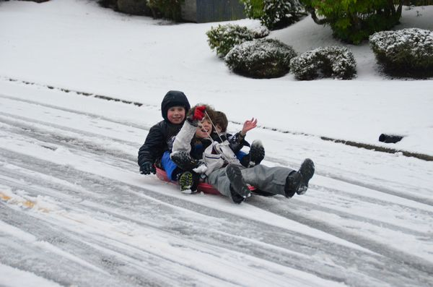

NOVEMBER 29, 2020

IF YOUR FAMILY IS IN NEED IN ANY WAY, PLEASE CONTACT YOUR DEACON OR THE CHURCH OFFICE.

**The next church business meeting will be held Wed, Dec 9.  The primary reason for the meeting is to consider the proposed 2021 church budget. Save this date and plan to attend.**

CALENDAR EVENTS

Tues. – 9:30 a.m. - Ladies Prayer Mtg.

Sun. – November – Adults, Teens and Children Sunday School Classes (9:15 A.M.)

Sun. - November 29 –Teens Night – 5:30 p.m.

Sun. – November 29 –Awana Clubs tonight - 5:30 p.m.

Wed. – December 2 - 7:00 p.m – Prayer Meeting

Wed. – December 2 – Deacon’s Meeting – 7:30 pm

Wed. – December 9 – Congregation Budget Mtg–7:00 pm

December – 24 & 25 – Church Office Closed – Holiday

**THE AWANA CLUBS OF GRAND HEIGHTS BAPTIST CHURCH**

**Meets Sunday Nights**

**@ 5:30 p.m.**



**Pre K – 6th Grades**

**AWANA Clubs of GHBC**

**PLEASE BRING IN YOUR FOOD DONATIONS TODAY**

**NON-PERISHABLE FOODS AND SUPPLIES ONLY**

**FOR MORE INFORMATION (please contact)**

**Grand Heights Baptist Church**

**937-878-7971 or www.grandheights.org**

**Grand Heights Baptist Church**

**1611 Armstrong Road**

Fairborn, OH 45324

**(937)878-7971**

**E-mail: ghbcnet@grandheights.org**