*Our Mission: We exist to glorify God as we help people move closer to Jesus in their spiritual journey.*

THANKS FOR EVERYONE’S DONATION

**Make out your check to Grand Heights Baptist Church and put it in the Offering Plate today. This money is to pay for shipping the Shoeboxes.**

**PRAY FOR THE CHILD WHO**

**WILL RECEIVE YOUR GIFT. INCLUDE A PERSONAL NOTE AND PHOTO.**

[](https://www.bing.com/images/search?view=detailV2&ccid=0AyXxXT/&id=8270317E782826C08864434482FB9A58AE88B85C&thid=OIP.0AyXxXT_ThLEapMNhQz-_QHaEM&mediaurl=http://www.holycrossclarence.com/wp-content/uploads/2014/09/church_powerpoint.jpg&exph=303&expw=535&q=operation+christmas+child+clip+art&simid=607999084073586506&ck=26BF103B2B777899C6A37BA0858F2CF7&selectedIndex=34&qpvt=operation+christmas+child+clip+art&FORM=IRPRST)

MISSIONS FOR THE MONTH OF NOVEMBER

Operation Christmas Child

**GHBC DEACONS UPDATE - NOVEMBER 22**

November and December are very memorable months each year. The memories of 2020 will be in our hearts and minds for a very long time, some good and some bad. Many have lost loved ones because of the virus that has hit our nation but with our faith and love for God, we will get through this time

In the meantime, however, we will continue to enjoy the pastoral ministry of Dr. Jason Lee since his status as our interim pastor has been renewed. This week Dr. Lee is with us for Sunday’s morning worship service. We will be having Communion during this service today.

Patrick Bain, a Cedarville University graduate student will be filling in for Dr. Lee, November 29th and will provide the scriptural message on that Sunday, He is pursuing his Masters in Divinity at Cedarville. Upon completion of his M.Div., Patrick desires to pursue his Ph.D. in Biblical Theology. Other activites that he is involved in at this time as a Graduate-Assistant with the Men’s Basketball Program plus he also works in the Global Outreach Department.

***NOVEMBER BIRTHDAYS & ANNIVERSARIES***

**Nov 22 Dave Imes (B) Nov 22 Rich & Ruth Marvin (A)**

*Welcome to* ***GRAND HEIGHTS***

**Welcome to our Sunday Service Today – RAIN or SHINE! In compliance with current safe distancing AND wearing face masks, we are having our indoor/outdoor service. You have the option of coming into the church or staying in your car in the church parking lot for the church message. It will be broadcasted on the 88.7 FM station.**

**An Order Of Service packet is available upon arrival. Arrive at 10:15 to allow time to park. Service is scheduled to begin at 10:30. This Indoor/Outdoor service will allow those in our fellowship with health issues to safely come and worship the way they would be most comfortable. The Order of Service can also be found on the Church Web Site.**

**NEW PHONE DIRECTORIES WILL BE COMING OUT BY THE BEGINNING OF 2021. IF YOU HAVE CHANGES PLEASE LET THE OFFICE KNOW!**



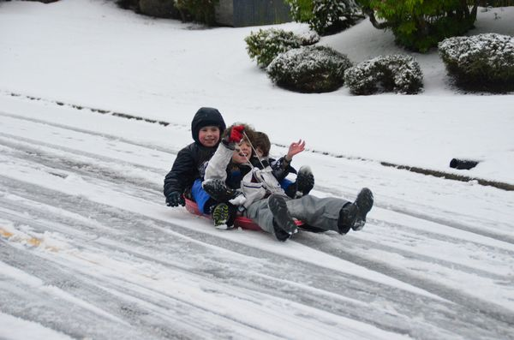

NOVEMBER 22, 2020

IF YOUR FAMILY IS IN NEED IN ANY WAY, PLEASE CONTACT YOUR DEACON OR THE CHURCH OFFICE.

**The next church business meeting will be held Wed, Dec 9.  The primary reason for the meeting is to consider the proposed 2021 church budget. Save this date and plan to attend.**



**THERE WILL BE NO AWANA TONIGHT!**

CALENDAR EVENTS

Tues. – 9:30 a.m. - Ladies Prayer Mtg.

Sun. – November – Adults, Teens and Children Sunday School Classes (9:15 A.M.)

Sun. – November 22 – Communion @ 10:30 a.m. Service

Sun. - November 22 –Teens Night – 5:30 p.m.

Sun. – November 22 – No Awana Clubs tonight

Wed. – November 25 - 7:00 p.m – NO Evening Church

Thur. – November 26 & 27 – Thanksgiving – Office Closed

Wed. – December 2 – Deacon’s Meeting – 7:30 pm

Wed. – December 9 – Congregation Budget Mtg–7:00 pm

**Pre K – 6th Grades**

**AWANA Clubs of GHBC**

DR. JASON LEE

**NOVEMBER HAS FIVE SUNDAYS FOR FISH DONATIONS**

**NON-PERISHABLE FOODS AND SUPPLIES ONLY**

**NORMALY WE HAVE A FELLOWSHIP THANKSGIVING FEAST THE SUNDAY BEFORE THE HOLIDAY BUT BECAUSE OF THE VIRUS ISSUES THIS YEAR, IT IS CANCELLED.**

**Grand Heights Baptist Church**

**1611 Armstrong Road**

Fairborn, OH 45324

**(937)878-7971**

**E-mail: ghbcnet@grandheights.org**