***The Dayton Gospel Mission needs volunteers to help serve the Thanks- giving Buffet, Friday November 27 from*** ***10-2. If interested, contact***

***Ken Clarkston@ 937-223-4513***

**GHBC DEACONS UPDATE - NOVEMBER 15**

"Pastor Eric Hines will not be starting his ministry at Grand Heights for several more weeks.  At the moment it is uncertain when exactly he will be joining us, but it is unlikely to be before December 1. November and December are very memorable months each year. The memories of 2020 will be in our hearts and minds for a very long time, some good and some bad. Many have lost loved ones because of the virus that has hit our planet but with our faith and love for God, we will get through it.

In the meantime, however, we will continue to enjoy the pastoral ministry of Dr. Jason Lee since his status as our interim pastor has been renewed. This week Dr. Lee has prior commitments and asked Dr. Randy McKinion to fill in for him at Grand Heights and to provide the congregation with a message from the scriptures.

Dr. Randy McKinion's academic preparation focused particularly on the study of a biblical narrative in the story of Joseph. His interests have also expanded to intertextuality in and among the prophets. Dr. McKinion desires to help the Church teach the Old Testament more effectively and faithfully.

[](https://www.bing.com/images/search?view=detailV2&ccid=0AyXxXT/&id=8270317E782826C08864434482FB9A58AE88B85C&thid=OIP.0AyXxXT_ThLEapMNhQz-_QHaEM&mediaurl=http://www.holycrossclarence.com/wp-content/uploads/2014/09/church_powerpoint.jpg&exph=303&expw=535&q=operation+christmas+child+clip+art&simid=607999084073586506&ck=26BF103B2B777899C6A37BA0858F2CF7&selectedIndex=34&qpvt=operation+christmas+child+clip+art&FORM=IRPRST)

COLLECTION WEEK – NOV. 16

How to pack your shoebox – select a quality toy (doll, soccer ball with pump, stuffed animal). Fill with other, hygiene items & school supplies. Most importantly,

**PRAY FOR THE CHILD WHO**

**WILL RECEIVE YOUR GIFT. INCLUDE A PERSONAL NOTE AND PHOTO.**

MISSIONS FOR THE MONTH OF NOVEMBER

Operation Christmas Child

**IF YOU HAVE ANY QUESTIONS OR NEED MORE SUPPLIES FOR YOUR SHOEBOX, PLEASE CONTACT BRENDON DIERKER! We need you to bring in your filled boxes by November 16. Make out your check to Grand Heights Baptist Church and put it in the Offering Plate on that Sunday.**

*Our Mission: We exist to glorify God as we help people move closer to Jesus in their spiritual journey.*

**NEW PHONE DIRECTORIES WILL BE COMING OUT BY THE BEGINNING OF 2021. IF YOU HAVE CHANGES PLEASE LET THE OFFICE KNOW!**



*Welcome to* ***GRAND HEIGHTS***

**Welcome to our Sunday Service Today – RAIN or SHINE! In compliance with current safe distancing AND wearing face masks, we are having our indoor/outdoor service. You have the option of coming into the church or staying in your car in the church parking lot for the church message. It will be broadcasted on the 88.7 FM station.**

**An Order Of Service packet is available upon arrival. Arrive at 10:15 to allow time to park. Service is scheduled to begin at 10:30. This Indoor/Outdoor service will allow those in our fellowship with health issues to safely come and worship the way they would be most comfortable. The Order of Service can also be found on the Church Web Site.**

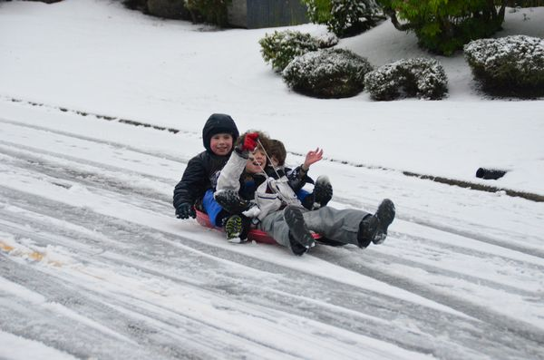

NOVEMBER 15, 2020

IF YOUR FAMILY IS IN NEED IN ANY WAY, PLEASE CONTACT YOUR DEACON OR THE CHURCH OFFICE.

**Pre K – 6th Grades**

**AWANA Clubs of GHBC**

**NOVEMBER BIRTHDAYS & ANNIVERSARIES**

**Nov 17 Vicki Lair (B) Nov 21 Matthew Coleman (B)**

**Nov 22 Dave Imes (B) Nov 22 Rich & Ruth Marvin (A)**

CALENDAR EVENTS

Tues. – 9:30 a.m. - Ladies Prayer Mtg.

Wed. – 7:00 p.m. – All Church Prayer Time

Sun. – November – Adults, Teens and Children Sunday School Classes (9:15 A.M.)

Sun. - November 15 – Awana & Teens Night – 5:30 p.m.

Wed. – November 18–Missions Prayer Meeting – 7:00 p.m.

Sun. – November 22 – Communion @ 10:30 a.m. Service

Thur. – November 26 & 27 – Thanksgiving – Office Closed

Wed. – December 9 – Congregation Budget Mtg–7:00 pm

WELCOME

DR. RANDY McKINION

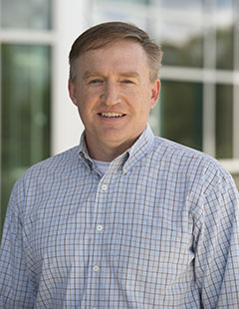

**NOVEMBER HAS FIVE SUNDAYS FOR FISH DONATIONS**

**NON-PERISHABLE FOODS AND SUPPLIES ONLY**



**THE AWANA CLUBS OF GRAND HEIGHTS BAPTIST CHURCH**

**Meets Sunday Nights**

**@ 5:30 p.m.**

**FOR MORE INFORMATION (please contact)**

**Grand Heights Baptist Church**

**937-878-7971 or www.grandheights.org**

**Grand Heights Baptist Church**

**1611 Armstrong Road**

Fairborn, OH 45324

**(937)878-7971**

**E-mail: ghbcnet@grandheights.org**