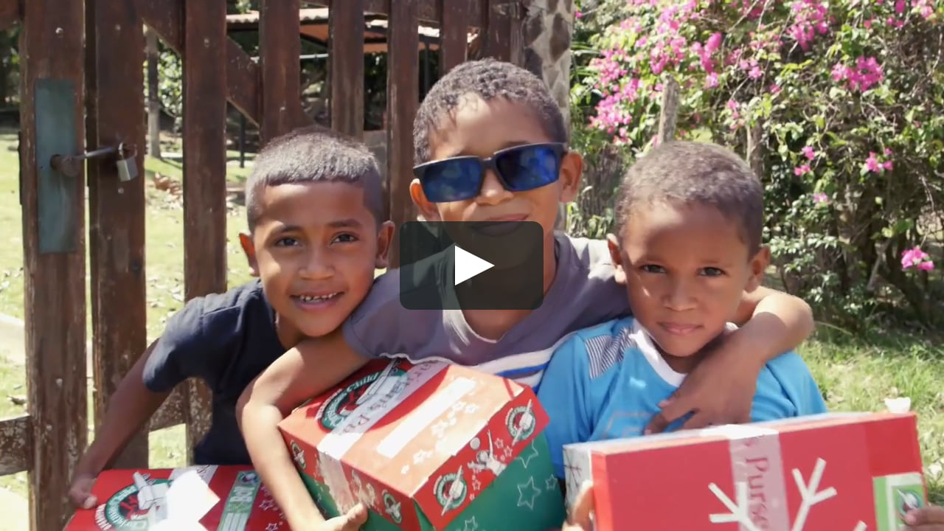

**Pamphlets and shoeboxes are available in the Foyer Area**

**as you exit.**

COLLECTION WEEK – NOV. 16-24

How to pack your shoebox – select a quality toy (doll, soccer ball with pump, stuffed animal). Fill with other, hygiene items & school supplies. Most importantly,

**PRAY FOR THE CHILD WHO WILL RECEIVE YOUR GIFT. INCLUDE A PERSONAL NOTE AND PHOTO.**

**IF YOU HAVE ANY QUESTIONS OR NEED MORE SUPPLIES FOR YOUR SHOEBOX, PLEASE CONTACT BRENDON DIERKER!**

MISSIONS FOR THE MONTH OF OCTOBER

Operation Christmas Child

**PULPIT COMMITTEE REPORT- October 4**

"Remember that we are having a special church business meeting this morning immediately following the worship service.  This meeting is to decide whether to call Eric Hines as our pastor.  All members may vote, including those staying outside in the parking lot.  Our constitution requires a secret ballot and an affirmative vote of at least 3/4 of those present and voting to extend a call to Eric."

**Jason K. Lee has served as the Dean of the School of Biblical and Theological Studies at Cedarville University since 2013.** **We are glad to have Dr. Jason Lee as Interim Pastor. Dr. Lee would like everyone to read Joshua Chapter 5 before today’s Sunday service.**



**SEPTEMBER/OCTOBER BIRTHDAYS & ANNIVERSERIES**

**Oct 4 Jim Howard (B) Oct 6 Barbara Howard (B)**

**Oct 11 Michael Coleman (B) Oct 14 Brian & Beth Hetzel (A)**

**Oct 21 Kylie Burk (B) Oct 22 Lincoln Hartong (B)**

**Oct 25 Keegan Dierker (B) Oct 29 Thelma Hughes (B)**

*Welcome to* ***GRAND HEIGHTS***

**Welcome to our Sunday Service Today – RAIN or SHINE! In compliance with current safe distancing we are having our indoor/outdoor service. Dr. Jason Lee, as our Interim Pastor, will be with us the next several months. His sermon this week is from Joshua Chapter 5. He would like you to read this Chapter prior to today’s service. You have the option of coming into the church or staying in your car in the church parking lot for the church message. It will be broadcasted on the 88.7 FM station. To pick up the Audio, you need to have a vehicle with a working FM radio.**

**A packet of information is available upon arrival. Arrive at 10:15 to allow time to park. Service is scheduled to begin at 10:30. This Indoor/Drive-in service will allow those in our fellowship with health issues to safely come and worship the way they would be most comfortable. The Order of Service Packet is available Sunday morning or on the Church Web Site. With Questions Talk With: Allan Hartong @ 937-718-0533.**

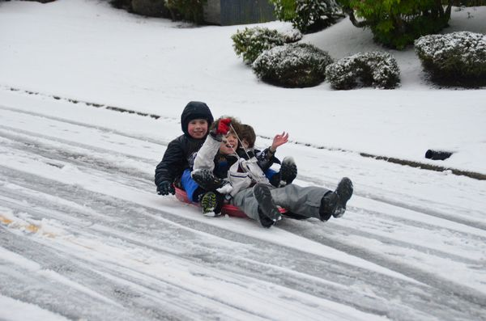

OCTOBER 4, 2020

IF YOUR FAMILY IS IN NEED IN ANY WAY, PLEASE CONTACT YOUR DEACON OR THE CHURCH OFFICE.

CALENDAR EVENTS

Tues. – 9:30 a.m. - Ladies Prayer Mtg.

Wed. – 7:00 p.m. – All Church Prayer Mtg.

Sun. – October 4 –Adults, Teens, and Children Sunday School Classes (9:15 A.M.)

Sun. - October 4 – Business Meeting @ 12:00

Sun. - October 4 – Awana (On-Line Internet Reality)

5:30 p.m. Will not be at the Church this week. This is a trial event. Next week it will be back at the Church.

Sun. – October 4 – 5:30 p.m. Teens in Church Bldg.

Wed. – October 14 – Board Meeting (7:30 P.M.) – Budget

Wed. – October 28 – Board Meeting (7:30 P.M.) - Budget

**THIS WEEK ONLY! Awana will not be held in the Church Building. It will be an On-Line Reality Event where it will take place in each childs home. This is a trial situation to see how it works. Next week it will be returned to normal**

**FOR MORE INFORMATION (please contact)**

**Grand Heights Baptist Church**

**937-878-7971 or www.grandheights.org**

**THE AWANA CLUBS OF GRAND HEIGHTS BAPTIST CHURCH**

**Meets Sunday Nights**

**@ 5:30 p.m.**



**Pre K – 6th Grades**

**AWANA Clubs of GHBC**

*Our Mission: We exist to glorify God as we help people move closer to Jesus in their*

*spiritual journey.*

A large sign in a field

Description generated with very high confidence

**Grand Heights Baptist Church**

**1611 Armstrong Road**

Fairborn, OH 45324

**(937)878-7971**

**E-mail: ghbcnet@grandheights.org**