**PULPIT COMMITTEE REPORT- October 18**

"**Pastor Eric Hines has accepted the call from Grand Heights Baptist Church to be its pastor. When contacted, Eric enthusiastically accepted the call.   Later in the week he indicated that his first day as Grand Heights Baptist Church Pastor would be October 26, and November 1 would be his first sermon as our pastor.   The Pulpit Committee thanks everyone for their prayers, encouragement, and support during the search." Alan Lair, Deacon**

**The Women’s Ministry is sponsoring a project to support a young woman who grew up in our church. Sandy Marvin Hazelbaker is expecting baby boy Jayden in early November. Her past baby items 5 years ago were passed on to others. A Flyer is available that will help to know what type of needs she and the baby have. Please pray about what you could do to help this baby start out well.**

**On Sunday, October 25th we will have boxes available for donations. Please either wrap or put in plastic bags for COVID safety. Any Questions call Cindy at**

**(937-237-7690) or Ruth Marvin (937-344-6156).**

**OCTOBER BIRTHDAYS & ANNIVERSERIES**

**Oct 21 Kylie Burk (B) Oct 22 Lincoln Hartong (B)**

**Oct 25 Keegan Dierker (B) Oct 29 Thelma Hughes (B)**

**IF YOU HAVE ANY QUESTIONS OR NEED MORE SUPPLIES FOR YOUR SHOEBOX, PLEASE CONTACT BRENDON DIERKER!**

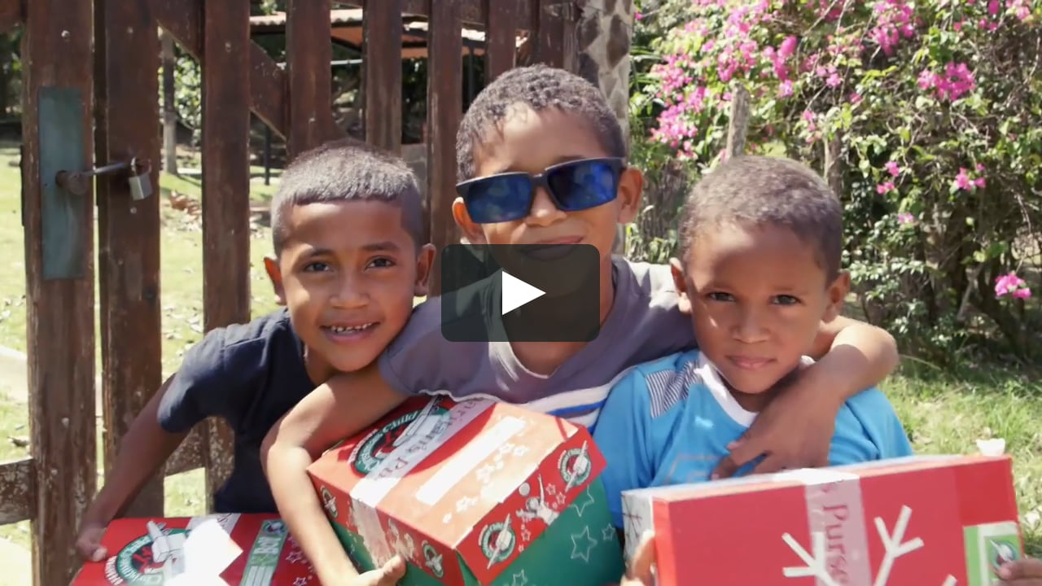

**Pamphlets and shoeboxes are available in the Foyer Area**

**as you exit.**

COLLECTION WEEK – NOV. 16-24

How to pack your shoebox – select a quality toy (doll, soccer ball with pump, stuffed animal). Fill with other, hygiene items & school supplies. Most importantly,

**PRAY FOR THE CHILD WHO WILL RECEIVE YOUR GIFT. INCLUDE A PERSONAL NOTE AND PHOTO.**

MISSIONS FOR THE MONTH OF OCTOBER

Operation Christmas Child

*Welcome to* ***GRAND HEIGHTS***

**Welcome to our Sunday Service Today – RAIN or SHINE! In compliance with current safe distancing we are having our indoor/outdoor service. Dr. Jason Lee, our Interim Pastor, will be with us for the next two weeks. His sermon this week is from Joshua Chapter 7 & 8. He would like you to read this Chapter prior to today’s service. You have the option of coming into the church or staying in your car in the church parking lot for the church message. It will be broadcasted on the 88.7 FM station. To pick up the Audio, you need to have a vehicle with a working FM radio.**

**A packet of information is available upon arrival. Arrive at 10:15 to allow time to park. Service is scheduled to begin at 10:30. This Indoor/Drive-in service will allow those in our fellowship with health issues to safely come and worship the way they would be most comfortable. The Order of Service Packet is available Sunday morning or on the Church Web Site. With Questions Talk With: Allan Hartong @ 937-718-0533.**

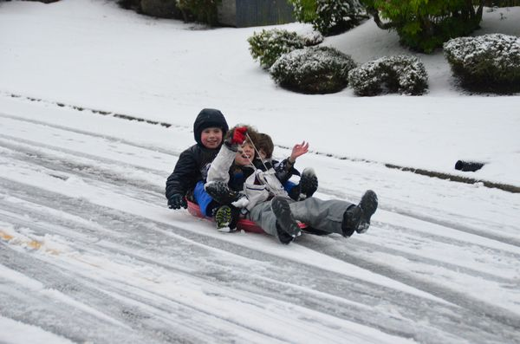

OCTOBER 18, 2020

IF YOUR FAMILY IS IN NEED IN ANY WAY, PLEASE CONTACT YOUR DEACON OR THE CHURCH OFFICE.

CALENDAR EVENTS

Tues. – 9:30 a.m. - Ladies Prayer Mtg.

Wed. – 7:00 p.m. – All Church Prayer Time

Sun. – October – Adults, Teens, and Children Sunday School Classes (9:15 A.M.)

Sun. - October 18 – Awana & Teens Night – 5:30 p.m.

Wed. – November 4 – Missions Prayer Meeting – 7:00 p.m.

Wed. – November 11 – Congregation Budget Mtg–7:00 pm

Thur. – November 26 – Thanksgiving – Office Closed

Fri. – November 27–Thanksgiving Holiday – Office Closed

**GRAND HEIGHTS BAPTIST CHURCH FAMILY**

**Thank you for your love, support and prayers during this time, after the loss of Greg’s Dad, Ron Dierker. We appreciate the cards, notes, calls, texts as well as the planter/flower. A special thank-you to those who attended the visitation/Celebration of Life Service and or made desserts for our family gathering afterwards. They were enjoyed by all. In Christ’s Love, The Dierker Family.**



**THE AWANA CLUBS OF GRAND HEIGHTS BAPTIST CHURCH**

**Meets Sunday Nights**

**@ 5:30 p.m.**

**Pre K – 6th Grades**

**AWANA Clubs of GHBC**

**FOR MORE INFORMATION (please contact)**

**Grand Heights Baptist Church**

**937-878-7971 or www.grandheights.org**

*Our Mission: We exist to glorify God as we help people move closer to Jesus in their*

*spiritual journey.*

A large sign in a field

Description generated with very high confidence

**Grand Heights Baptist Church**

**1611 Armstrong Road**

Fairborn, OH 45324

**(937)878-7971**

**E-mail: ghbcnet@grandheights.org**