**The Women’s Ministry is sponsoring a project to support a young woman who grew up in our church. Sandy Marvin Hazelbaker is expecting baby boy Jayden in early November. Her past baby items 5 years ago were passed on to others. Please see the Flyer that is included in this weeks Bulletin. It lets you know what type of needs she and the baby have. Please pray about what you could do to help this baby start out well.**

**On Sunday, October 25th we will have boxes available for donations. Please either wrap or put in plastic bags for COVID safety. Any Questions call Cindy at**

**(937-237-7690) or Ruth Marvin (937-344-6156).**

PULPIT COMMITTEE REPORT- October 11

"Pastor Eric Hines has accepted the call from Grand Heights Baptist Church to be its pastor. Eric said that he was delighted for the call and had thought he would ask for a day or two to think about it but decided that that would not be necessary.  He will let us know within a few days when he expects to arrive, but he did say that he expected it to be in 3 or 4 weeks.  The Pulpit Committee thanks everyone for their prayers, encouragement, and support during the search."

Information provided by Alan Lair, Deacon Chairman.

**IF YOU HAVE ANY QUESTIONS OR NEED MORE SUPPLIES FOR YOUR SHOEBOX, PLEASE CONTACT BRENDON DIERKER!**

**OCTOBER BIRTHDAYS & ANNIVERSERIES**

**Oct 11 Michael Coleman (B) Oct 14 Brian & Beth Hetzel (A)**

**Oct 21 Kylie Burk (B) Oct 22 Lincoln Hartong (B)**

**Oct 25 Keegan Dierker (B) Oct 29 Thelma Hughes (B)**

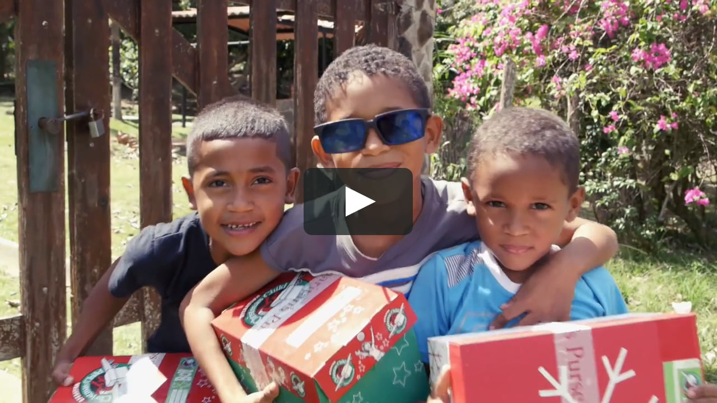

**Pamphlets and shoeboxes are available in the Foyer Area**

**as you exit.**

COLLECTION WEEK – NOV. 16-24

How to pack your shoebox – select a quality toy (doll, soccer ball with pump, stuffed animal). Fill with other, hygiene items & school supplies. Most importantly,

**PRAY FOR THE CHILD WHO WILL RECEIVE YOUR GIFT. INCLUDE A PERSONAL NOTE AND PHOTO.**

MISSIONS FOR THE MONTH OF OCTOBER

Operation Christmas Child

*Welcome to* ***GRAND HEIGHTS***

**Welcome to our Sunday Service Today – RAIN or SHINE! In compliance with current safe distancing we are having our indoor/outdoor service. Dr. Jason Lee, as our Interim Pastor, will be with us the next several months. His sermon this week is from Joshua Chapter 7 & 8. He would like you to read this Chapter prior to today’s service. You have the option of coming into the church or staying in your car in the church parking lot for the church message. It will be broadcasted on the 88.7 FM station. To pick up the Audio, you need to have a vehicle with a working FM radio.**

**A packet of information is available upon arrival. Arrive at 10:15 to allow time to park. Service is scheduled to begin at 10:30. This Indoor/Drive-in service will allow those in our fellowship with health issues to safely come and worship the way they would be most comfortable. The Order of Service Packet is available Sunday morning or on the Church Web Site. With Questions Talk With: Allan Hartong @ 937-718-0533.**

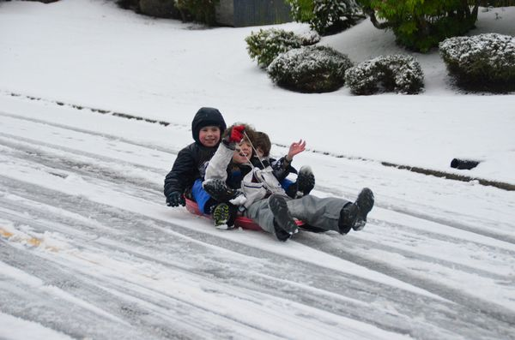

OCTOBER 11, 2020

IF YOUR FAMILY IS IN NEED IN ANY WAY, PLEASE CONTACT YOUR DEACON OR THE CHURCH OFFICE.

CALENDAR EVENTS

Tues. – 9:30 a.m. - Ladies Prayer Mtg.

Wed. – 7:00 p.m. – All Church Prayer Mtg.

Sun. – October – Adults, Teens, and Children Sunday School Classes (9:15 A.M.)

Sun. - October 11 – Awana at Grand Heights – 5:30 p.m.

Sun. – October 11 – 5:30 p.m. Teens at Grand Heights

Wed. – October 14 – Board Meeting (7:30 P.M.) – Budget

Wed. – November 4 – Missions Prayer Meeting – 7:00 p.m.

Wed. – November 11 – Congregation Budget Mtg–7:00 pm

Thur. – November 26 – Thanksgiving – Office Closed

Fri. – November 27–Thanksgiving Holiday – Office Closed

*Our Mission: We exist to glorify God as we help people move closer to Jesus in their*

*spiritual journey.*

**THIS WEEK! Awana will be back to their regular meeting place and time. The On-Line Reality Event worked for part of the group. This was a trial situation to see how it works and if necessary to use this format.**

**FOR MORE INFORMATION (please contact)**

**Grand Heights Baptist Church**

**937-878-7971 or www.grandheights.org**

**THE AWANA CLUBS OF GRAND HEIGHTS BAPTIST CHURCH**

**Meets Sunday Nights**

**@ 5:30 p.m.**



**Pre K – 6th Grades**

**AWANA Clubs of GHBC**

A large sign in a field

Description generated with very high confidence

**Grand Heights Baptist Church**

**1611 Armstrong Road**

Fairborn, OH 45324

**(937)878-7971**

**E-mail: ghbcnet@grandheights.org**