Calvert County Baptist Church

ROAD TO THE RESURRECTION 2026
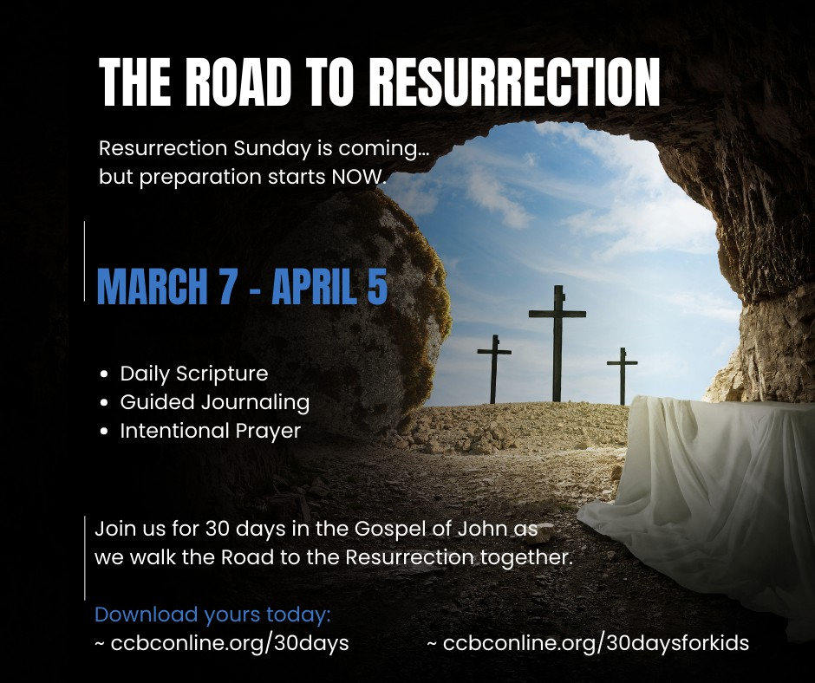

A 30-Day Journey to Resurrection Through the Gospel of John

Calvert County Baptist Church

“These are written so that you may believe that Jesus is the Messiah, the Son of God, and that by believing you may have life in His name.” John 20:31

Calvert County Baptist Church | Road to the Resurrection 2026

Dear Calvert County Baptist Church Family,
As spring buds begin to bloom and creation awakens around us, we invite you to embark on a beautiful journey together—our “Road to Resurrection.” This special 30-day prayer and fasting adventure isn’t just a spiritual exercise; it’s our collective pilgrimage toward the glorious promise of resurrection morning!
Think of this devotional handbook as your trusted map for the journey. Each day brings fresh Scripture to illuminate your path, reflections to warm your heart, and prayer prompts to lift your spirit. As we walk this road together—supporting one another through hunger pangs and celebratory moments alike—we’ll discover renewed strength to love God more deeply and follow Him more faithfully.
Just as Jesus walked a difficult road to bring us resurrection life, our temporary sacrifices through fasting clear away distractions so we can hear His gentle whispers more clearly. In those quiet moments, He’ll prepare our hearts not only to celebrate His resurrection but to carry His light into our community with fresh passion.
Whether this is your first fasting experience or you’re a seasoned prayer warrior, your participation strengthens our church family and makes everyone feel valued. Together, we’re creating space for God to transform us into more effective disciples who make disciples!
So lace up your spiritual walking shoes, bring your water bottle of faith, and let’s set out on this Road to Resurrection together. The destination promises to be glorious, but the journey itself—shared with friends and family in Christ—will be unforgettable.
With great anticipation,
Pastor Deborah J. Chambers & Reverend Alan Chambers

The Road to Resurrection: A Journey of Prayer & Fasting
Dear Church Family,
We are excited to invite you on our “Road to Resurrection” journey through prayer and fasting—a sacred time to draw closer to God as we prepare to celebrate Christ’s resurrection.

The Journey
Our congregation-wide fast begins Saturday, March 7, and concludes on Resurrection Sunday, April 5. During these 30 days, we invite you to join us in seeking God’s presence with renewed intentionality.

The Invitation
Perhaps God is calling you to step beyond your comfort zone—to try something new or seek Him like never before. When we quiet ourselves, we position our hearts to hear His voice. There are treasures He longs to reveal, wisdom He desires to impart, and breakthroughs awaiting those who pursue Him, making this journey deeply meaningful for your spiritual growth.
Scripture reminds us in Matthew 17:21: “However, this kind does not go out except by prayer and fasting.”
Some circumstances in our lives will only shift through dedicated prayer and fasting. Would you risk missing what God has specifically for you simply because you didn’t participate?

Understanding Fasting
Fasting is the purposeful abstinence from something pleasurable to redirect our focus from flesh to spirit. This spiritual discipline has been practiced throughout biblical history as a powerful response to challenging situations, circumstances, and needs.
As Joel 1:14 instructs: “Consecrate a fast, call a sacred assembly; gather the elders and all the inhabitants of the land into the house of the Lord your God and cry out to the Lord.”
While fasting traditionally involves abstaining from food, your fast may take many forms:
- Specific types of food (sugar, meat, etc.)
- Social media or entertainment
- Other regular pleasures or activities

Important Guidelines
- Choose a fast limited to this designated time period (1 Corinthians 7:5)
- Some may prefer sunup to sundown fasting
- Important health note: Please consult your physician before beginning any fast from food or medication
- Remember that everyone can participate—if you cannot fast from food for health reasons, consider other meaningful sacrifices, like digital or activity fasts, that help you draw closer to God, ensuring inclusivity and comfort for all.

We’ve provided this guide to help you prepare your heart and mind. Let us approach these 30 days with expectation, knowing that as we draw near to God, He promises to draw near to us.
In anticipation of what God will do.

THREE TYPES OF FASTING

- Normal Fast
What it involves: Abstaining from all forms of food while drinking only water.

Biblical examples:
  - Jesus in the wilderness (Luke 4:1-2, Matthew 4:2-3)
  - Abraham’s servant, while on his mission (Genesis 24:33)

Absolute Fast (Total Fast)
What it involves: Abstaining from both food and water completely.
Important caution: This type of fast requires extreme care and should be practiced for no more than 3 days, as it can be physically dangerous if extended.

Biblical examples:
  - Esther and the Jews before she approached the king (Esther 4:16)
  - Paul, after his encounter with Christ (Acts 9:9)

Partial Fast
What it involves: Selectively abstaining from certain foods or following specific eating patterns.

Common approaches:
  - Daniel Fast: Consuming only fruits, vegetables, whole grains, legumes, nuts, seeds, and water
  - Selective Restriction: Abstaining from specific categories like meats, sweets, or carbohydrates
  - Intermittent Fasting: Restricting eating to certain time windows

Biblical example:
  - Daniel’s refusal of royal food and wine (Daniel 1:12-15)

Things to Fast From Besides Food Digital/Technology Fasts
- Social Media - Abstaining from platforms like Instagram, Facebook, Twitter, TikTok
- Screen Time - Limiting or eliminating TV, video games, and streaming services
- Smartphone Usage - Reducing phone time or setting specific no-phone hours
- Email/Work Communications - Setting boundaries on checking work messages
- Digital News - Taking a break from news consumption

Consumption Fasts
- Shopping - No non-essential purchases for a set period
- Fast Fashion - Avoiding clothing purchases
- Amazon/Online Shopping - Specifically cutting out impulse online buys
- Dining Out - Cooking at home instead of restaurant meals
- Subscription Services - Pausing or canceling recurring services

Food and Beverage Related
- Meat - Practicing vegetarianism temporarily
- Caffeine - Giving up coffee, tea, or energy drinks
- Sugar - Eliminating added sugars and sweets
- Processed Foods - Focusing on whole, unprocessed foods only

Lifestyle Fasts
- Complaining - Consciously avoiding negative talk
- Gossip - Refraining from speaking about others
- Multitasking - Focusing on one activity at a time
- Rushing - Intentionally slowing down daily activities
- Noise - Creating periods of silence in your day

THE SPIRITUAL BENEFITS OF FASTING
Divine Reward
“When you fast, do not look somber as the hypocrites do... But when you fast, put oil on your head and wash your face, so that it will not be obvious to others that you are fasting, but only to your unseen Father; and your Father, who sees what is done in secret, will reward you.” (Matthew 6:16-18)

Spiritual Humility
“I humbled myself with fasting.” (Psalm 35:13)

Spiritual Breakthrough
“Go, gather together all the Jews... and fast for me. Do not eat or drink for three days, night or day.” (Esther 4:16)

Liberation and Healing
“Then your light will break forth like the dawn, and your healing will quickly appear.” (Isaiah 58:8)

Divine Guidance
“While they were worshiping the Lord and fasting, the Holy Spirit said, ‘Set apart for me Barnabas and Saul.’” (Acts 13:2)

Answered Prayer
“So we fasted and petitioned our God about this, and he answered our prayer.” (Ezra 8:23-24)

HEALTH & SAFETY GUIDELINES
Consult Your Physician — Everyone should consult their physician before beginning any fast, especially:
- Those under medical care
- People taking medications
- Individuals with existing health conditions
- Anyone with a history of eating disorders
Breaking Your Fast — When your designated fasting period ends, transition gradually:
- Do not rush back to solid foods
- Begin with small portions and simple foods
- Allow your body time to readjust
- Serious side effects can occur from breaking a fast too quickly
Spiritual Focus — When cravings arise:
- Recognize these as the flesh opposing the spirit
- Use these moments as triggers for prayer
- Redirect your attention to praising God

- Meditate on Scripture during times of temptation
Pure Intentions — Fast as unto the Lord:
- Present your fast as a form of worship
- Offer it as a sacrifice to God (Zechariah 7:5)
- Let it be a time of seeking His presence (Acts 13:2)

THE ROAD TO RESURRECTION FASTING

Options:
- DANIEL FAST: Fruits, vegetables, whole grains, legumes, nuts, seeds, water
- INTERMITTENT FASTING: Eating window from 12
PM-8 PM only
- LIQUID FAST: Consume only liquids until 3 PM
- ONE MEAL A DAY: Single well-balanced meal

Fast from 6 AM to 6 PM
- Or as recommended by your healthcare provider.

YOUR DAILY PRAYER COMMITMENT
My Plan to Pray Daily for My “FRANCES”:
- Friends: Those closest to you who need spiritual growth
- Relatives: Family members near and far
- Acquaintances: People you know casually
- Neighbors: Those living in proximity to you
- Co-workers: Colleagues in your workplace
- Enemies: Those with whom relationships are strained
- Strangers: People estranged from the church

YOUR PLAN TO “BLESS” OTHERS:
- Begin with Prayer
- Listen and Ask Questions
- Eat: Show hospitality and build relationships
- Serve: and find ways to be served
- Share Your Story about Jesus: Ask for a response

WEEKLY PRAYER CALLS

Wednesdays at Noon

Wednesday, March 11, 2026
Wednesday, March 18, 2026
Wednesday, March 25, 2026
Wednesday, April 1, 2026

Dial-in Number: 848-777-1500
Conference ID: 410-535-6155

“Is not this the kind of fasting I have chosen: to loose the chains of injustice and untie the cords of the yoke, to set the oppressed free and break every yoke?” - Isaiah 58:6

HOW TO USE THIS BOOKLET
Each daily devotion includes:
- Scripture Reading
- Reflection
- Prayer
- Journaling Space

Set aside time each day to read prayerfully, reflect honestly, and listen for the voice of the Holy Spirit as you journey toward Resurrection Sunday.

SOAP Method
Scripture – Read the biblical text carefully.

Observation – Identify what the text says. What stands out? What is happening?
Application – Reflect on how this passage applies to your life today.
Prayer – Respond to God based on what you have read and learned.

🔹 DAILY DEVOTIONAL PAGES

Calvert County Baptist Church | Road to the Resurrection 2026 | John 20:31

Day 1 –

Scripture: John 1:1–5

Observation:

What I observe about the text is…

Application:

This applies to my life in the following ways…

Prayer:

Dear Lord…

Corporate Prayer | Pray that we walk in the light of Christ.

Day 2 – Children of God

Scripture: John 1:6–13

Observation:

What I observe about the text is…

Application:

This applies to my life in the following ways…

Prayer:

Dear Lord…

Corporate Prayer | Pray that we embrace our identity as God’s children.

Day 3 – Grace and Truth

Scripture: John 1:14–18

Observation:

What I observe about the text is…

Application:

This applies to my life in the following ways…

Prayer:

Dear Lord…

Corporate Prayer | Pray that we reflect both grace and truth.

Day 4 – The Lamb of God

Scripture: John 1:29–34

Observation:

What I observe about the text is…

Application:

This applies to my life in the following ways…

Prayer:

Dear Lord…

Corporate Prayer | Pray in gratitude for the sacrifice of Christ.

Day 5 – Come and See

Scripture: John 1:35–42

Observation:

What I observe about the text is…

Application:

This applies to my life in the following ways…

Prayer:

Dear Lord…

CORPORATE PRAYER | Pray for hearts open to follow Jesus.

Day 6 – New Wine

Scripture: John 2:1–11

Observation:

What I observe about the text is…

Application:

This applies to my life in the following ways…

Prayer:

Dear Lord…

CORPORATE PRAYER | Pray for transformation in our homes and families.

Day 7 – Zeal for God’s House

Scripture: John 2:13–25

Observation:

What I observe about the text is…

Application:

This applies to my life in the following ways…

Prayer:

Dear Lord…

CORPORATE PRAYER | Pray for renewed passion for God’s presence

Day 8 – Born Again

Scripture: John 3:1–8

Observation:

What I observe about the text is…

Application:

This applies to my life in the following ways…

Prayer:

Dear Lord…

CORPORATE PRAYER | Pray for spiritual renewal.

Day 9 – Loved by God

Scripture: John 3:16–21

Observation:

What I observe about the text is…

Application:

This applies to my life in the following ways…

Prayer:

Dear Lord…

CORPORATE PRAYER | Pray that we walk confidently in God’s love.

Day 10 – Living Water

Scripture: John 4:7–14

Observation:

What I observe about the text is…

Application:

This applies to my life in the following ways…

Prayer:

Dear Lord…

CORPORATE PRAYER | Pray for spiritual fulfillment in Christ.

Day 11 – True Worship

Scripture: John 4:23–26

The Father seeks worshippers in spirit and truth.

Observation:

What I observe about the text is…

Application:

This applies to my life in the following ways…

Prayer:

Dear Lord…

CORPORATE PRAYER | Pray that our worship be authentic.

Day 12 – Rise and Walk

Scripture: John 5:1–9

Observation:

What I observe about the text is…

Application:

This applies to my life in the following ways…

Prayer:

Dear Lord…

CORPORATE PRAYER | Pray for strength to rise from what has held us back.

Day 13 – Bread of Life

Scripture: John 6:35

Observation:

What I observe about the text is…

Application:

This applies to my life in the following ways…

Prayer:

Dear Lord…

CORPORATE PRAYER | Pray for daily dependence on Christ.

Day 14 – Staying with Jesus

Scripture: John 6:66–69

Observation:

What I observe about the text is…

Application:

This applies to my life in the following ways…

Prayer:

Dear Lord…

CORPORATE PRAYER | Pray for steadfast faith.

Day 15 – Light of the World

Scripture: John 8:12

Observation:

What I observe about the text is…

Application:

This applies to my life in the following ways…

Prayer:

Dear Lord…

CORPORATE PRAYER | Pray that we shine His light.

Day 16 – From Blindness to Belief

Scripture: John 9:35–38

Observation:

What I observe about the text is…

Application:

This applies to my life in the following ways…

Prayer:

Dear Lord…

CORPORATE PRAYER | Pray for open spiritual eyes.

Day 17 – The Good Shepherd

Scripture: John 10:10–11

Observation:

What I observe about the text is…

Application:

This applies to my life in the following ways…

Prayer:

Dear Lord…

CORPORATE PRAYER | Pray that we trust the Shepherd’s voice.

Day 18 – Resurrection and Life

Scripture: John 11:25–26

Observation:

What I observe about the text is…

Application:

This applies to my life in the following ways…

Prayer:

Dear Lord…

CORPORATE PRAYER | Pray for faith in life beyond death.

Day 19 – Extravagant Worship

Scripture: John 12:1–8

Observation:

What I observe about the text is…

Application:

This applies to my life in the following ways…

Prayer:

Dear Lord…

CORPORATE PRAYER | Pray for surrendered hearts.

🕊 HOLY WEEK –

FROM THE CROSS TO THE EMPTY TOMB

Day 20 – The Hour Has Come Scripture: John 12:23–26 Observation:
What I observe about the text is…

Application:

This applies to my life in the following ways…

Prayer:

Dear Lord…

CORPORATE PRAYER | Pray for hearts willing to surrender fully to God’s will.

Day 21 – Hosanna

Scripture: John 12:12–19

Observation:

What I observe about the text is…

Application:

This applies to my life in the following ways…

Prayer:

Dear Lord…

CORPORATE PRAYER | Pray for hearts that welcome the King.

Day 22 – Love That Serves

Scripture: John 13:1–17

Observation:

What I observe about the text is…

Application:

This applies to my life in the following ways…

Prayer:

Dear Lord…

CORPORATE PRAYER | Pray for servant hearts.

Day 23 – A New Commandment

Scripture: John 13:34–35

Observation:

What I observe about the text is…

Application:

This applies to my life in the following ways…

Prayer:

Dear Lord…

CORPORATE PRAYER | Pray that love defines our church.

Day 24 – The Truth on Trial

Scripture: John 18:33–38

Observation:

What I observe about the text is…

Application:

This applies to my life in the following ways…

Prayer:

Dear Lord…

CORPORATE PRAYER | Pray for boldness in truth.

Day 25 – It Is Finished

Scripture: John 19:16–30

Observation:

What I observe about the text is…

Application:

This applies to my life in the following ways…

Prayer:

Dear Lord…

CORPORATE PRAYER | Pray in gratitude for completed salvation.

Day 26 – Waiting in Faith

Scripture: John 19:38–42

Observation:

What I observe about the text is…

Application:

This applies to my life in the following ways…

Prayer:

Dear Lord…

CORPORATE PRAYER | Pray for patience in seasons of waiting.

Day 27 – The Empty Tomb

Scripture: John 20:1–10

Observation:

What I observe about the text is…

Application:

This applies to my life in the following ways…

Prayer:

Dear Lord…

CORPORATE PRAYER | Pray for resurrection faith.

Day 28 – Seen, Known, and Called by Name

Scripture: John 20:11–18

Observation:

What I observe about the text is…

Application:

This applies to my life in the following ways…

Prayer:

Dear Lord…

CORPORATE PRAYER | Pray that we hear His voice clearly.

Day 29 – Peace Be with You

Scripture: John 20:19–23

Observation:

What I observe about the text is…

Application:

This applies to my life in the following ways…

Prayer:

Dear Lord…

CORPORATE PRAYER | Pray that we carry resurrection peace into the world.

Day 30 – Believe and Live

Scripture: John 20:30–31

Observation:

What I observe about the text is…

Application:

This applies to my life in the following ways…

Prayer:

Dear Lord…

CORPORATE PRAYER | Pray that our faith produces a living testimony.

Closing Prayer

Risen Savior,
Thank You for walking with us from the cross to the empty tomb. Send us out as people of resurrection hope, love, and power.
In Jesus’ name, Amen.

Calvert County Baptist Church | Road to the Resurrection 2026 | John 20:3

