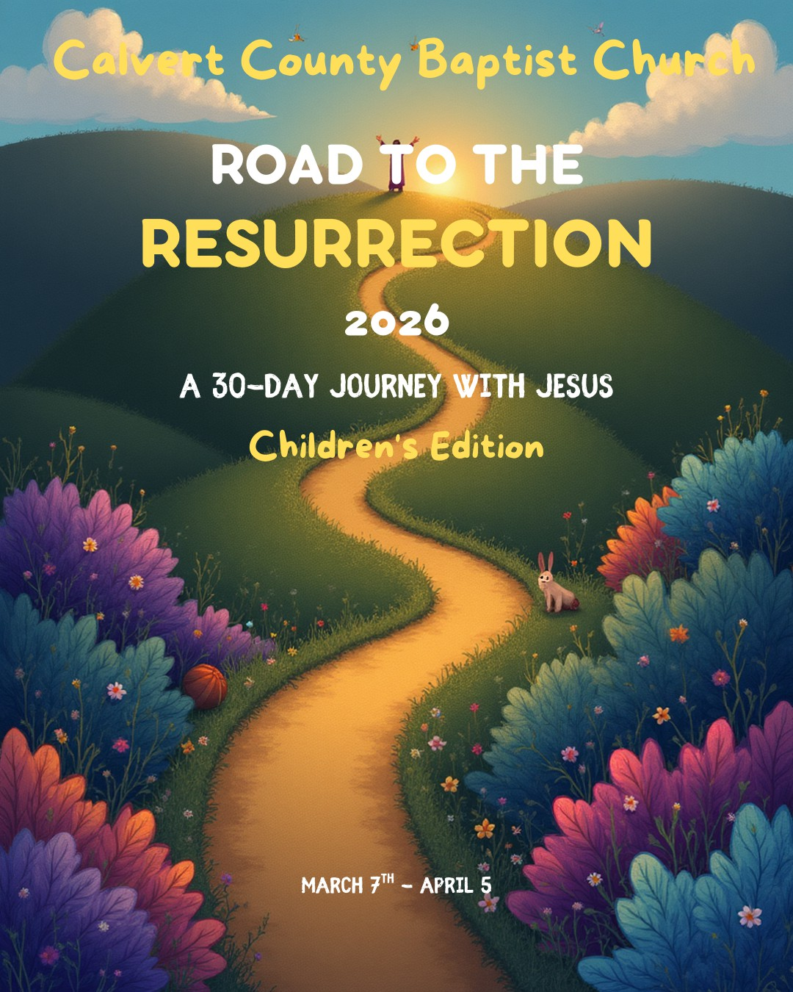

A 30-Day Journey of Prayer, Fasting & Renewal
Dear Calvert County Baptist Church Family,
Spring is here! Flowers are blooming, birds are singing, and everything feels fresh and new. Just like the world around us is waking up, we want our hearts to wake up too! That’s why we’re inviting you to join us on a special 30-day adventure called “Road to Resurrection.”
This isn’t just something to read—it’s a journey we take together. Think of this book like a treasure map. Each day has:
- A Bible verse to guide you
- A short message to help you understand it
- A prayer idea to help you talk to God
As we travel this road together, we’ll learn how to listen to God better, trust Him more, and love others in bigger ways.
Some families may choose to “fast,” which means giving up something for a little while—like a favorite snack, a video game, or extra screen time. When we give something up, it helps us remember to spend that time talking to God instead. It’s not about being hungry—it’s about making more room in our hearts for Him.
Jesus walked a hard road to bring us new life and hope. As we get closer to Resurrection Sunday (Easter), we remember how much He loves us. By praying and spending special time with God, we get our hearts ready to celebrate the amazing truth that Jesus is alive!
It doesn’t matter if this is your first time doing something like this or if you’ve done it before. You can join for all 30 days or just some of them. What matters most is that we’re growing together as a church family.
So grab your Bible, bring your brave heart, and get ready for an exciting journey. The best part isn’t just the celebration at the end—it’s walking the road together with God and with each other.

We can’t wait to see how God grows us over these 30 days! With joy and excitement,

Pastor Deborah J. Chambers & Reverend Alan Chambers

ROAD TO THE RESURRECTION 2026

A 30-Day Journey with Jesus (Children’s Edition) Theme Verse:
"These are written so that you may believe that Jesus is the Messiah, the Son of God, and that by believing you may have life in His name." — John 20:31

How to Use This Book

Each day includes:
- 📖 A Scripture

- 💡 A Big Idea

🤔 Think About It

- 🙏 A Prayer

✏ My Journal Line

Take 5–10 minutes each day with your family.

🌟 WEEK 1 – WHO IS JESUS?

Day 1 – Jesus Is the Light John 1:1–5

Big Idea: Jesus has always been with God. He is the Light that shines in darkness.
Think About It: Where do I need Jesus’ light today?
Prayer: Jesus, shine in my heart today.

✏ My Journal:

Day 2 – I Am God’s Child John 1:6–13

Big Idea: When we believe in Jesus, we become God’s children.
Think About It: What does it mean to belong to God?

Prayer: Thank You, Father, for choosing me.
✏

Day 3 – Grace and Truth

John 1:14–18
Big Idea: Jesus shows kindness and teaches truth. Think About It: How can I be kind and honest today? Prayer: Help me live like You, Jesus.
✏

Day 4 – The Lamb of God John 1:29–34
Big Idea: Jesus gave His life for us.
Think About It: Why is Jesus’ love special?

Prayer: Thank You for loving me so much.
✏

Day 5 – Come and See John 1:35–42
Big Idea: Jesus invites us to follow Him. Think About It: How can I follow Jesus today? Prayer: I want to follow You.
✏

Day 6 – Jesus Makes Things New John 2:1–11

Big Idea: Jesus can turn ordinary into extraordinary.
Think About It: What needs changing in my life?
Prayer: Change my heart, Lord.
✏

Day 7 – Loving God’s House John 2:13–25
Big Idea: God’s house is special.
Think About It: How can I honor God?
Prayer: Help me love what You love.
✏

🌟 WEEK 2 – GROWING IN FAITH

Day 8 – Born Again John 3:1–8
Big Idea: We need spiritual new life.
Prayer: Make me new inside.
✏

Day 9 – God Loves the World John 3:16–21
Big Idea: God loves everyone.
Prayer: Thank You for loving me.
✏

Day 10 – Living Water John 4:7–14
Big Idea: Jesus satisfies our hearts.
Prayer: Fill me up, Jesus.
✏

Day 11 – True Worship

John 4:23–26
Big Idea: Worship comes from the heart.
Prayer: Help me worship You truly.
✏

Day 12 – Get Up and Walk

John 5:1–9
Big Idea: Jesus helps us move forward.
Prayer: Help me get up and try again.
✏

Day 13 – Bread of Life John 6:35
Big Idea: Jesus gives daily strength.
Prayer: Be my strength today.
✏

Day 14 – Staying with Jesus John 6:66–69
Big Idea: Stay faithful even when it’s hard.
Prayer: Help me stay close to You.
✏

🌟 WEEK 3 – SEEING AND BELIEVING

Day 15 – Light of the World John 8:12
Big Idea: Jesus leads us out of darkness.
Prayer: Shine through me.
✏

Day 16 – From Blind to Seeing John 9:35–38
Big Idea: Jesus opens our eyes.
Prayer: Help me see Your truth.
✏

Day 17 – The Good Shepherd John 10:10–11
Big Idea: Jesus cares for us.
Prayer: Help me hear Your voice.
✏

Day 18 – Resurrection and Life John 11:25–26
Big Idea: Jesus gives eternal life.
Prayer: I believe in You.
✏

Day 19 – Worship with Your Whole Heart John 12:1–8
Big Idea: Give Jesus your best.
Prayer: I give You my heart.
✏

🌿 HOLY WEEK – FROM CROSS TO EMPTY TOMB

Day 20 – Hosanna! John 12:12–19
Big Idea: Praise the King!
Prayer: Hosanna!
✏

Day 21 – Love Like Jesus John 13:1–17
Big Idea: Serving is loving.
Prayer: Help me serve others.
✏

Day 22 – A New Commandment John 13:34–35
Big Idea: Love one another.
Prayer: Help me love like You.
✏

Day 23 – Stand for Truth John 18:33–38
Big Idea: Truth matters.
Prayer: Help me stand strong.
✏

Day 24 – It Is Finished John 19:16–30
Big Idea: Jesus completed His mission.
Prayer: Thank You for the cross.

Day 25 – Waiting in Faith John 19:38–42
Big Idea: God is working even in silence.
Prayer: Help me trust You.
✏

Day 26 – The Empty Tomb John 20:1–10
Big Idea: Jesus is alive!
Prayer: Hallelujah!
✏

Day 27 – Jesus Knows My Name John 20:11–18
Big Idea: Jesus calls us personally.
Prayer: Thank You for knowing me.
✏

✌ Day 28 – Peace Be With You John 20:19–23
Big Idea: Jesus gives peace.
Prayer: Fill me with Your peace.
✏

Day 29 – Believe and Live John 20:30–31
Big Idea: Believe in Jesus and have life.
Prayer: I believe!
✏

DAY 30 – RESURRECTION CELEBRATION

Jesus Is Alive!

Review John 20
Big Idea: Because Jesus lives, we have hope!

✏

Final Prayer:

Risen Jesus, thank You for walking with me for 30 days. Help me live every day as a Resurrection Kid! Amen.

