We Are Climbing Jacob’s Ladder
Lift Every Voice and Sing II, #220
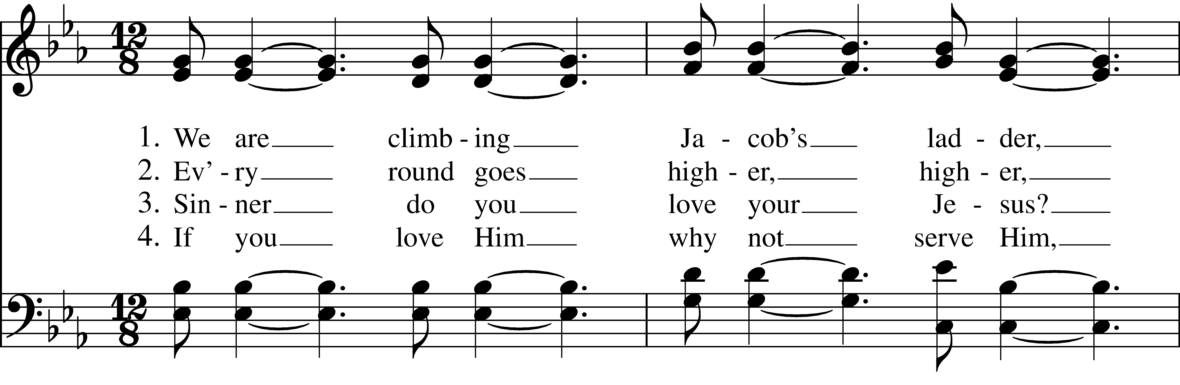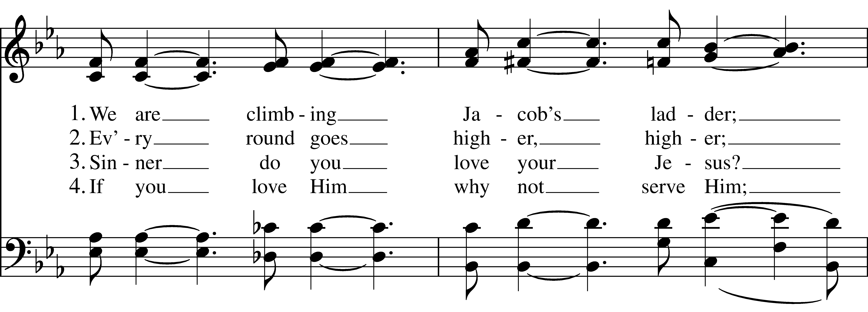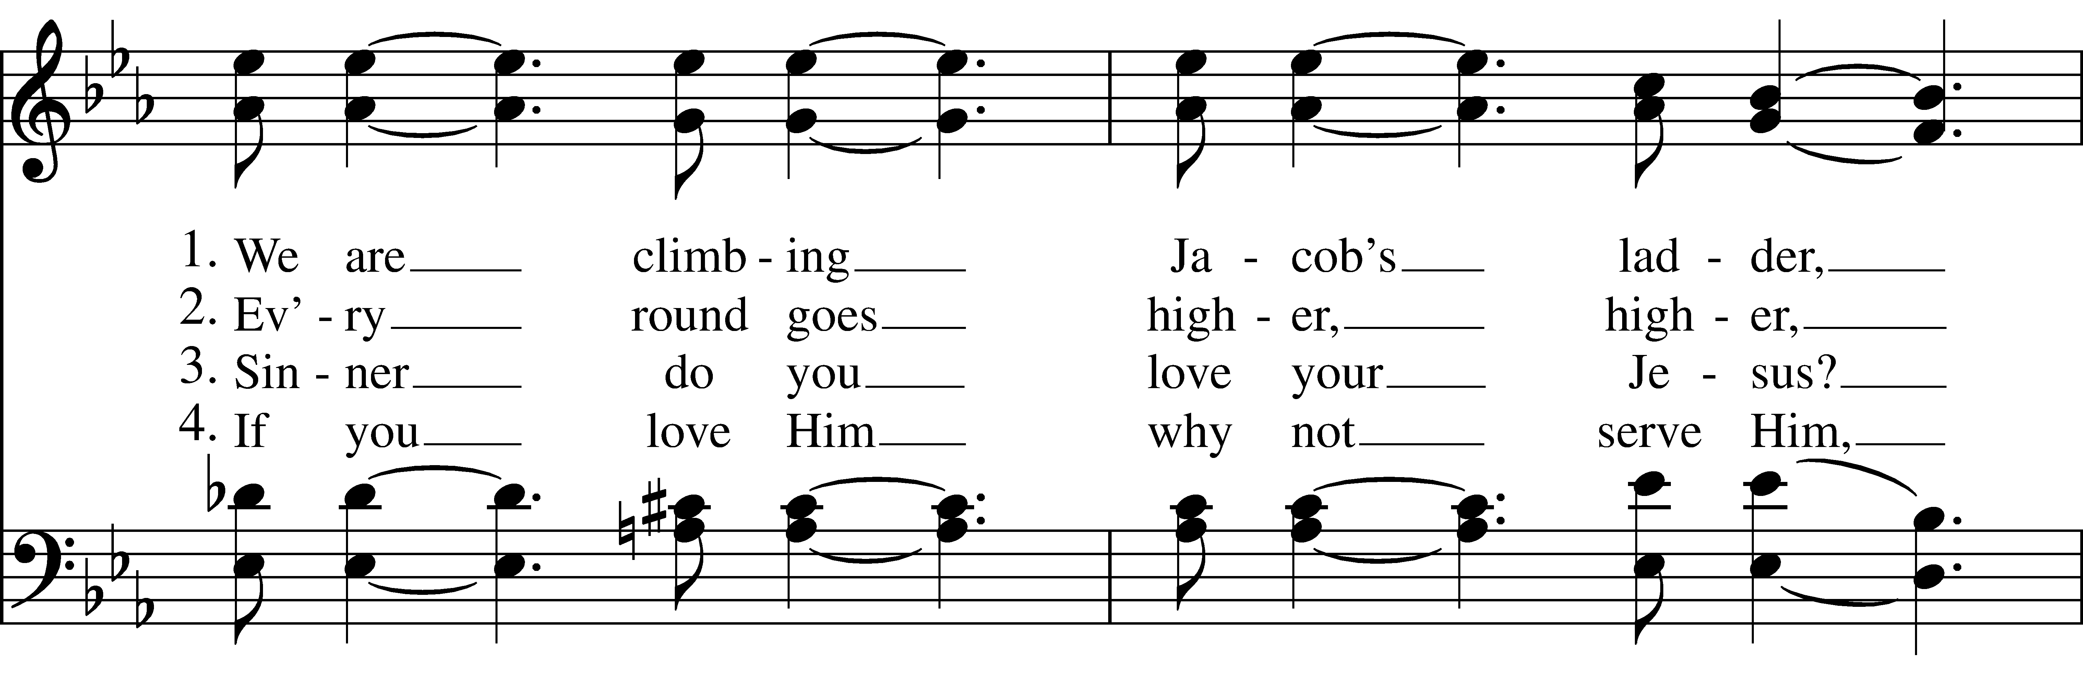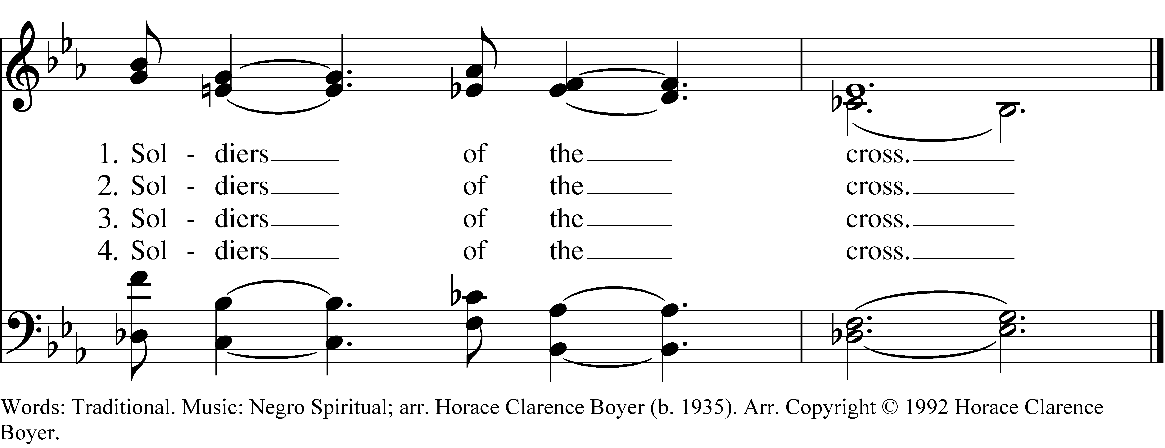

1 We are climbing Jacob’s ladder,
Soldiers of the cross.

2 Ev’ry round goes higher, higher
Soldiers of the cross.

3 Sinner do you love your Jesus?
Soldiers of the cross.

4 If you love Him why not serve Him,
Soldiers of the cross.
We Are Climbing Jacob’s Ladder, #220 from Lift Every Voice and Sing II — Words: Traditional. Music: Negro Spiritual; arr. Horace Clarence Boyer (b. 1935). Arr. Copyright © 1992 Horace Clarence Boyer.
About your RiteSong license
By purchasing this RiteSong license, you, for yourself and on behalf of your organization, agree to comply with the following terms and conditions. RiteSong licenses protect the owner of any underlying copyright included with this RiteSong license and thus you are permitted to use or print a copy of the applicable piece of music included in your RiteSong license for a single service, no matter the type of RiteSong license you have purchased. Any further use will require the purchase of an additional RiteSong license. Note that if you have purchased the annual RiteSong license, you will still need to download each piece of music for each service to ensure proper attribution to the applicable copyright holder.
No permission is granted with this RiteSong license to include any piece of music, in whole or in part, that is included in this RiteSong license, in a hymnal or other permanent or semi-permanent collection of songs. Apart from the written music included with this RiteSong license, no other form of the music, whether for use by a choir, organ or other accompaniments is included with this license and you agree not to modify the written music for such a purpose. Please contact Church Publishing Incorporated at cpirights@cpg.org to secure further materials and applicable use rights.
L220 / LEVAS_220

