Children of the Heavenly Father
Lift Every Voice and Sing II, #213
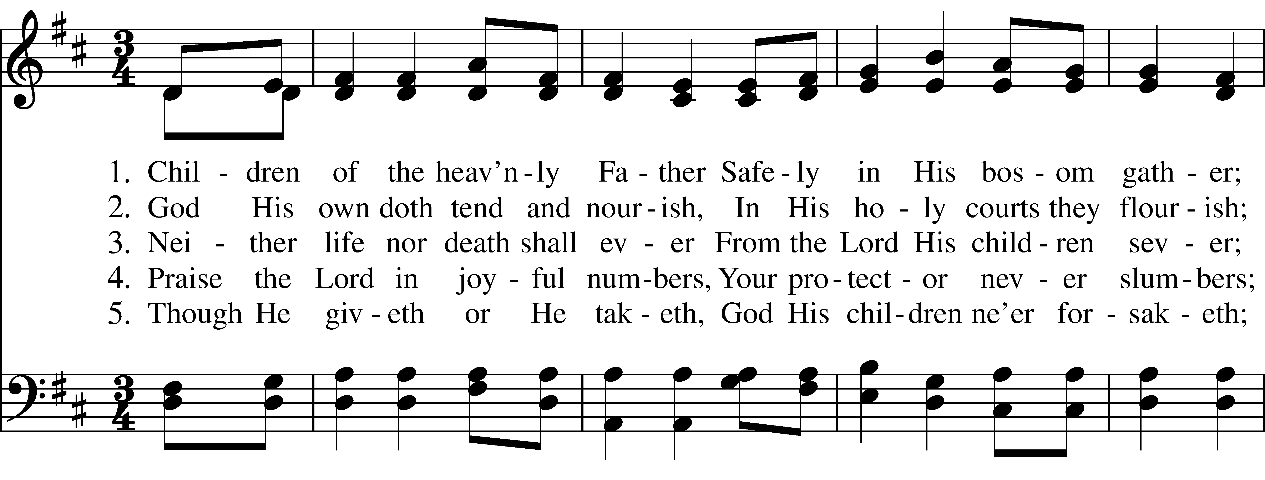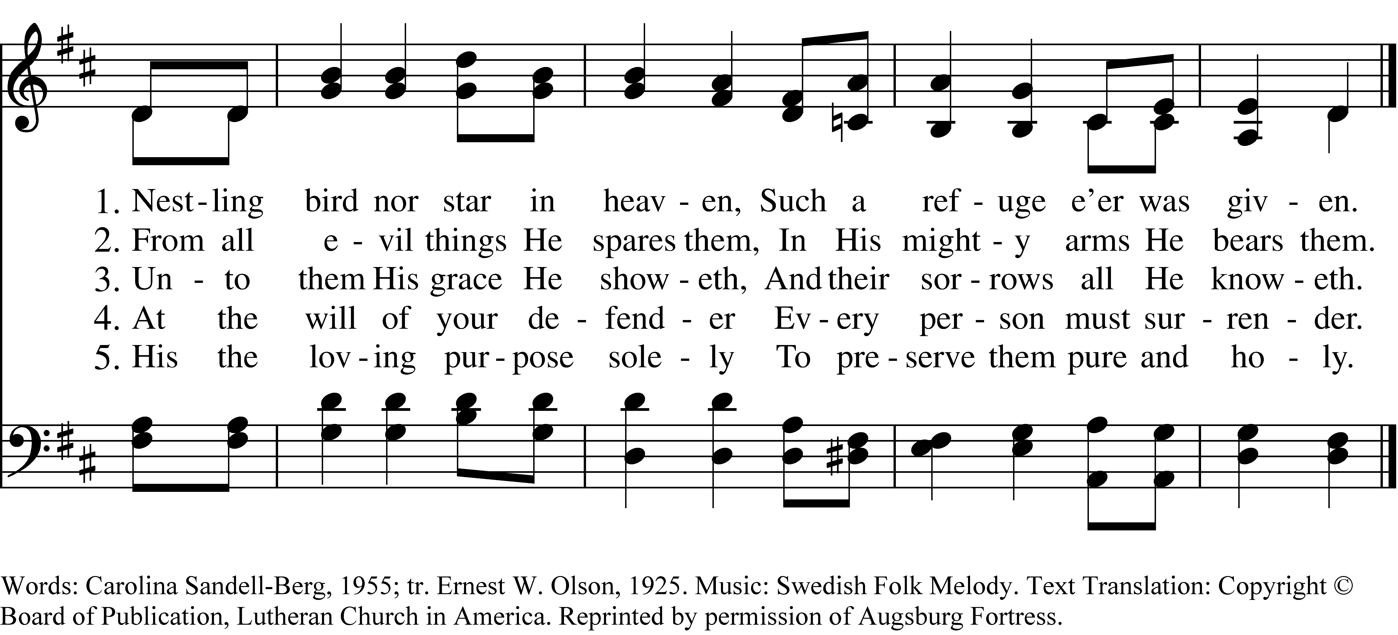

1 Children of the heav’nly Father
Safely in His bosom gather;
Nestling bird nor star in heaven,
Such a refuge e’er was given.

2 God His own doth tend and nourish,
In His holy courts they flourish;
From all evil things He spares them,
In His mighty arms He bears them.

3 Neither life nor death shall ever
From the Lord His children sever;
Unto them His grace He showeth,
And their sorrows all He knoweth.

4 Praise the Lord in joyful numbers,
Your protector never slumbers;
At the will of your defender
Every person must surrender.

5 Though He giveth or He taketh,
God His children ne’er forsaketh;
His the loving purpose solely
To preserve them pure and holy.
Children of the Heavenly Father, #213 from Lift Every Voice and Sing II — Words: Carolina Sandell-Berg, 1955; tr. Ernest W. Olson, 1925. Music: Swedish Folk Melody. Text Translation: Copyright © Board of Publication, Lutheran Church in America. Reprinted by permission of Augsburg Fortress.
About your RiteSong license
By purchasing this RiteSong license, you, for yourself and on behalf of your organization, agree to comply with the following terms and conditions. RiteSong licenses protect the owner of any underlying copyright included with this RiteSong license and thus you are permitted to use or print a copy of the applicable piece of music included in your RiteSong license for a single service, no matter the type of RiteSong license you have purchased. Any further use will require the purchase of an additional RiteSong license. Note that if you have purchased the annual RiteSong license, you will still need to download each piece of music for each service to ensure proper attribution to the applicable copyright holder.
No permission is granted with this RiteSong license to include any piece of music, in whole or in part, that is included in this RiteSong license, in a hymnal or other permanent or semi-permanent collection of songs. Apart from the written music included with this RiteSong license, no other form of the music, whether for use by a choir, organ or other accompaniments is included with this license and you agree not to modify the written music for such a purpose. Please contact Church Publishing Incorporated at cpirights@cpg.org to secure further materials and applicable use rights.
L213 / LEVAS_213

