Where He Leads Me

Lift Every Voice and Sing II, #144

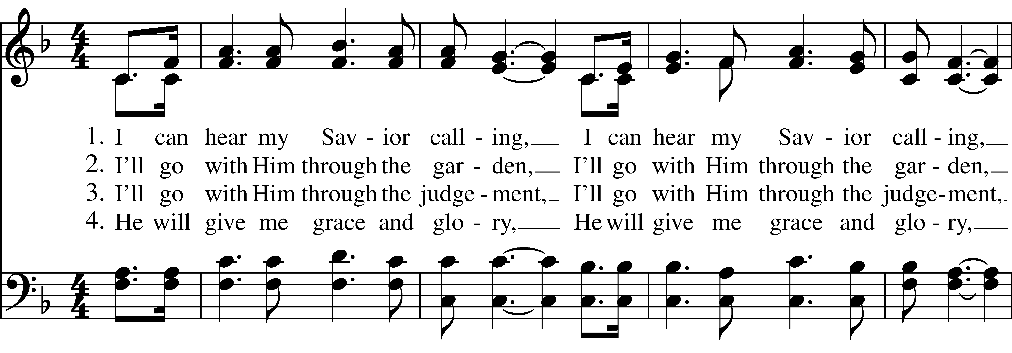  
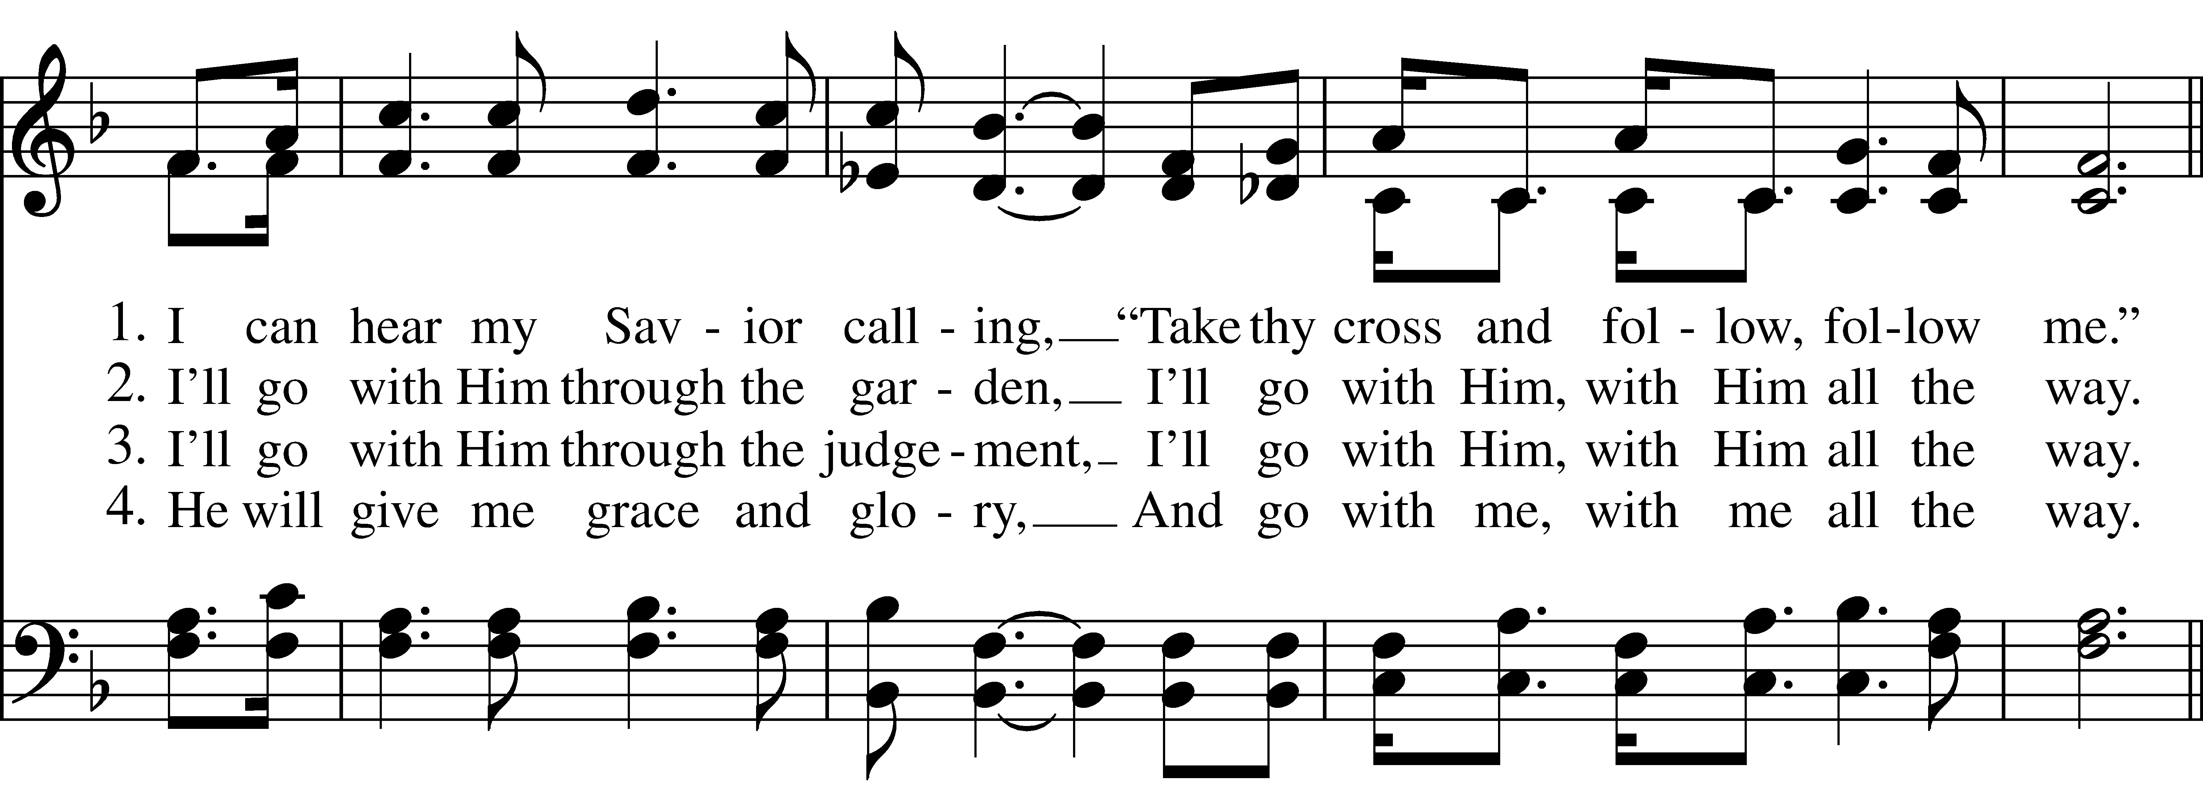  
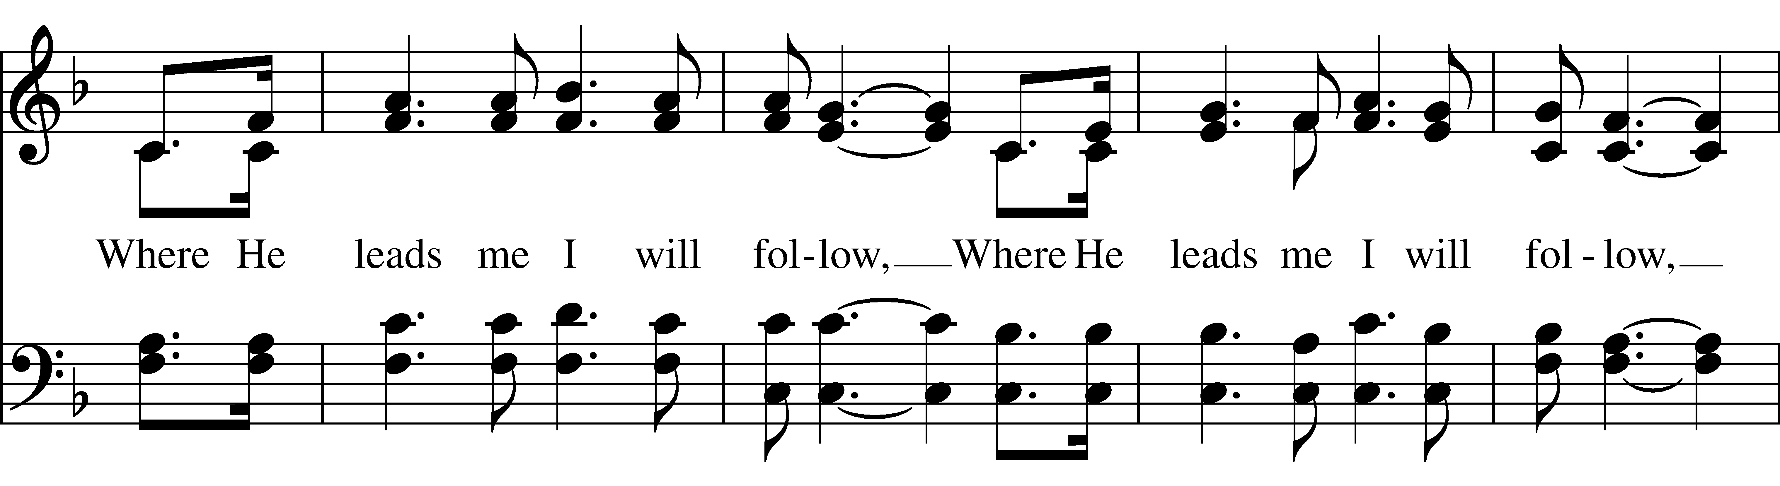  
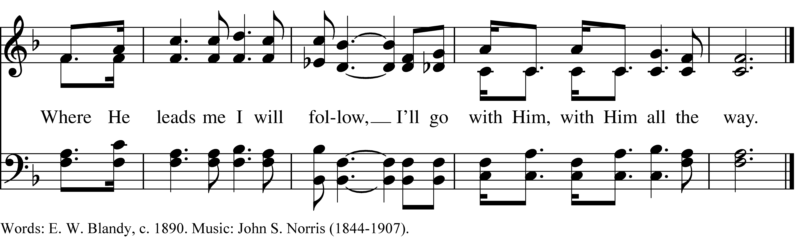

1 I can hear my Savior calling,

“Take thy cross and follow, follow me.”

*Where He leads me I will follow,*

*I’ll go with Him, with Him all the way.*

2 I’ll go with Him through the garden,

I’ll go with Him, with Him all the way.

*Refrain*

3 I’ll go with Him through the judgement,

I’ll go with Him, with Him all the way.

*Refrain*

4 He will give me grace and glory,

And go with me, with me all the way.

*Refrain*

***Where He Leads Me***, #144 from *Lift Every Voice and Sing II* — Words: E. W. Blandy, c. 1890. Music: John S. Norris (1844-1907).

About your RiteSong license

By purchasing this RiteSong license, you, for yourself and on behalf of your organization, agree to comply with the following terms and conditions. RiteSong licenses protect the owner of any underlying copyright included with this RiteSong license and thus you are permitted to use or print a copy of the applicable piece of music included in your RiteSong license for a single service, no matter the type of RiteSong license you have purchased. Any further use will require the purchase of an additional RiteSong license. Note that if you have purchased the annual RiteSong license, you will still need to download each piece of music for each service to ensure proper attribution to the applicable copyright holder.

No permission is granted with this RiteSong license to include any piece of music, in whole or in part, that is included in this RiteSong license, in a hymnal or other permanent or semi-permanent collection of songs. Apart from the written music included with this RiteSong license, no other form of the music, whether for use by a choir, organ or other accompaniments is included with this license and you agree not to modify the written music for such a purpose. Please contact Church Publishing Incorporated at [cpirights@cpg.org](mailto:cpirights@cpg.org) to secure further materials and applicable use rights.

L144 / LEVAS_144