Sweet, Sweet Spirit
Lift Every Voice and Sing II, #120
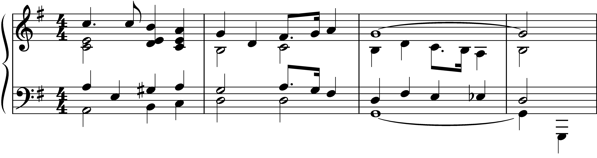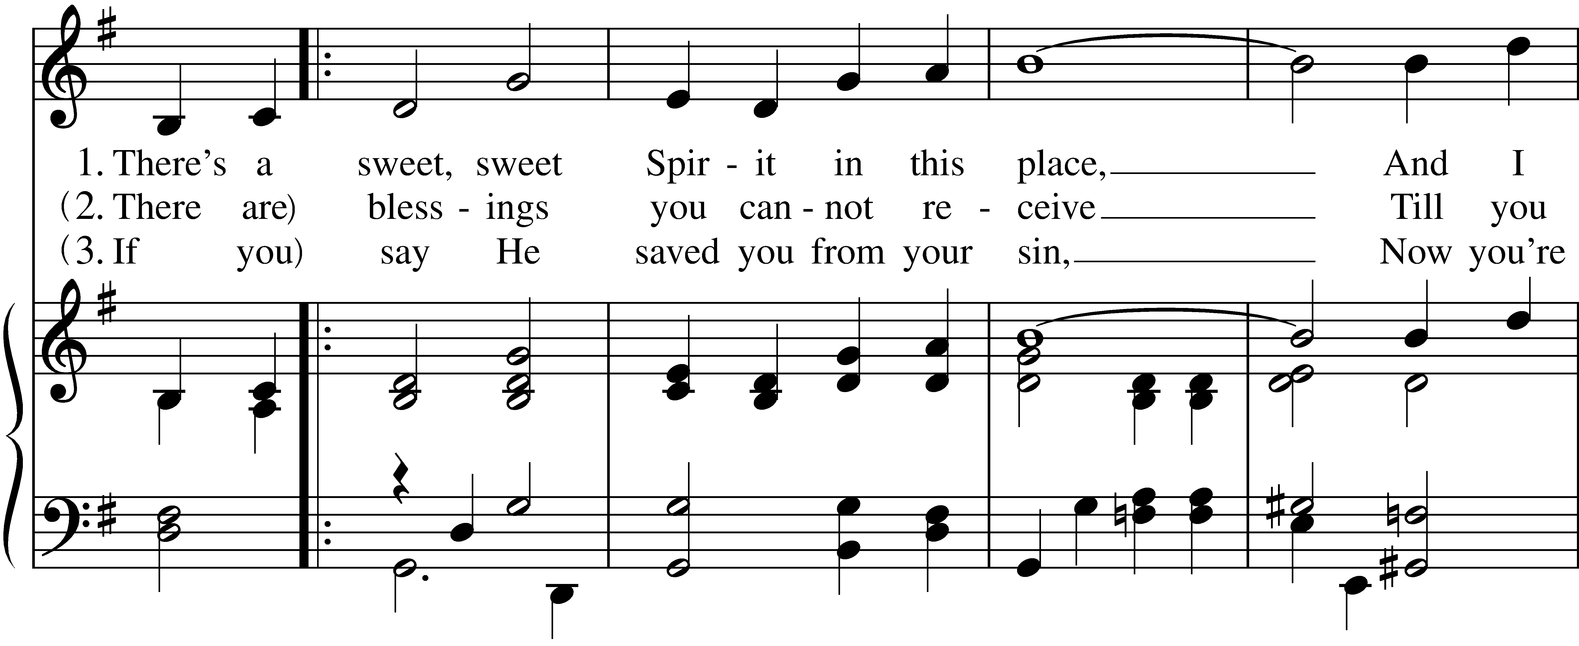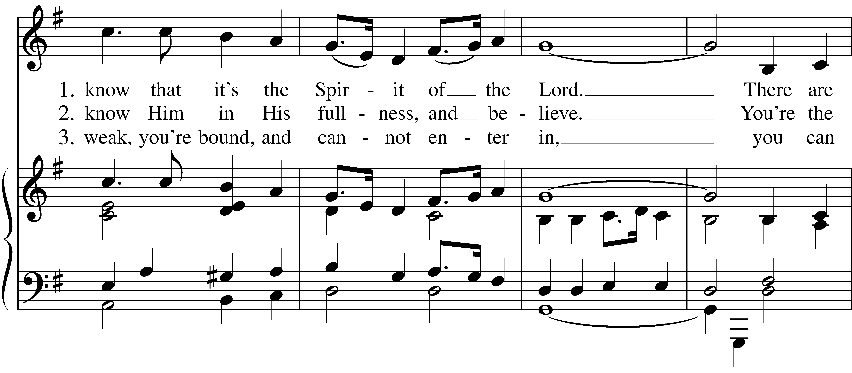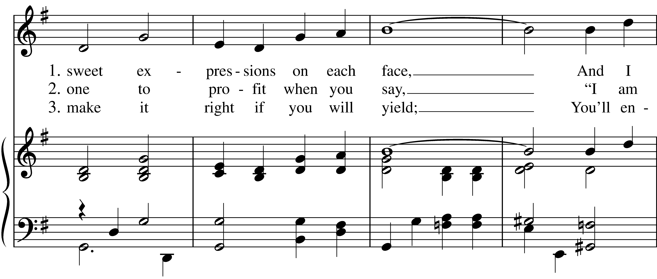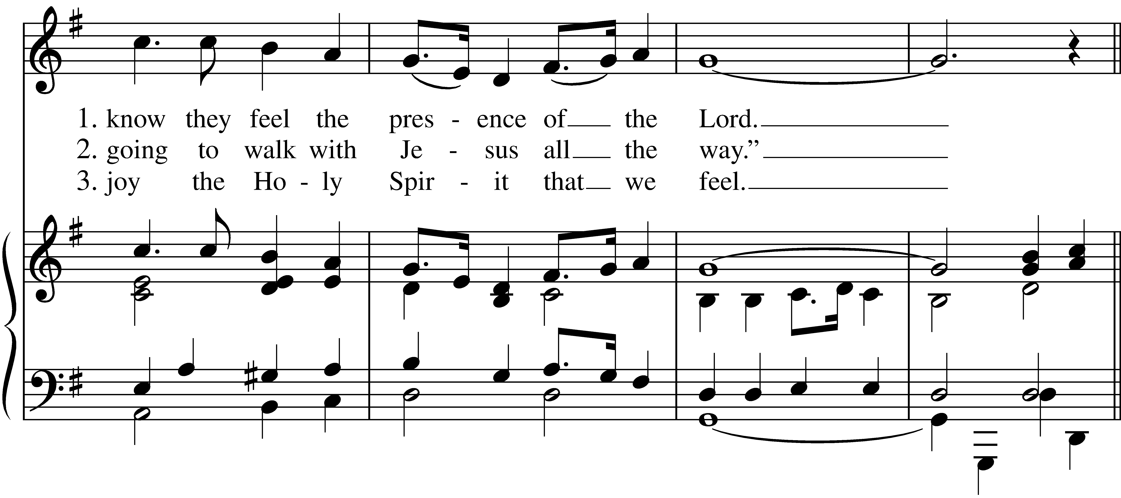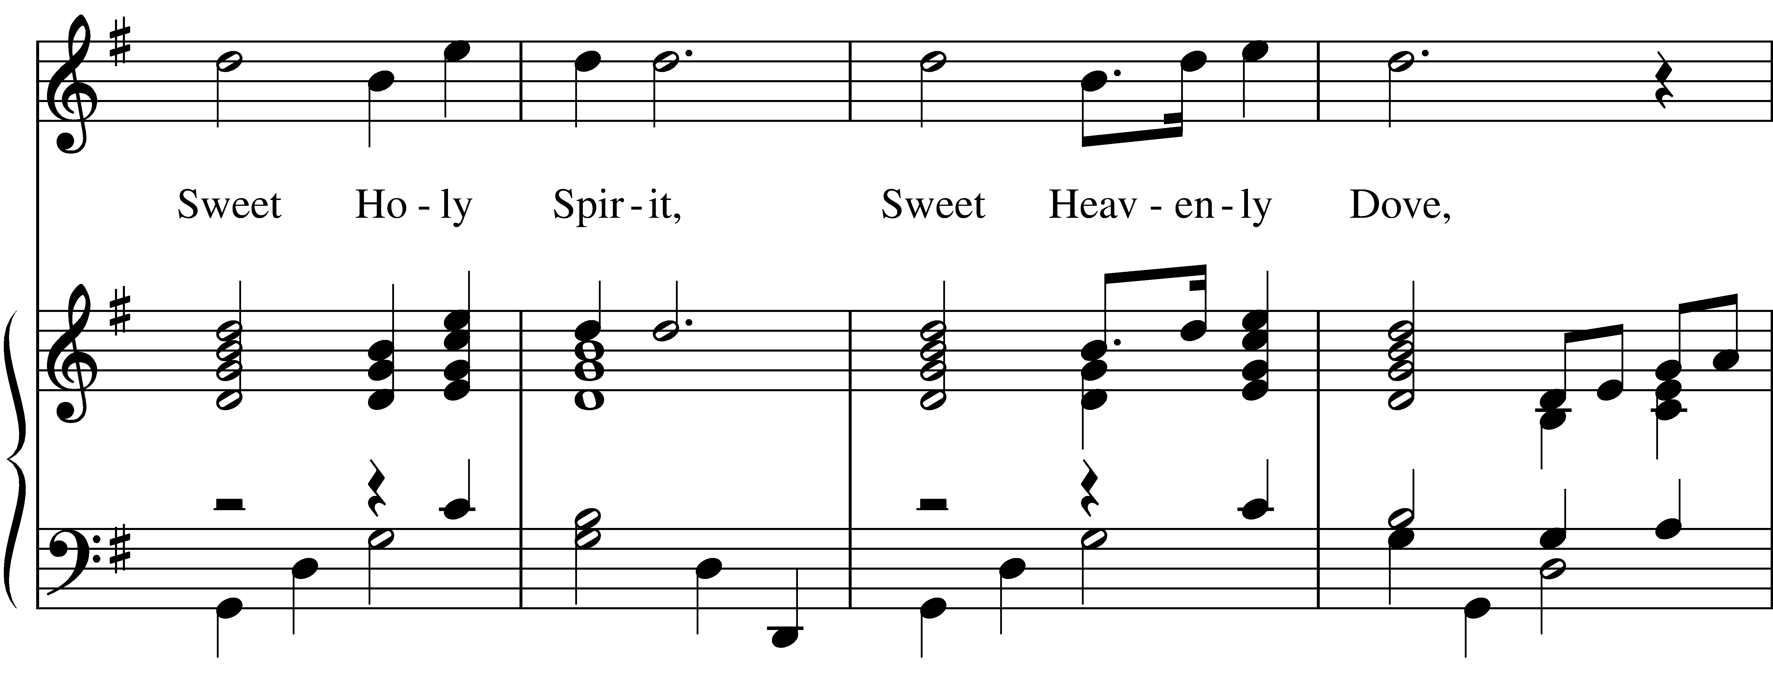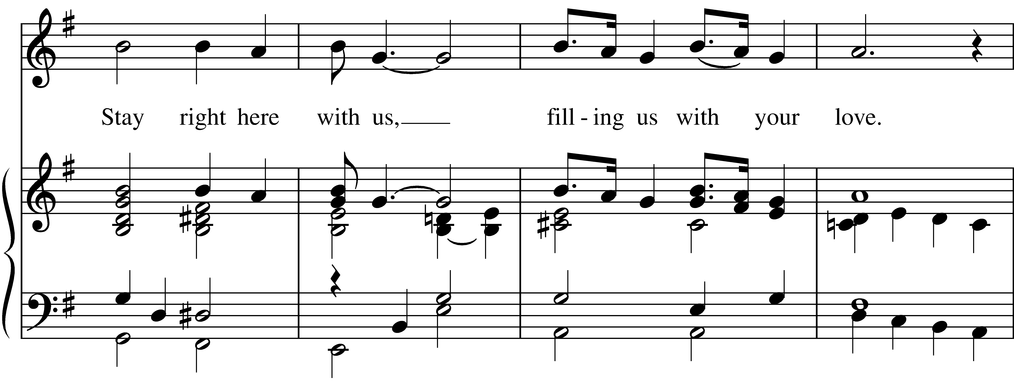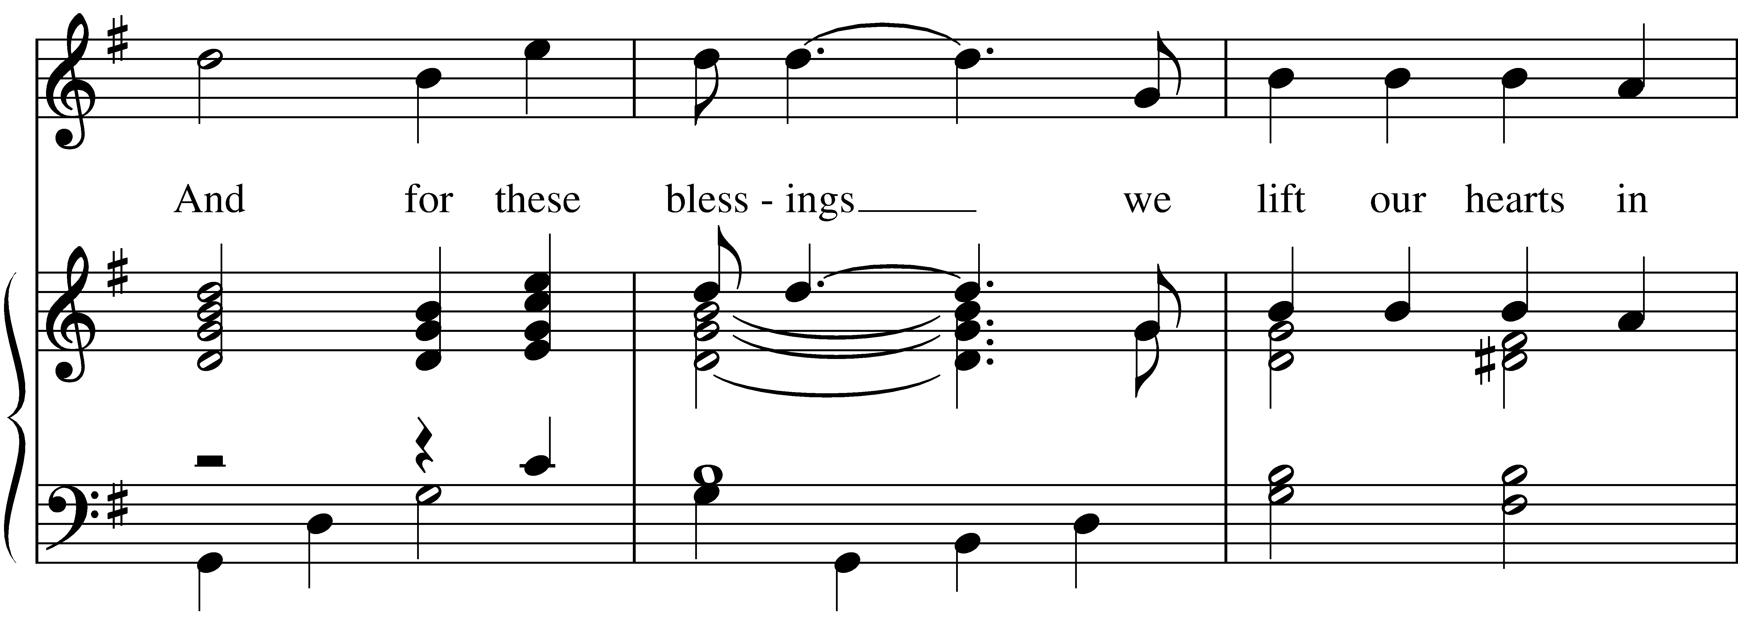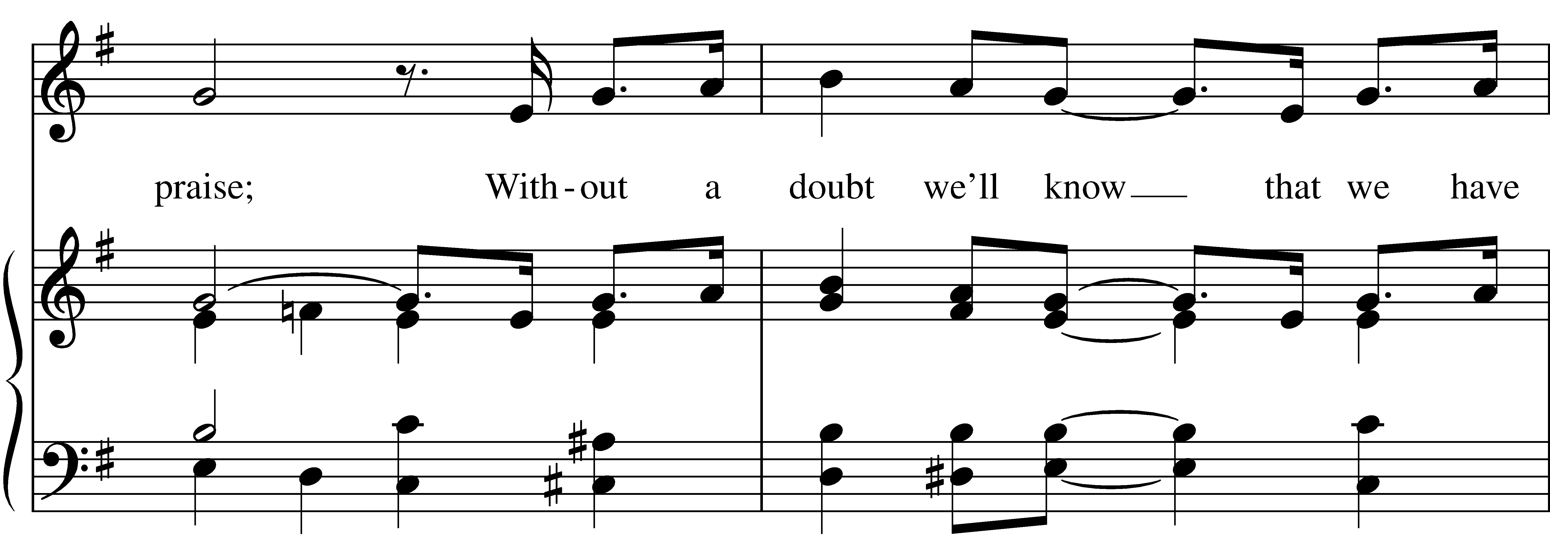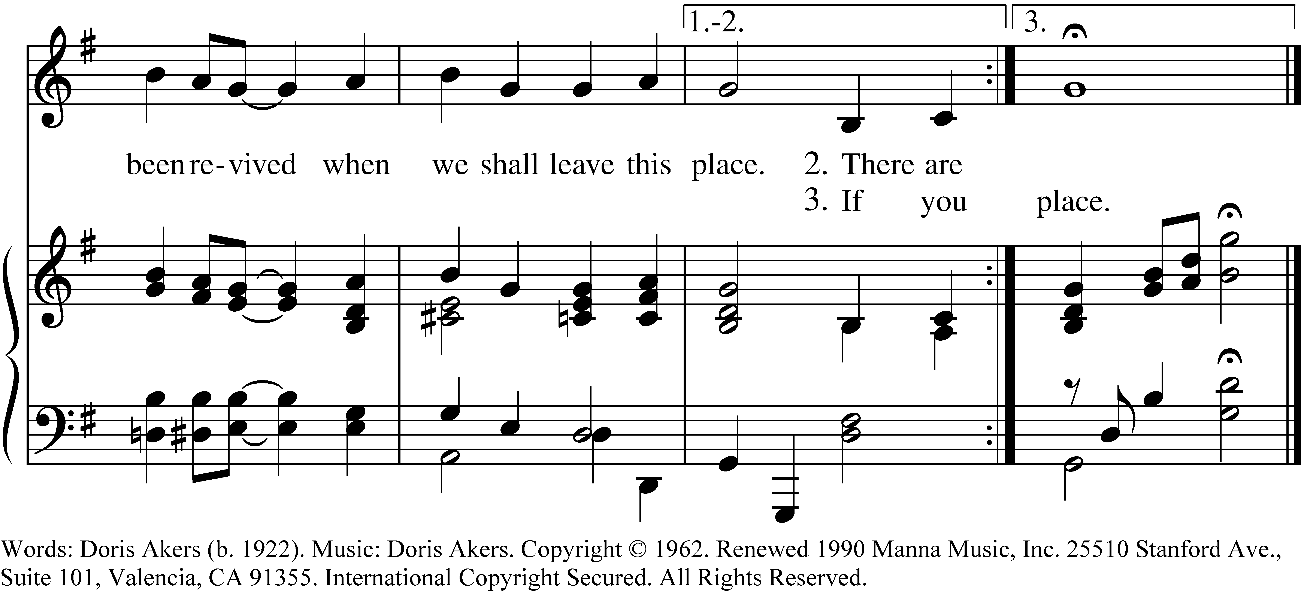

1 There’s a sweet, sweet Spirit in this place,
And I know that it’s the Spirit of the Lord.
There are sweet expressions on each face,
And I know they feel the presence of the Lord.

Sweet Holy Spirit, Sweet Heavenly Dove,
Stay right here with us, filling us with your love.
And for these blessings we lift our hearts in praise;
Without a doubt we’ll know that we have been revived
when we shall leave this place.

2 There are blessings you cannot receive
Till you know Him in His fullness, and believe.
You’re the one to profit when you say,
“I am going to walk with Jesus all the way.”

Refrain

3 If you say He saved you from your sin,
Now you’re weak, you’re bound, and cannot enter in,
you can make it right if you will yield;
You’ll enjoy the Holy Spirit that we feel.

Refrain
Sweet, Sweet Spirit, #120 from Lift Every Voice and Sing II — Words: Doris Akers (b. 1922). Music: Doris Akers. Copyright © 1962. Renewed 1990 Manna Music, Inc. 25510 Stanford Ave., Suite 101, Valencia, CA 91355. International Copyright Secured. All Rights Reserved.
About your RiteSong license
By purchasing this RiteSong license, you, for yourself and on behalf of your organization, agree to comply with the following terms and conditions. RiteSong licenses protect the owner of any underlying copyright included with this RiteSong license and thus you are permitted to use or print a copy of the applicable piece of music included in your RiteSong license for a single service, no matter the type of RiteSong license you have purchased. Any further use will require the purchase of an additional RiteSong license. Note that if you have purchased the annual RiteSong license, you will still need to download each piece of music for each service to ensure proper attribution to the applicable copyright holder.
No permission is granted with this RiteSong license to include any piece of music, in whole or in part, that is included in this RiteSong license, in a hymnal or other permanent or semi-permanent collection of songs. Apart from the written music included with this RiteSong license, no other form of the music, whether for use by a choir, organ or other accompaniments is included with this license and you agree not to modify the written music for such a purpose. Please contact Church Publishing Incorporated at cpirights@cpg.org to secure further materials and applicable use rights.
L120 / LEVAS_120

