When Jesus wept, the falling tear
The Hymnal 1982, #715
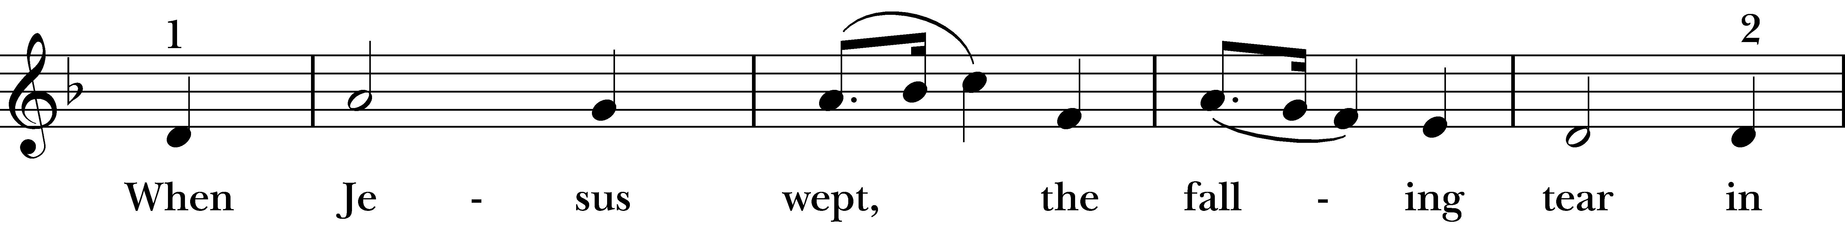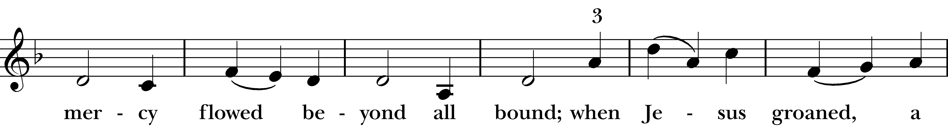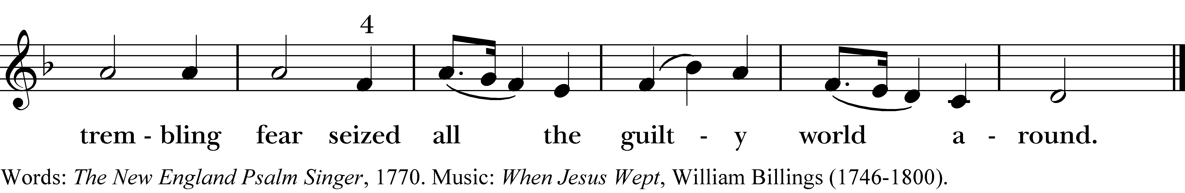

When Jesus wept, the falling tear
in mercy flowed beyond all bound;
when Jesus groaned, a trembling fear
seized all the guilty world around.
When Jesus wept, the falling tear, #715 from The Hymnal 1982 — Words: The New England Psalm Singer, 1770. Music: When Jesus Wept, William Billings (1746-1800).
About your RiteSong license
By purchasing this RiteSong license, you, for yourself and on behalf of your organization, agree to comply with the following terms and conditions. RiteSong licenses protect the owner of any underlying copyright included with this RiteSong license and thus you are permitted to use or print a copy of the applicable piece of music included in your RiteSong license for a single service, no matter the type of RiteSong license you have purchased. Any further use will require the purchase of an additional RiteSong license. Note that if you have purchased the annual RiteSong license, you will still need to download each piece of music for each service to ensure proper attribution to the applicable copyright holder.
No permission is granted with this RiteSong license to include any piece of music, in whole or in part, that is included in this RiteSong license, in a hymnal or other permanent or semi-permanent collection of songs. Apart from the written music included with this RiteSong license, no other form of the music, whether for use by a choir, organ or other accompaniments is included with this license and you agree not to modify the written music for such a purpose. Please contact Church Publishing Incorporated at cpirights@cpg.org to secure further materials and applicable use rights.
H715 / H82_715

