“Forgive our sins as we forgive”

The Hymnal 1982, #674

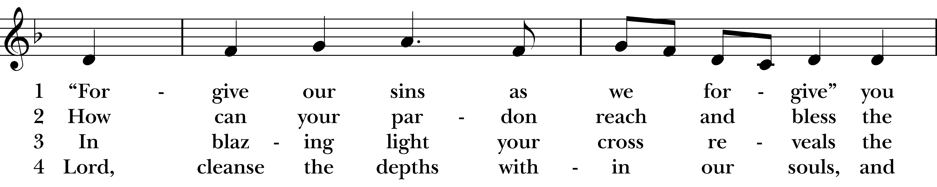  
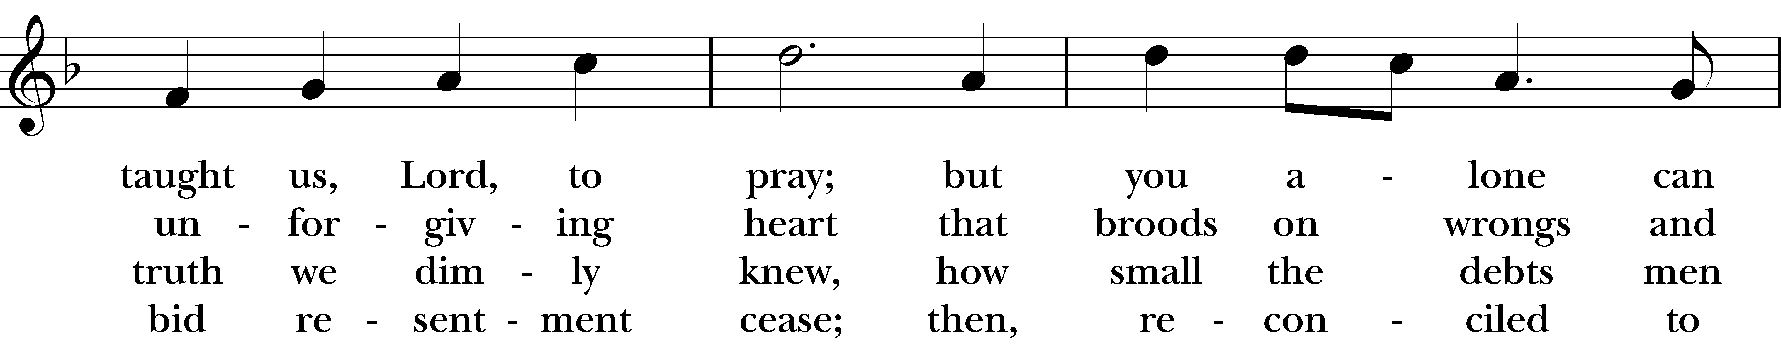  
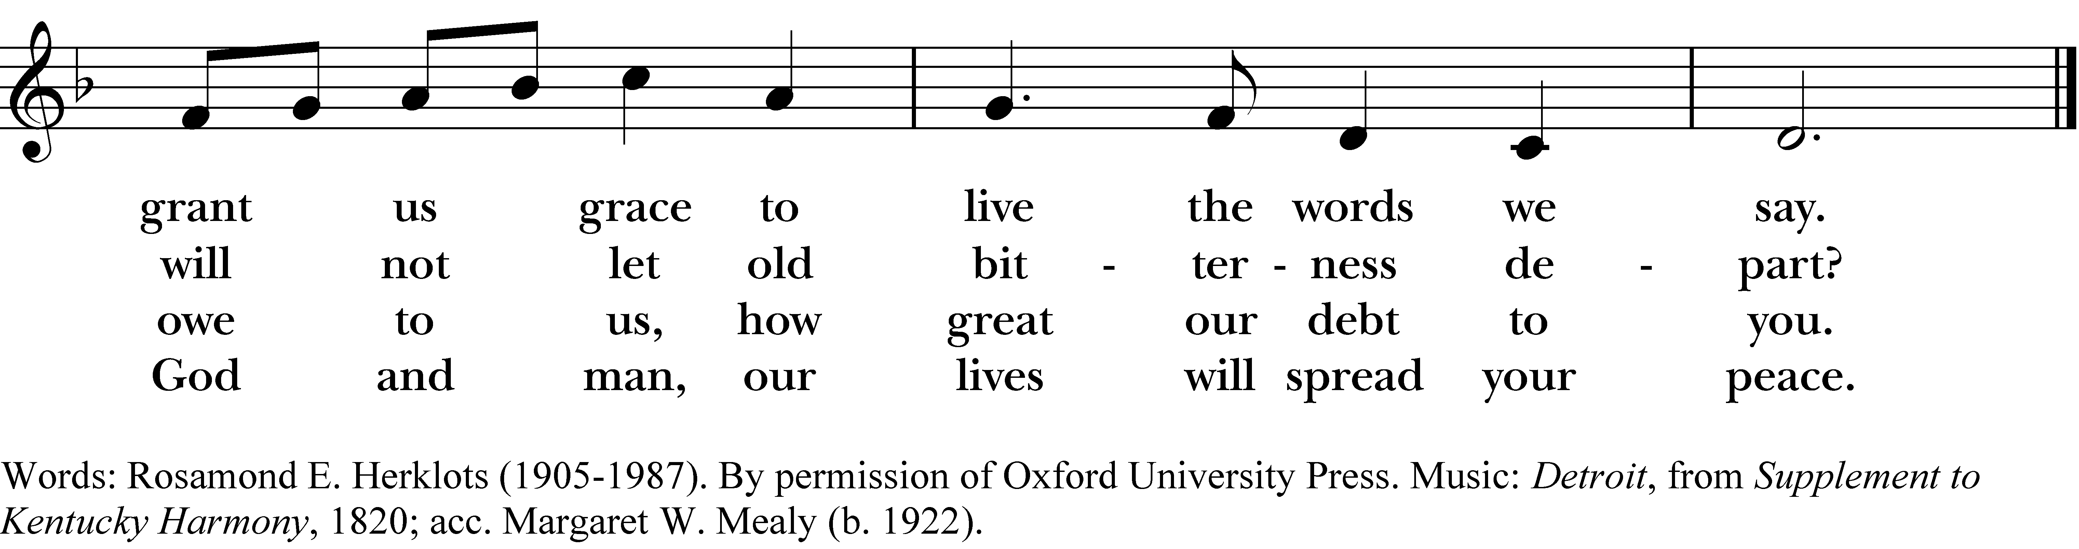

1 “Forgive our sins as we forgive”

you taught us, Lord, to pray;

but you alone can grant us grace

to live the words we say.

2 How can your pardon reach and bless

the unforgiving heart

that broods on wrongs and will not let

old bitterness depart?

3 In blazing light your cross reveals

the truth we dimly knew,

how small the debts men owe to us,

how great our debt to you.

4 Lord, cleanse the depths within our souls,

and bid resentment cease;

then, reconciled to God and man,

our lives will spread your peace.

***“Forgive our sins as we forgive”***, #674 from *The Hymnal 1982* — Words: Rosamond E. Herklots (1905-1987). By permission of Oxford University Press. Music: *Detroit*, from *Supplement to Kentucky Harmony*, 1820; acc. Margaret W. Mealy (b. 1922).

About your RiteSong license

By purchasing this RiteSong license, you, for yourself and on behalf of your organization, agree to comply with the following terms and conditions. RiteSong licenses protect the owner of any underlying copyright included with this RiteSong license and thus you are permitted to use or print a copy of the applicable piece of music included in your RiteSong license for a single service, no matter the type of RiteSong license you have purchased. Any further use will require the purchase of an additional RiteSong license. Note that if you have purchased the annual RiteSong license, you will still need to download each piece of music for each service to ensure proper attribution to the applicable copyright holder.

No permission is granted with this RiteSong license to include any piece of music, in whole or in part, that is included in this RiteSong license, in a hymnal or other permanent or semi-permanent collection of songs. Apart from the written music included with this RiteSong license, no other form of the music, whether for use by a choir, organ or other accompaniments is included with this license and you agree not to modify the written music for such a purpose. Please contact Church Publishing Incorporated at [cpirights@cpg.org](mailto:cpirights@cpg.org) to secure further materials and applicable use rights.

H674 / H82_674