Lord, for ever at thy side
The Hymnal 1982, #670
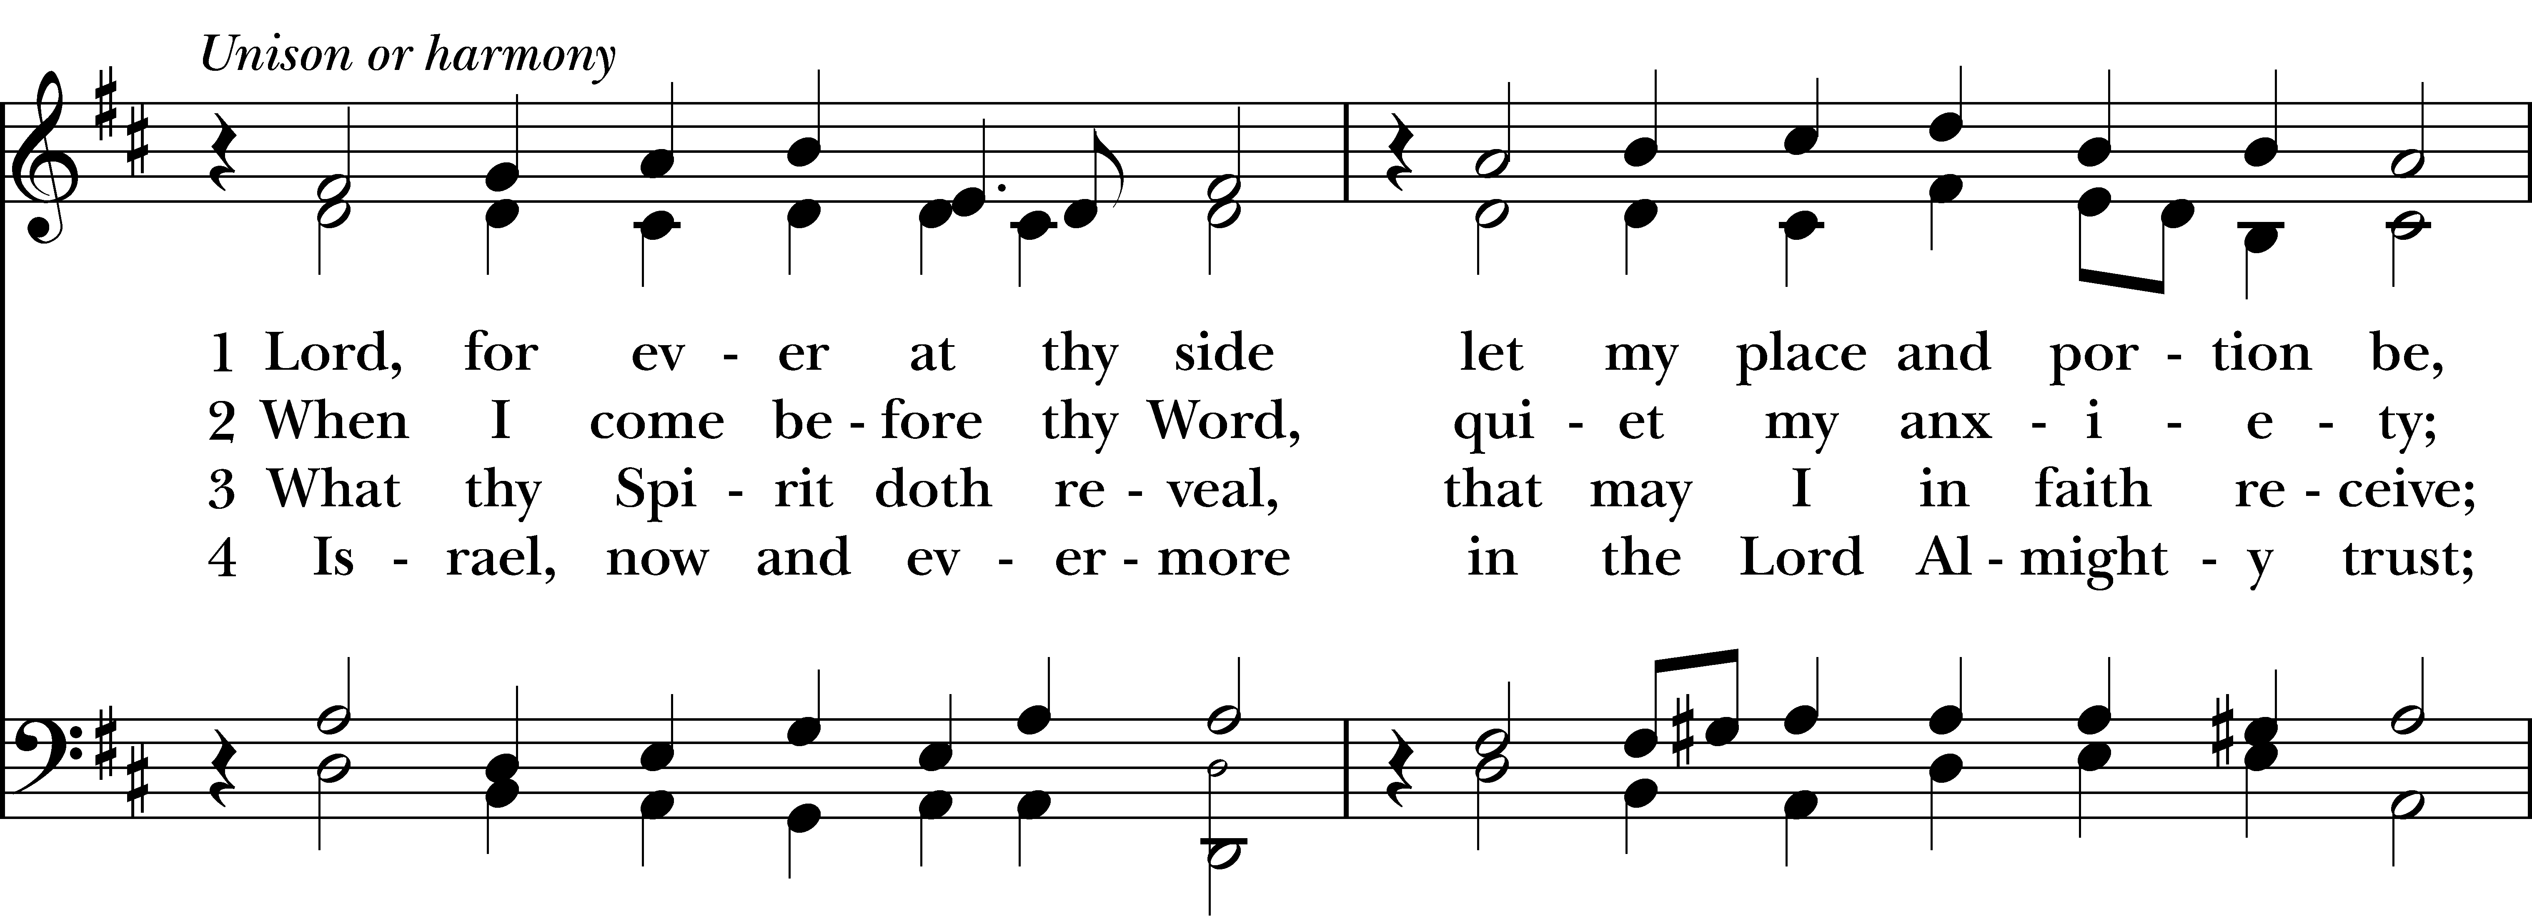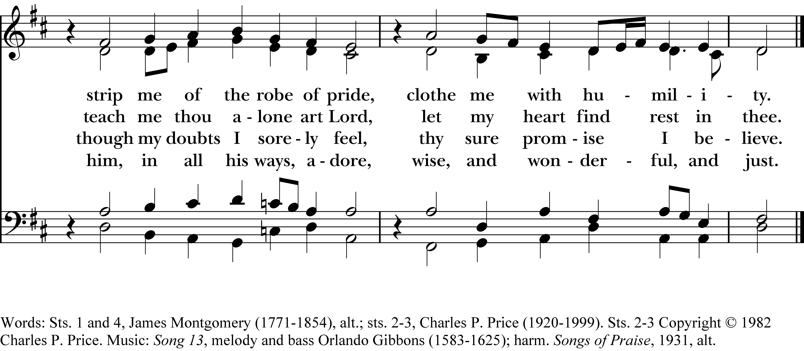

1 Lord, for ever at thy side
let my place and portion be,
strip me of the robe of pride,
clothe me with humility.

2 When I come before thy Word,
quiet my anxiety;
teach me thou alone art Lord,
let my heart find rest in thee.

3 What thy Spirit doth reveal,
that may I in faith receive;
though my doubts I sorely feel,
thy sure promise I believe.

4 Israel, now and evermore
in the Lord Almighty trust;
him, in all his ways, adore,
wise, and wonderful, and just.
Lord, for ever at thy side, #670 from The Hymnal 1982 — Words: Sts. 1 and 4, James Montgomery (1771-1854), alt.; sts. 2-3, Charles P. Price (1920-1999). Sts. 2-3 Copyright © 1982 Charles P. Price. Music: Song 13, melody and bass Orlando Gibbons (1583-1625); harm. Songs of Praise, 1931, alt.
About your RiteSong license
By purchasing this RiteSong license, you, for yourself and on behalf of your organization, agree to comply with the following terms and conditions. RiteSong licenses protect the owner of any underlying copyright included with this RiteSong license and thus you are permitted to use or print a copy of the applicable piece of music included in your RiteSong license for a single service, no matter the type of RiteSong license you have purchased. Any further use will require the purchase of an additional RiteSong license. Note that if you have purchased the annual RiteSong license, you will still need to download each piece of music for each service to ensure proper attribution to the applicable copyright holder.
No permission is granted with this RiteSong license to include any piece of music, in whole or in part, that is included in this RiteSong license, in a hymnal or other permanent or semi-permanent collection of songs. Apart from the written music included with this RiteSong license, no other form of the music, whether for use by a choir, organ or other accompaniments is included with this license and you agree not to modify the written music for such a purpose. Please contact Church Publishing Incorporated at cpirights@cpg.org to secure further materials and applicable use rights.
H670 / H82_670

