Sing alleluia forth in duteous praise
The Hymnal 1982, #619
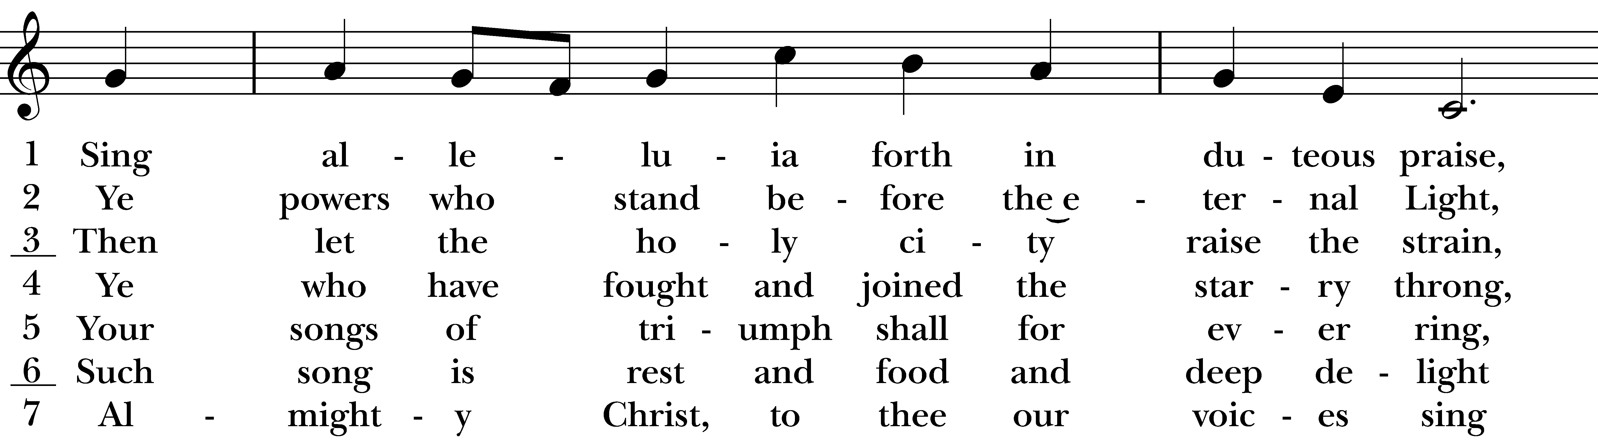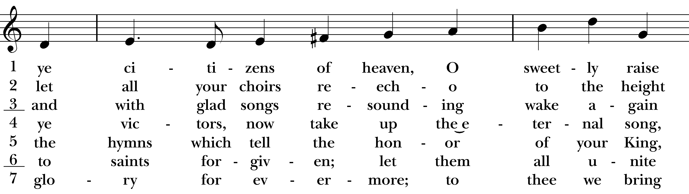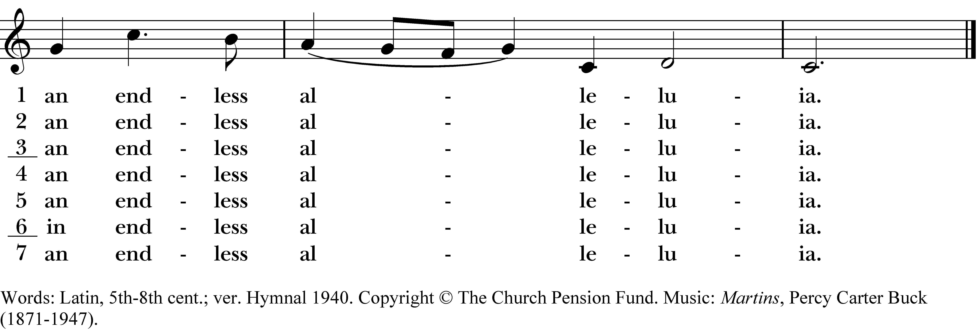

1 Sing alleluia forth in duteous praise,
ye citizens of heaven, O sweetly raise
an endless alleluia.

2 Ye powers who stand before the eternal Light,
let all your choirs re-echo to the height
an endless alleluia.

3 Then let the holy city raise the strain,
and with glad songs resounding wake again
an endless alleluia.

4 Ye who have fought and joined the starry throng,
ye victors, now take up the eternal song,
an endless alleluia.

5 Your songs of triumph shall for ever ring,
the hymns which tell the honor of your King,
an endless alleluia.

6 Such song is rest and food and deep delight
to saints forgiven; let them unite
in endless alleluia.

7 Almighty Christ, to thee our voices sing
glory for evermore; to thee we bring
an endless alleluia.
Sing alleluia forth in duteous praise, #619 from The Hymnal 1982 — Words: Latin, 5th-8th cent.; ver. Hymnal 1940. Copyright © The Church Pension Fund. Music: Martins, Percy Carter Buck (1871-1947).
About your RiteSong license
By purchasing this RiteSong license, you, for yourself and on behalf of your organization, agree to comply with the following terms and conditions. RiteSong licenses protect the owner of any underlying copyright included with this RiteSong license and thus you are permitted to use or print a copy of the applicable piece of music included in your RiteSong license for a single service, no matter the type of RiteSong license you have purchased. Any further use will require the purchase of an additional RiteSong license. Note that if you have purchased the annual RiteSong license, you will still need to download each piece of music for each service to ensure proper attribution to the applicable copyright holder.
No permission is granted with this RiteSong license to include any piece of music, in whole or in part, that is included in this RiteSong license, in a hymnal or other permanent or semi-permanent collection of songs. Apart from the written music included with this RiteSong license, no other form of the music, whether for use by a choir, organ or other accompaniments is included with this license and you agree not to modify the written music for such a purpose. Please contact Church Publishing Incorporated at cpirights@cpg.org to secure further materials and applicable use rights.
H619 / H82_619

