Here in Christ we gather, love of Christ our calling
The Hymnal 1982, #577
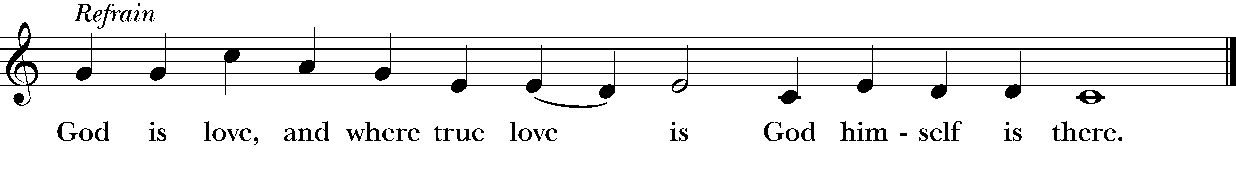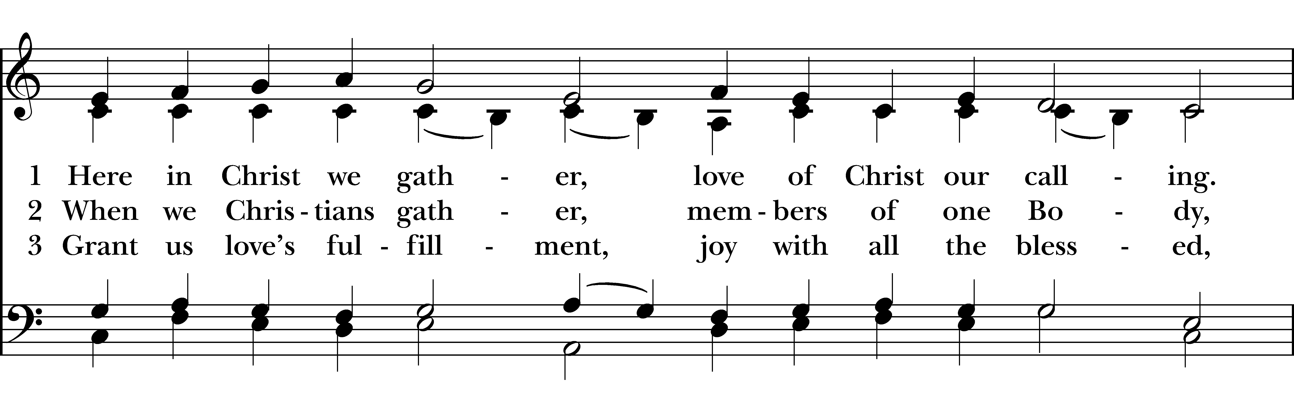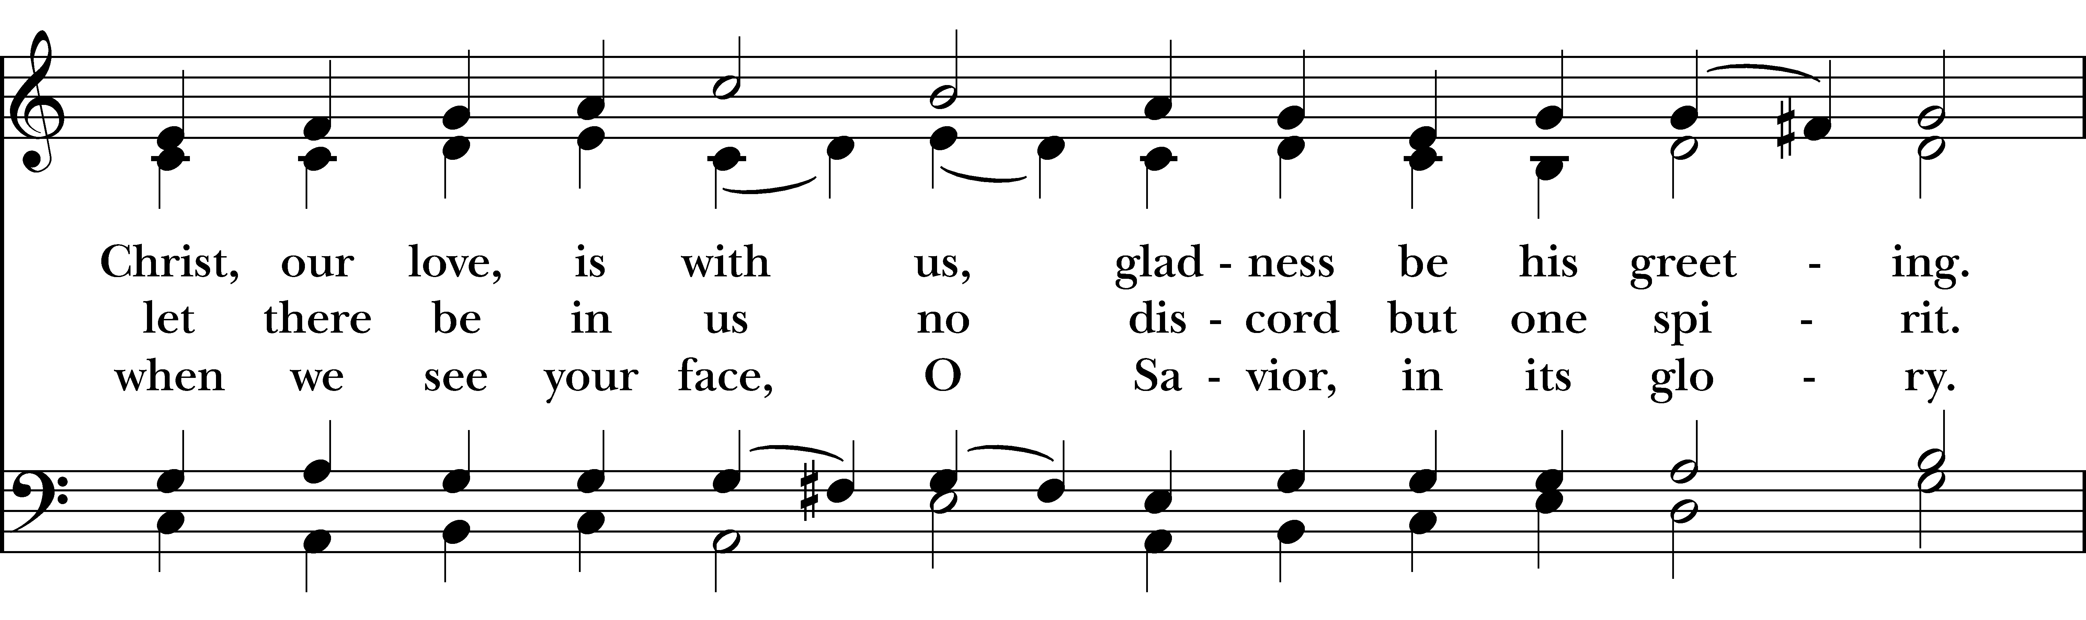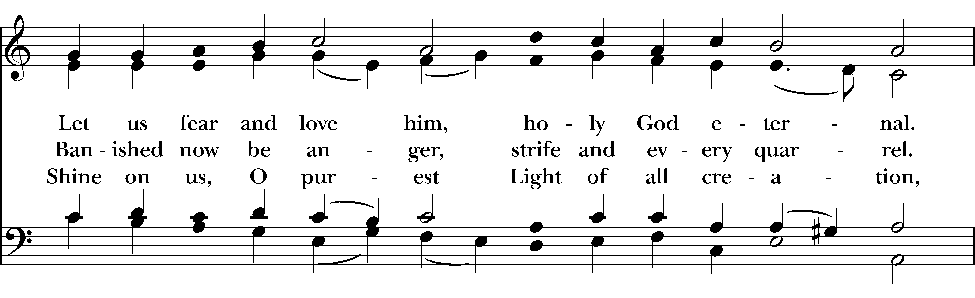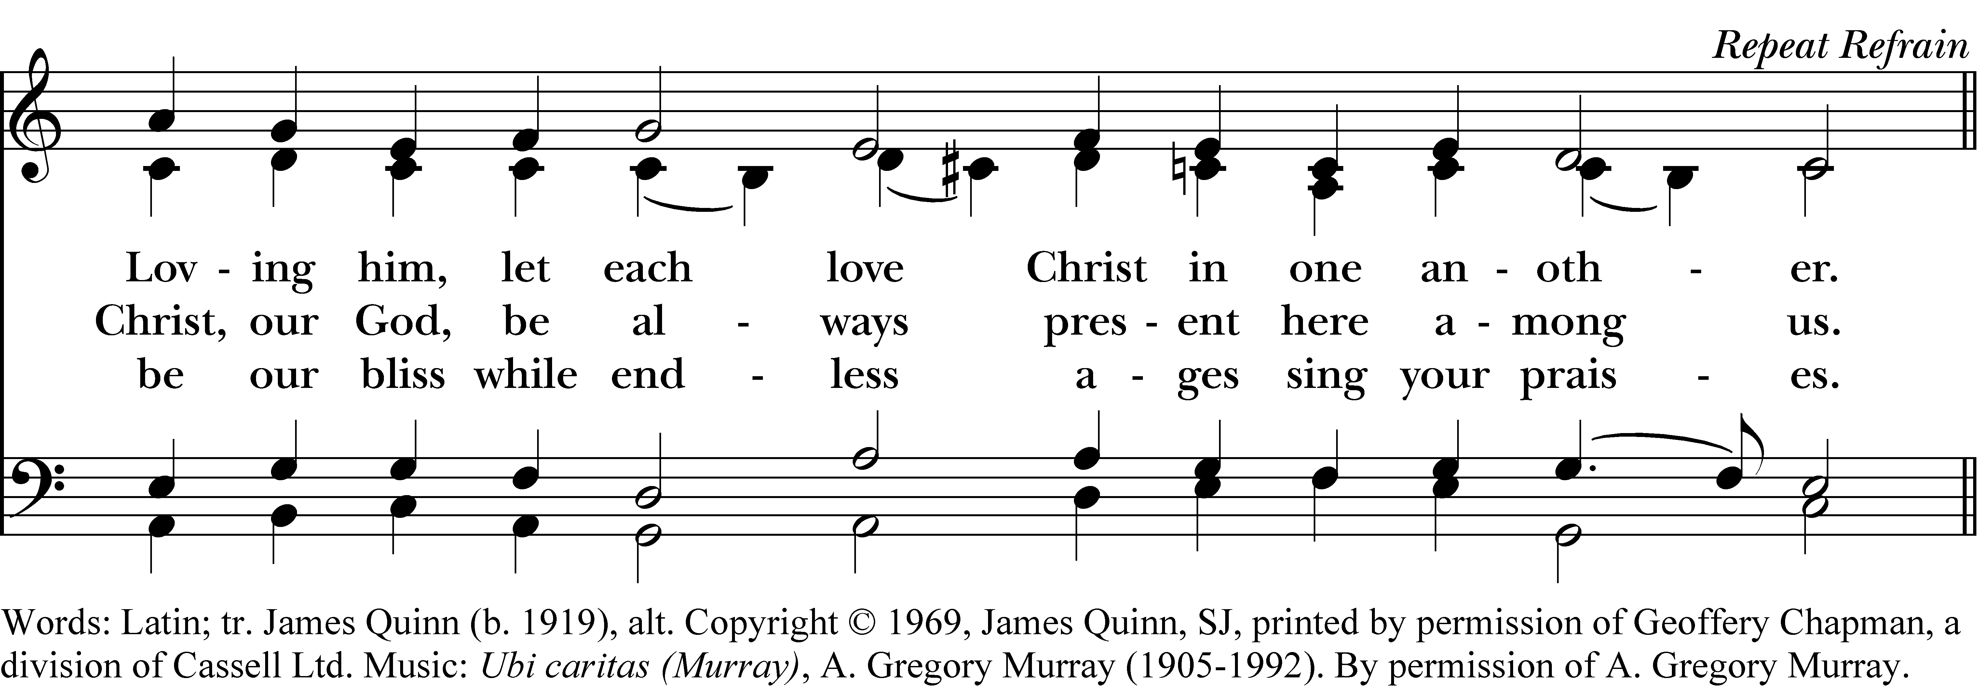

God is love, and where true love is
God himself is there.

1 Here in Christ we gather, love of Christ our calling.
Christ, our love, is with us, gladness be his greeting.
Let us fear and love him, holy God eternal.
Loving him, let each love Christ in one another.

Refrain

2 When we Christians gather, members of one Body,
let there be in us no discord but one spirit.
Banished now be anger, strife and every quarrel.
Christ, our God, be always present here among us.

Refrain

3 Grant us love’s fulfillment, joy with all the blessèd,
when we see your face, O Savior, in its glory.
Shine on us, O purest Light of all creation,
be our bliss while endless ages sing your praises.

Refrain
Here in Christ we gather, love of Christ our calling, #577 from The Hymnal 1982 — Words: Latin; tr. James Quinn (b. 1919), alt. Copyright © 1969, James Quinn, SJ, printed by permission of Geoffery Chapman, a division of Cassell Ltd. Music: Ubi caritas (Murray), A. Gregory Murray (1905-1992). By permission of A. Gregory Murray.
About your RiteSong license
By purchasing this RiteSong license, you, for yourself and on behalf of your organization, agree to comply with the following terms and conditions. RiteSong licenses protect the owner of any underlying copyright included with this RiteSong license and thus you are permitted to use or print a copy of the applicable piece of music included in your RiteSong license for a single service, no matter the type of RiteSong license you have purchased. Any further use will require the purchase of an additional RiteSong license. Note that if you have purchased the annual RiteSong license, you will still need to download each piece of music for each service to ensure proper attribution to the applicable copyright holder.
No permission is granted with this RiteSong license to include any piece of music, in whole or in part, that is included in this RiteSong license, in a hymnal or other permanent or semi-permanent collection of songs. Apart from the written music included with this RiteSong license, no other form of the music, whether for use by a choir, organ or other accompaniments is included with this license and you agree not to modify the written music for such a purpose. Please contact Church Publishing Incorporated at cpirights@cpg.org to secure further materials and applicable use rights.
H577 / H82_577

