The great Creator of the worlds
The Hymnal 1982, #489
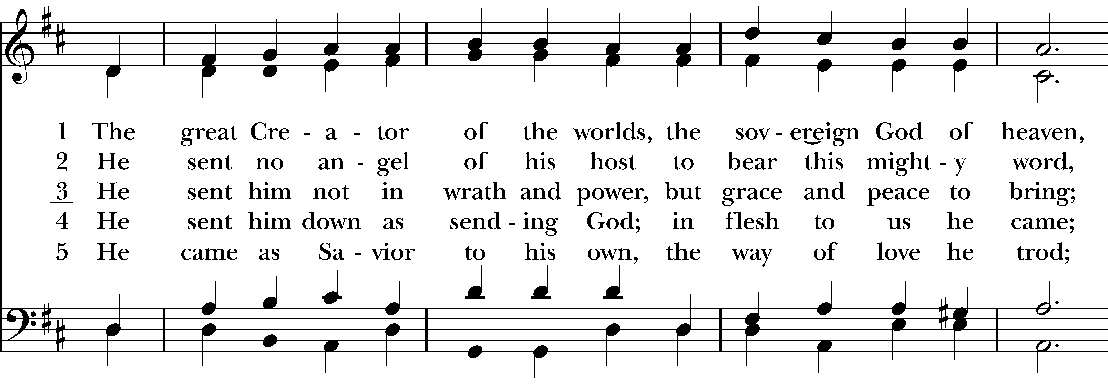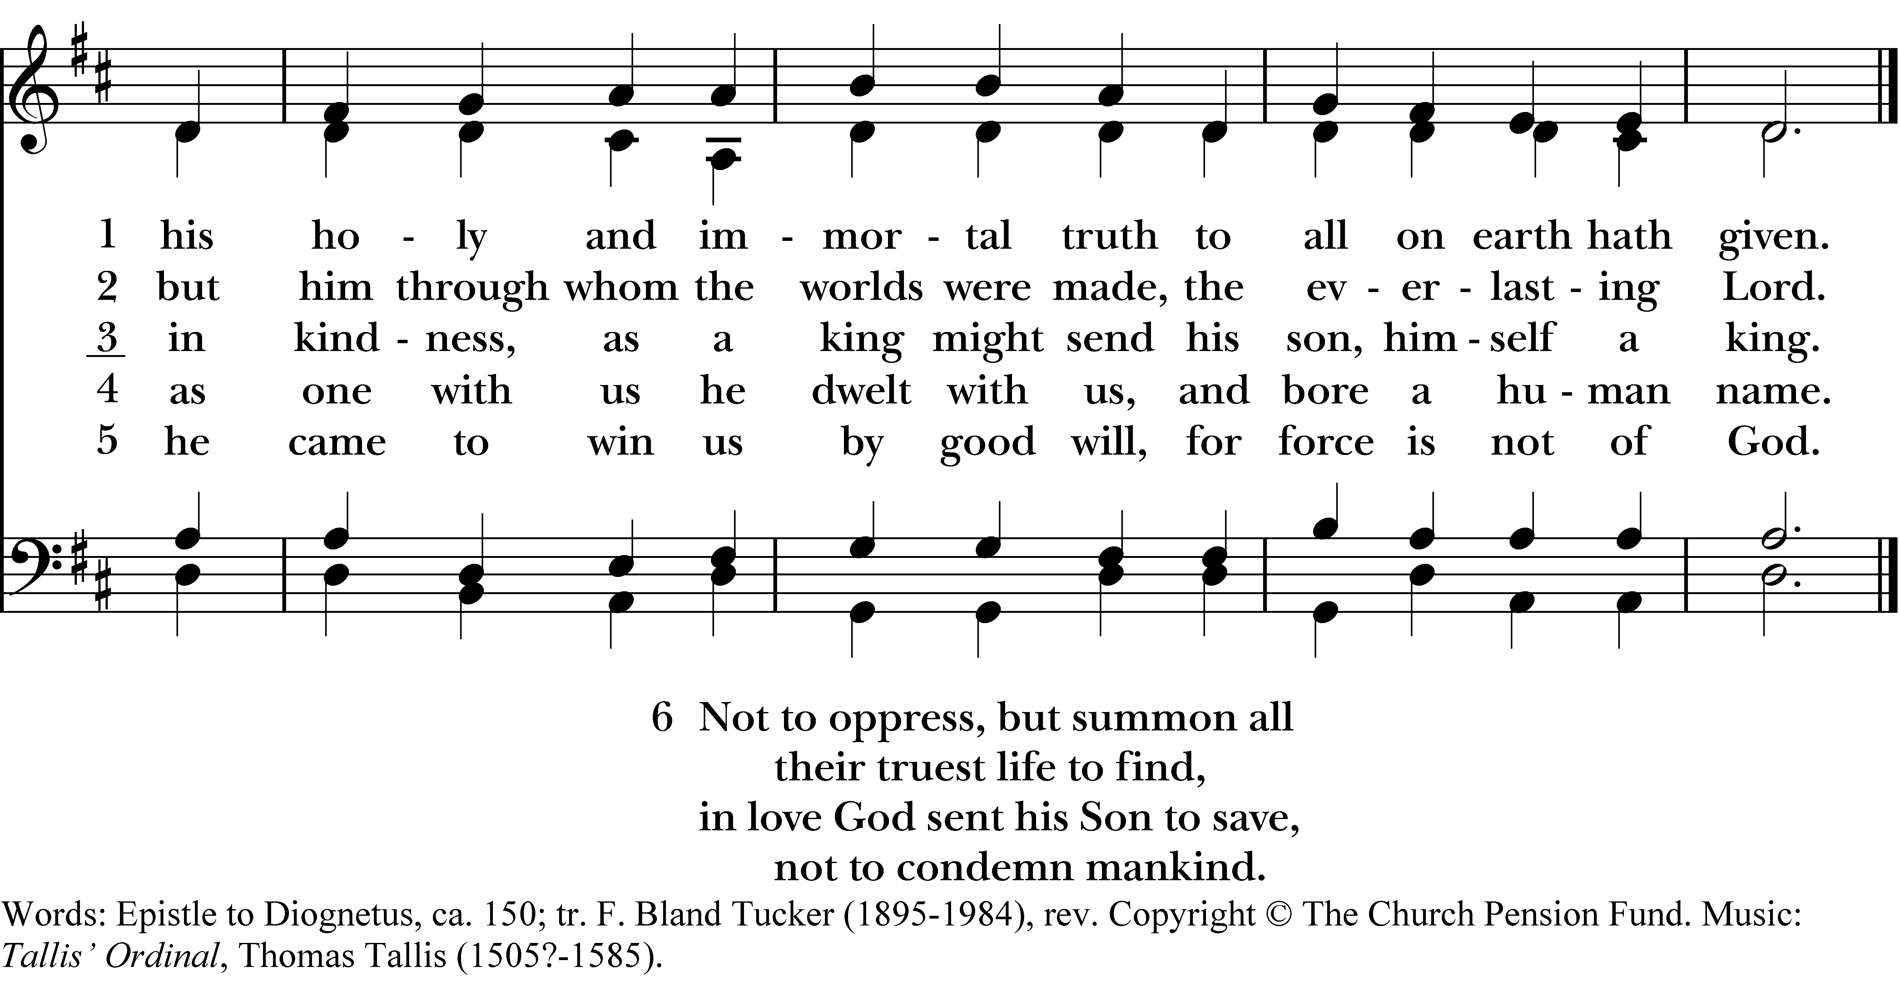

1 The great Creator of the worlds,
the sovereign God of heaven,
his holy and immortal truth
to all on earth hath given.

2 He sent no angel of his host
to bear this mighty word,
but him through whom the worlds were made,
the everlasting Lord.

3 He sent him not in wrath and power,
but grace and peace to bring;
in kindness, as a king might send
his son, himself a king.

4 He sent him down as sending God;
in flesh to us he came;
as one with us he dwelt with us,
and bore a human name.

5 He came as Savior to his own,
the way of love he trod;
he came to win us by good will,
for force is not of God.

6 Not to oppress, but summon all
their truest life to find,
in love God sent his Son to save,
not to condemn mankind.
The great Creator of the worlds, #489 from The Hymnal 1982 — Words: Epistle to Diognetus, ca. 150; tr. F. Bland Tucker (1895-1984), rev. Copyright © The Church Pension Fund. Music: Tallis’ Ordinal, Thomas Tallis (1505?-1585).
About your RiteSong license
By purchasing this RiteSong license, you, for yourself and on behalf of your organization, agree to comply with the following terms and conditions. RiteSong licenses protect the owner of any underlying copyright included with this RiteSong license and thus you are permitted to use or print a copy of the applicable piece of music included in your RiteSong license for a single service, no matter the type of RiteSong license you have purchased. Any further use will require the purchase of an additional RiteSong license. Note that if you have purchased the annual RiteSong license, you will still need to download each piece of music for each service to ensure proper attribution to the applicable copyright holder.
No permission is granted with this RiteSong license to include any piece of music, in whole or in part, that is included in this RiteSong license, in a hymnal or other permanent or semi-permanent collection of songs. Apart from the written music included with this RiteSong license, no other form of the music, whether for use by a choir, organ or other accompaniments is included with this license and you agree not to modify the written music for such a purpose. Please contact Church Publishing Incorporated at cpirights@cpg.org to secure further materials and applicable use rights.
H489 / H82_489

