The Lord will come and not be slow

The Hymnal 1982, #462

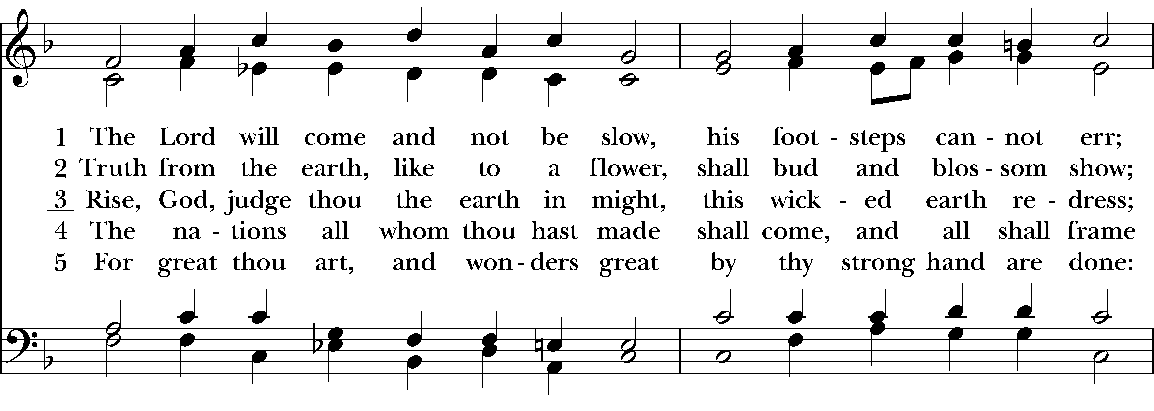  
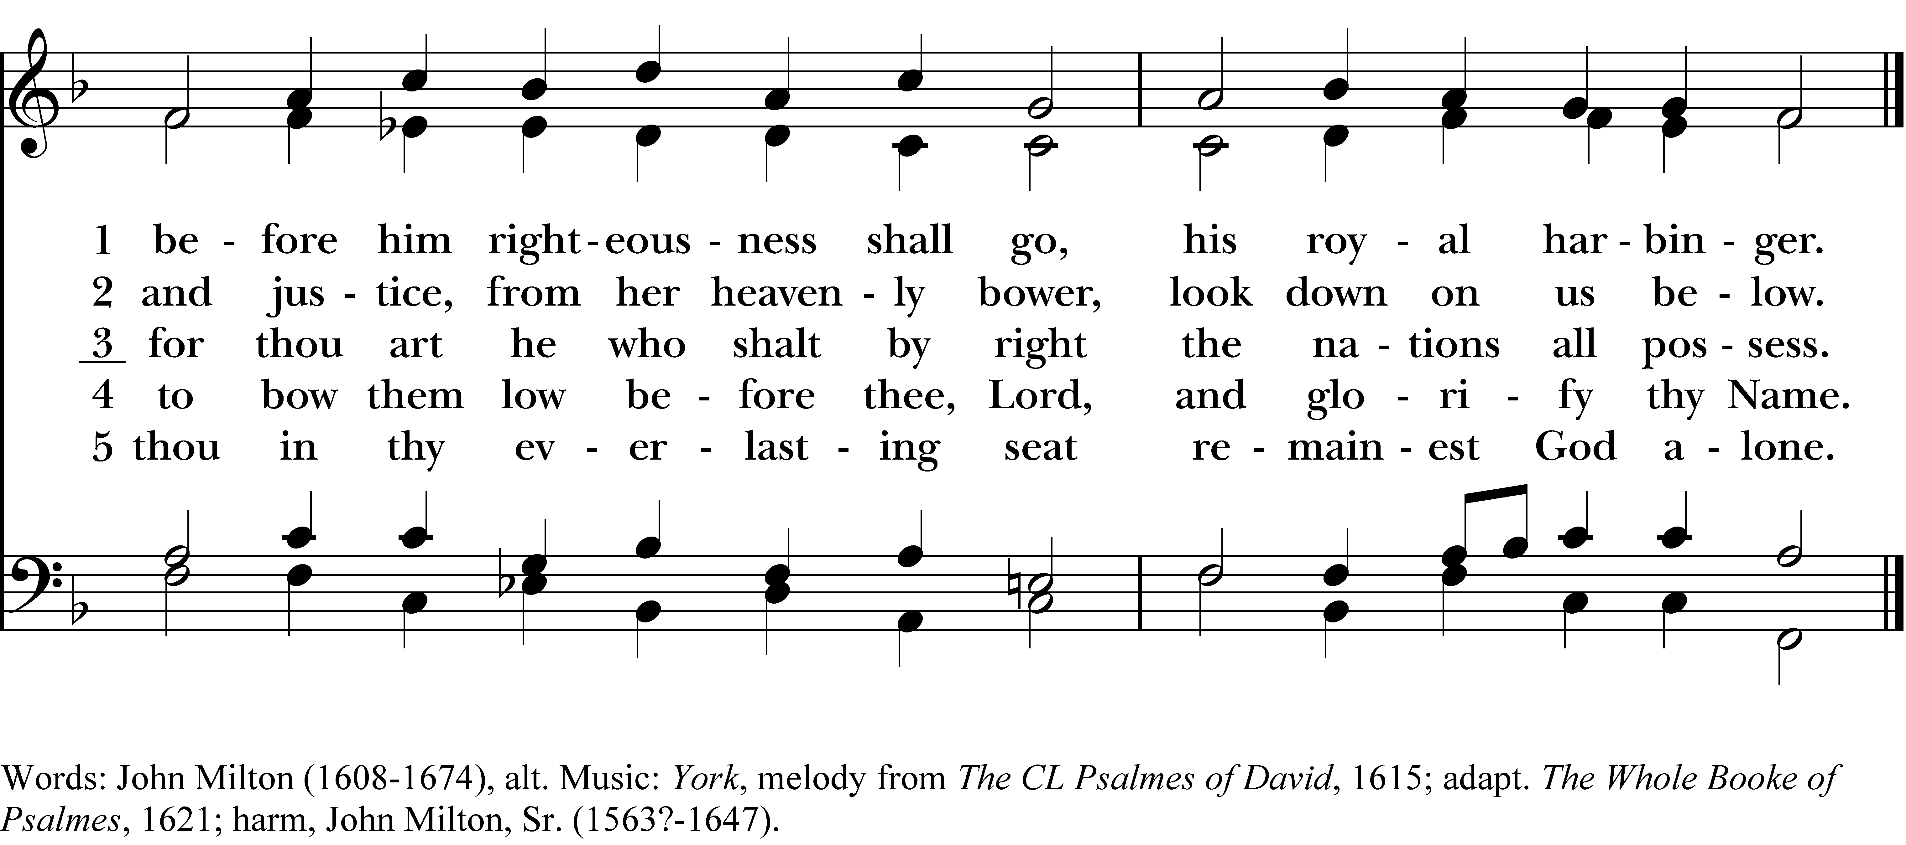

1 The Lord will come and not be slow,

his footsteps cannot err;

before him righteousness shall go,

his royal harbinger.

2 Truth from the earth, like to a flower,

shall bud and blossom show;

and justice, from her heavenly bower,

look down on us below.

3 Rise, God, judge thou the earth in might,

this wicked earth redress;

for thou art he who shalt by right

the nations all possess.

4 The nations all whom thou hast made

shall come, and all shall frame

to bow them low before thee, Lord,

and glorify thy Name.

5 For great thou art, and wonders great

by thy strong hand are done:

thou in thy everlasting seat

remainest God alone.

***The Lord will come and not be slow***, #462 from *The Hymnal 1982* — Words: John Milton (1608-1674), alt. Music: *York*, melody from *The CL Psalmes of David*, 1615; adapt. *The Whole Booke of Psalmes*, 1621; harm, John Milton, Sr. (1563?-1647).

About your RiteSong license

By purchasing this RiteSong license, you, for yourself and on behalf of your organization, agree to comply with the following terms and conditions. RiteSong licenses protect the owner of any underlying copyright included with this RiteSong license and thus you are permitted to use or print a copy of the applicable piece of music included in your RiteSong license for a single service, no matter the type of RiteSong license you have purchased. Any further use will require the purchase of an additional RiteSong license. Note that if you have purchased the annual RiteSong license, you will still need to download each piece of music for each service to ensure proper attribution to the applicable copyright holder.

No permission is granted with this RiteSong license to include any piece of music, in whole or in part, that is included in this RiteSong license, in a hymnal or other permanent or semi-permanent collection of songs. Apart from the written music included with this RiteSong license, no other form of the music, whether for use by a choir, organ or other accompaniments is included with this license and you agree not to modify the written music for such a purpose. Please contact Church Publishing Incorporated at [cpirights@cpg.org](mailto:cpirights@cpg.org) to secure further materials and applicable use rights.

H462 / H82_462