From God Christ’s deity came forth
The Hymnal 1982, #443
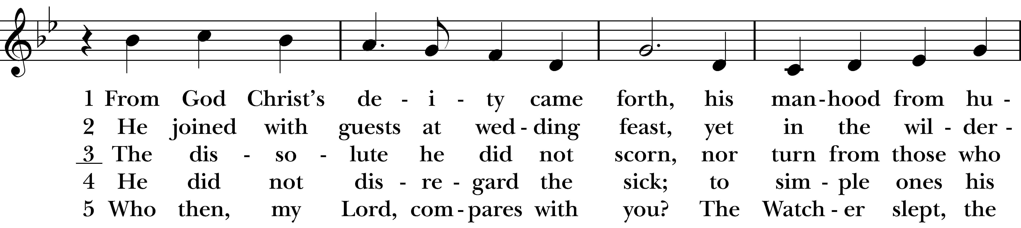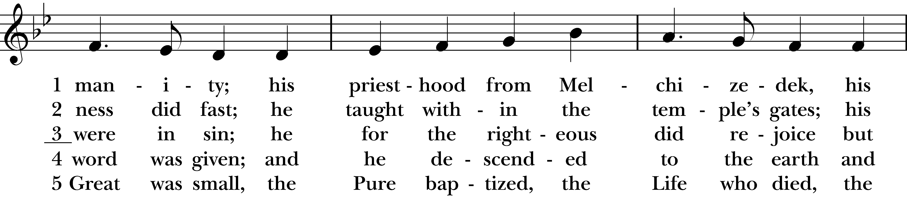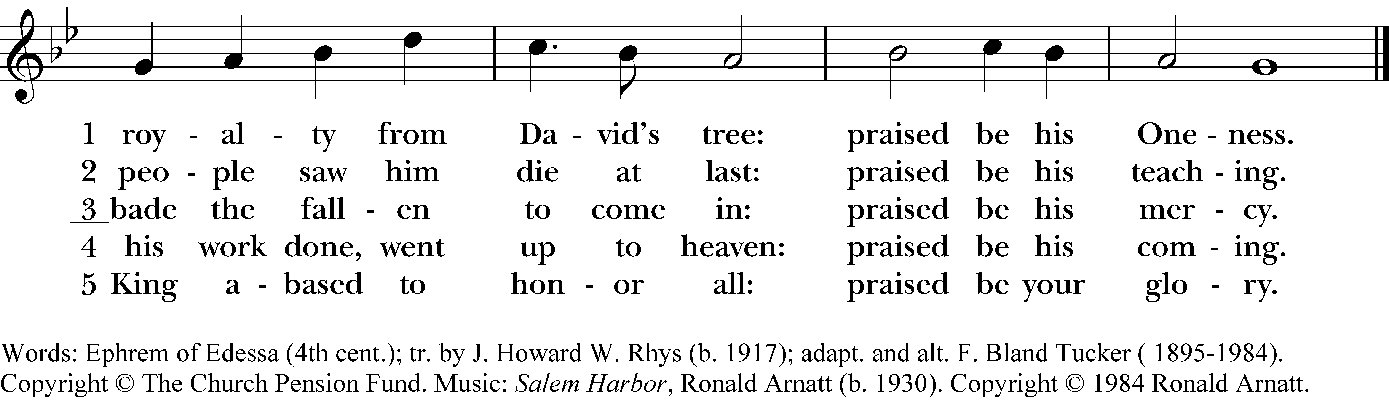

1 From God Christ’s deity came forth,
his manhood from humanity;
his priesthood from Melchizedek,
his royalty from David’s tree:
praised be his Oneness.

2 He joined with guests at wedding feast,
yet in the wilderness did fast;
he taught within the temple’s gates;
his people saw him die at last:
praised be his teaching.

3 The dissolute he did not scorn,
nor turn from those who were in sin;
he for the righteous did rejoice
but bade the fallen to come in:
praised be his mercy.

4 He did not disregard the sick;
to simple ones his word was given;
and he descended to the earth
and his work done, went up to heaven:
praised be his coming.

5 Who then, my Lord, compares with you?
The Watcher slept, the Great was small,
the Pure baptized, the Life who died,
the King abased to honor all:
praised be your glory.
From God Christ’s deity came forth, #443 from The Hymnal 1982 — Words: Ephrem of Edessa (4th cent.); tr. by J. Howard W. Rhys (b. 1917); adapt. and alt. F. Bland Tucker ( 1895-1984). Copyright © The Church Pension Fund. Music: Salem Harbor, Ronald Arnatt (b. 1930). Copyright © 1984 Ronald Arnatt.
About your RiteSong license
By purchasing this RiteSong license, you, for yourself and on behalf of your organization, agree to comply with the following terms and conditions. RiteSong licenses protect the owner of any underlying copyright included with this RiteSong license and thus you are permitted to use or print a copy of the applicable piece of music included in your RiteSong license for a single service, no matter the type of RiteSong license you have purchased. Any further use will require the purchase of an additional RiteSong license. Note that if you have purchased the annual RiteSong license, you will still need to download each piece of music for each service to ensure proper attribution to the applicable copyright holder.
No permission is granted with this RiteSong license to include any piece of music, in whole or in part, that is included in this RiteSong license, in a hymnal or other permanent or semi-permanent collection of songs. Apart from the written music included with this RiteSong license, no other form of the music, whether for use by a choir, organ or other accompaniments is included with this license and you agree not to modify the written music for such a purpose. Please contact Church Publishing Incorporated at cpirights@cpg.org to secure further materials and applicable use rights.
H443 / H82_443

