I sing a song of the saints of God
The Hymnal 1982, #293
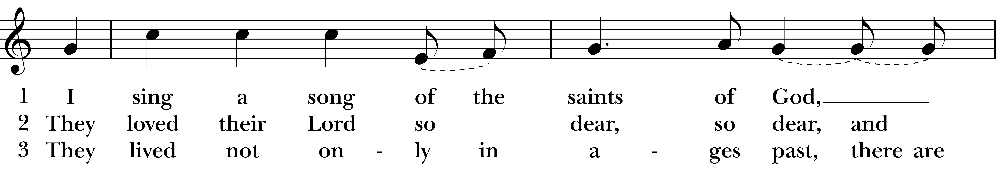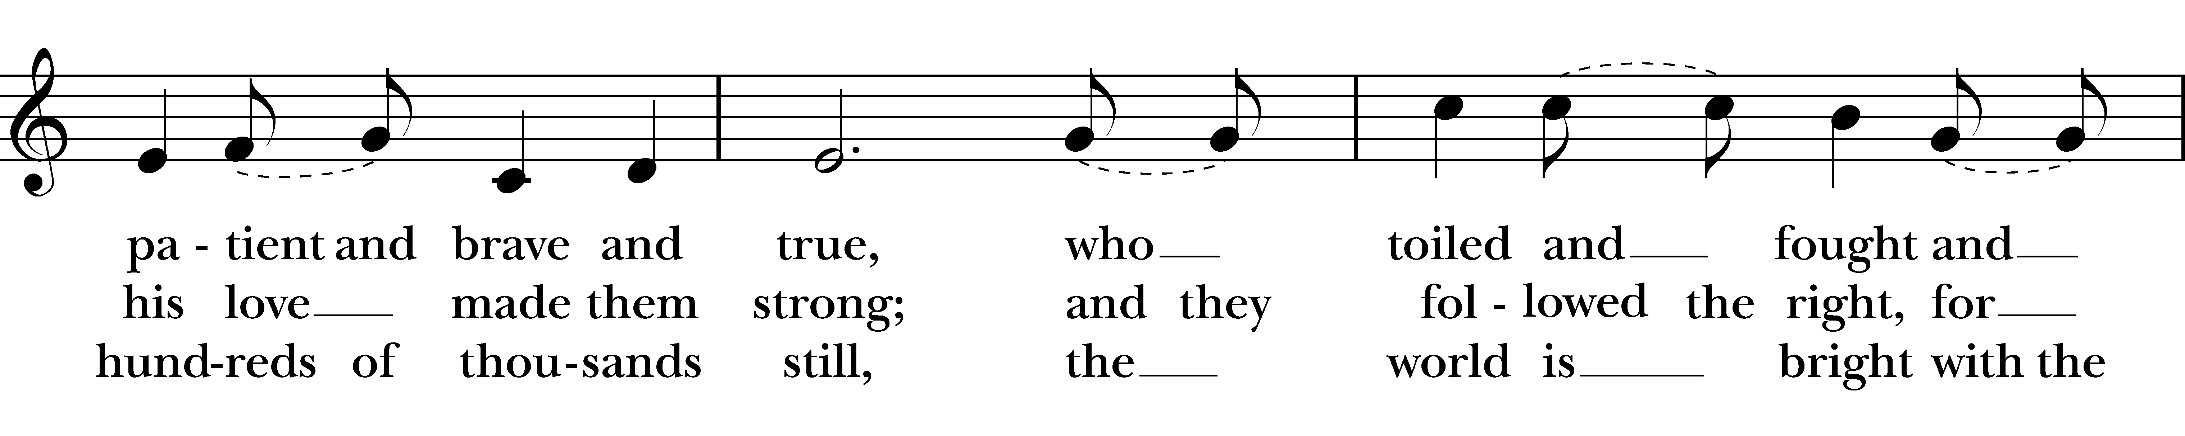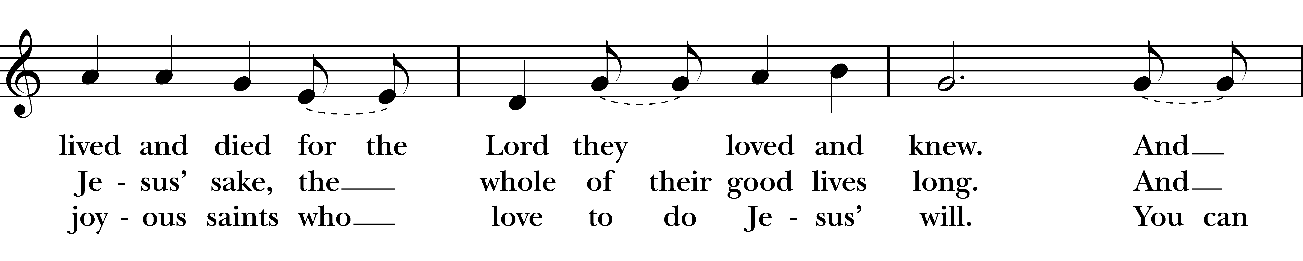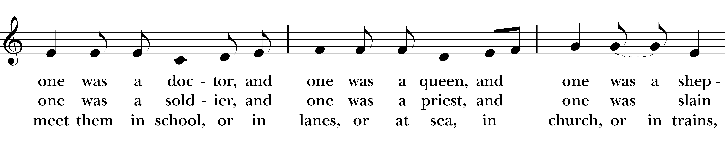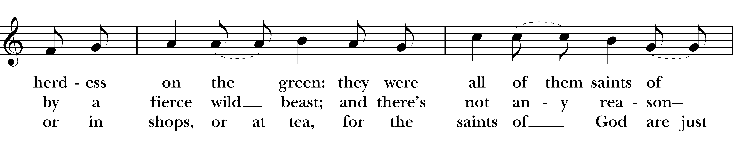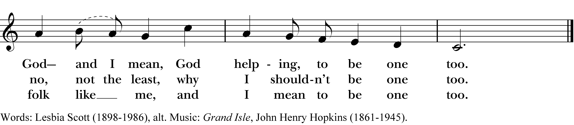

1 I sing a song of the saints of God,
patient and brave and true,
who toiled and fought and lived and died
for the Lord they loved and knew.
And one was a doctor, and one was a queen,
and one was a shepherdess on the green:
they were all of them saints of God and I mean,
God helping, to be one too.

2 They loved their Lord so dear, so dear,
and his love made them strong;
and they followed the right, for Jesus’ sake,
the whole of their good lives long.
And one was a soldier, and one was a priest,
and one was slain by a fierce wild beast;
and there’s not any reason no, not the least,
why I shouldn’t be one too.

3 They lived not only in ages past,
there are hundreds of thousands still,
the world is bright with the joyous saints
who love to do Jesus’ will.
You can meet them in school, or in lanes, or at sea,
in church, or in trains, or in shops, or at tea,
for the saints of God are just folk like me,
and I mean to be one too.
I sing a song of the saints of God, #293 from The Hymnal 1982 — Words: Lesbia Scott (1898-1986), alt. Music: Grand Isle, John Henry Hopkins (1861-1945).
About your RiteSong license
By purchasing this RiteSong license, you, for yourself and on behalf of your organization, agree to comply with the following terms and conditions. RiteSong licenses protect the owner of any underlying copyright included with this RiteSong license and thus you are permitted to use or print a copy of the applicable piece of music included in your RiteSong license for a single service, no matter the type of RiteSong license you have purchased. Any further use will require the purchase of an additional RiteSong license. Note that if you have purchased the annual RiteSong license, you will still need to download each piece of music for each service to ensure proper attribution to the applicable copyright holder.
No permission is granted with this RiteSong license to include any piece of music, in whole or in part, that is included in this RiteSong license, in a hymnal or other permanent or semi-permanent collection of songs. Apart from the written music included with this RiteSong license, no other form of the music, whether for use by a choir, organ or other accompaniments is included with this license and you agree not to modify the written music for such a purpose. Please contact Church Publishing Incorporated at cpirights@cpg.org to secure further materials and applicable use rights.
H293 / H82_293

