What thanks and praise to thee we owe
The Hymnal 1982, #285
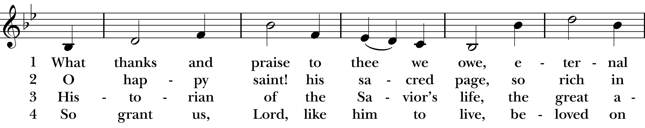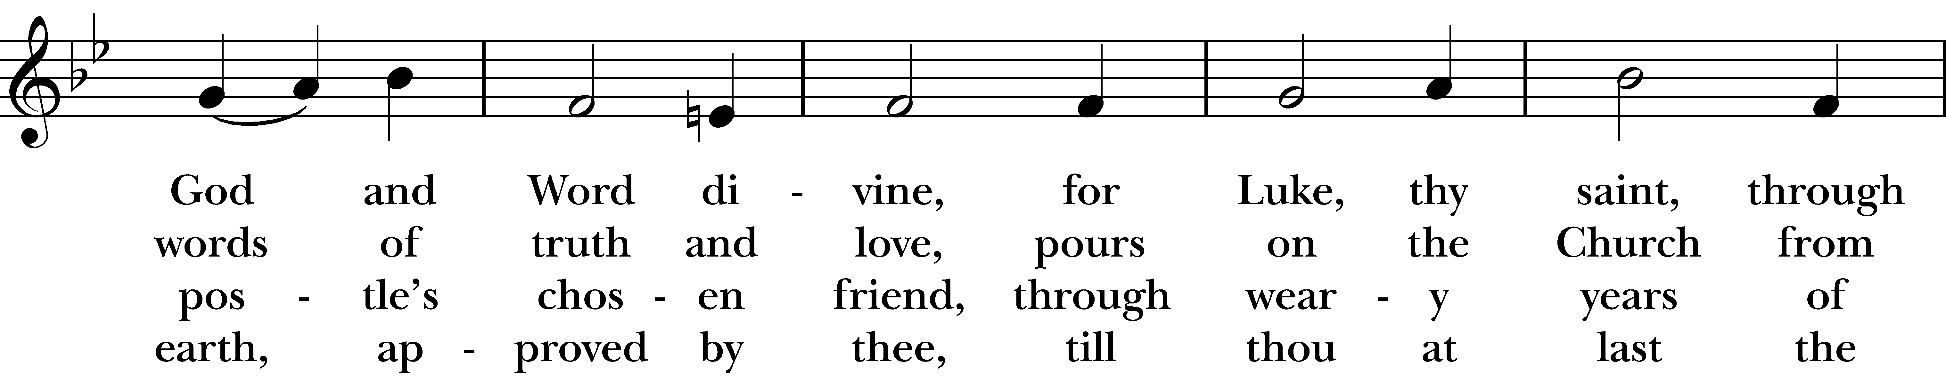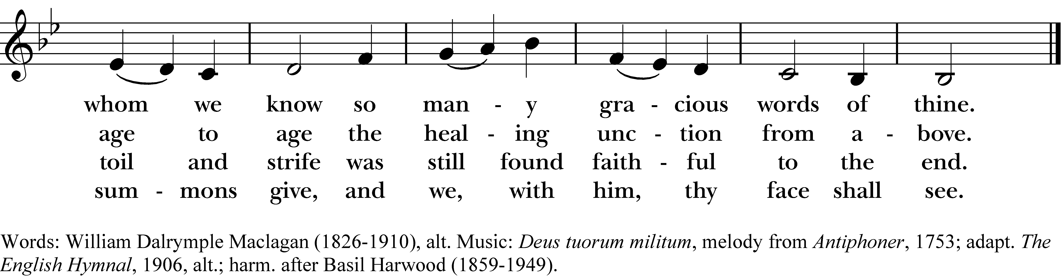

1 What thanks and praise to thee we owe,
eternal God and Word divine,
for Luke, thy saint, through whom we know
so many gracious words of thine.

2 O happy saint! his sacred page,
so rich in words of truth and love,
pours on the Church from age to age
the healing unction from above.

3 Historian of the Savior’s life,
the great apostle’s chosen friend,
through weary years of toil and strife
was still found faithful to the end.

4 So grant us, Lord, like him to live,
beloved on earth, approved by thee,
till thou at last the summons give,
and we, with him, thy face shall see.
What thanks and praise to thee we owe, #285 from The Hymnal 1982 — Words: William Dalrymple Maclagan (1826-1910), alt. Music: Deus tuorum militum, melody from Antiphoner, 1753; adapt. The English Hymnal, 1906, alt.; harm. after Basil Harwood (1859-1949).
About your RiteSong license
By purchasing this RiteSong license, you, for yourself and on behalf of your organization, agree to comply with the following terms and conditions. RiteSong licenses protect the owner of any underlying copyright included with this RiteSong license and thus you are permitted to use or print a copy of the applicable piece of music included in your RiteSong license for a single service, no matter the type of RiteSong license you have purchased. Any further use will require the purchase of an additional RiteSong license. Note that if you have purchased the annual RiteSong license, you will still need to download each piece of music for each service to ensure proper attribution to the applicable copyright holder.
No permission is granted with this RiteSong license to include any piece of music, in whole or in part, that is included in this RiteSong license, in a hymnal or other permanent or semi-permanent collection of songs. Apart from the written music included with this RiteSong license, no other form of the music, whether for use by a choir, organ or other accompaniments is included with this license and you agree not to modify the written music for such a purpose. Please contact Church Publishing Incorporated at cpirights@cpg.org to secure further materials and applicable use rights.
H285 / H82_285

