How oft, O Lord, thy face hath shone
The Hymnal 1982, #242
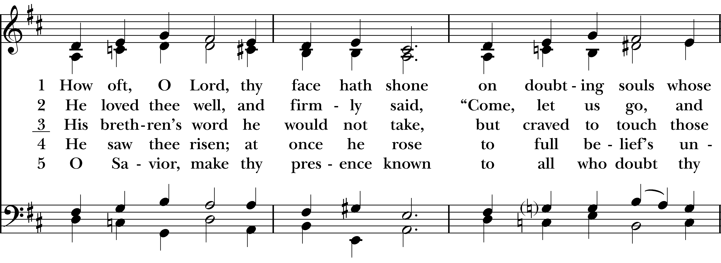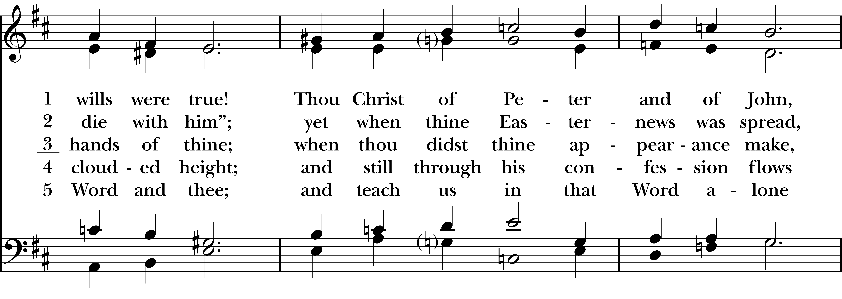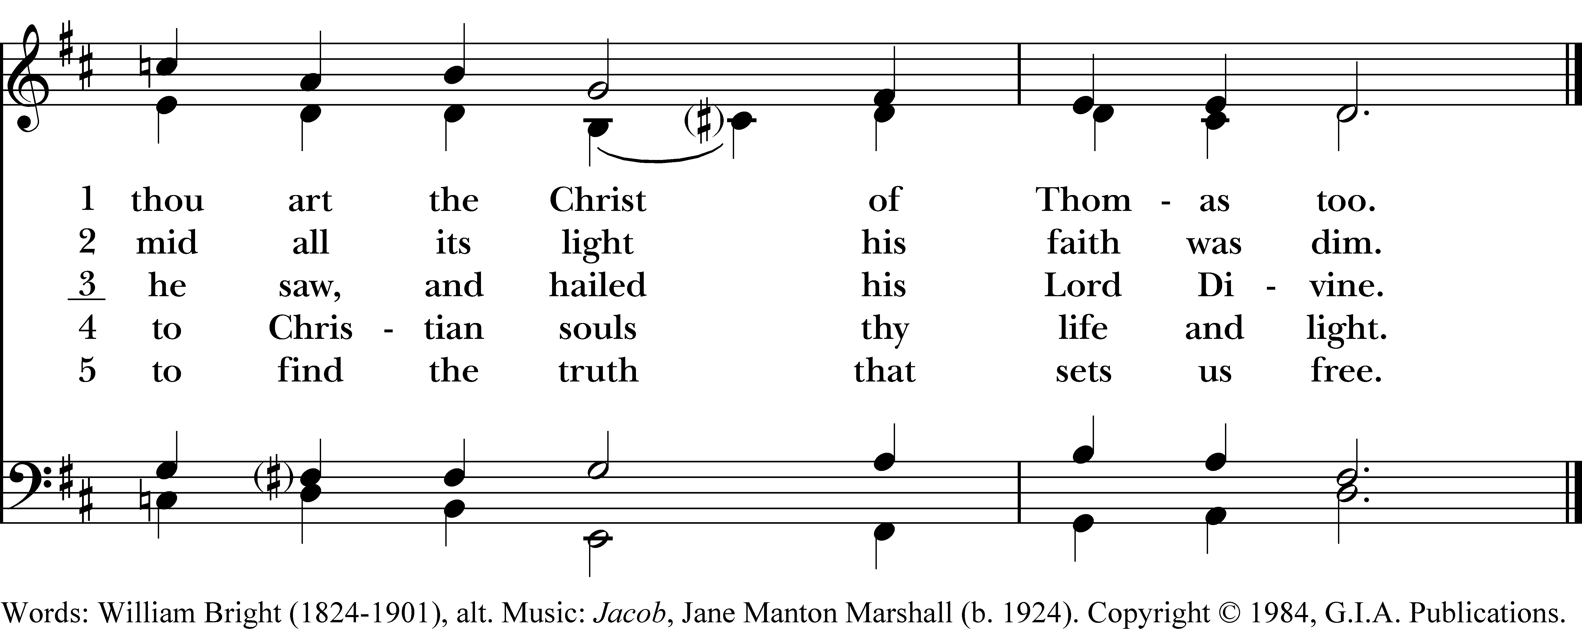

1 How oft, O Lord, thy face hath shone
on doubting souls whose wills were true!
Thou Christ of Peter and of John,
thou art the Christ of Thomas too.

2 He loved thee well, and firmly said,
“Come, let us go, and die with him”;
yet when thine Easter-news was spread,
mid all its light his faith was dim.

3 His brethren’s word he would not take,
but craved to touch those hands of thine;
when thou didst thine appearance make,
he saw, and hailed his Lord Divine.

4 He saw thee risen; at once he rose
to full belief’s unclouded height;
and still through his confession flows
to Christian souls thy life and light.

5 O Savior, make thy presence known
to all who doubt thy Word and thee;
and teach us in that Word alone
to find the truth that sets us free.
How oft, O Lord, thy face hath shone, #242 from The Hymnal 1982 — Words: William Bright (1824-1901), alt. Music: Jacob, Jane Manton Marshall (b. 1924). Copyright © 1984, G.I.A. Publications.
About your RiteSong license
By purchasing this RiteSong license, you, for yourself and on behalf of your organization, agree to comply with the following terms and conditions. RiteSong licenses protect the owner of any underlying copyright included with this RiteSong license and thus you are permitted to use or print a copy of the applicable piece of music included in your RiteSong license for a single service, no matter the type of RiteSong license you have purchased. Any further use will require the purchase of an additional RiteSong license. Note that if you have purchased the annual RiteSong license, you will still need to download each piece of music for each service to ensure proper attribution to the applicable copyright holder.
No permission is granted with this RiteSong license to include any piece of music, in whole or in part, that is included in this RiteSong license, in a hymnal or other permanent or semi-permanent collection of songs. Apart from the written music included with this RiteSong license, no other form of the music, whether for use by a choir, organ or other accompaniments is included with this license and you agree not to modify the written music for such a purpose. Please contact Church Publishing Incorporated at cpirights@cpg.org to secure further materials and applicable use rights.
H242 / H82_242

