Lo, in the likeness of fire, on those who await his appearing
The Hymnal 1982, #225
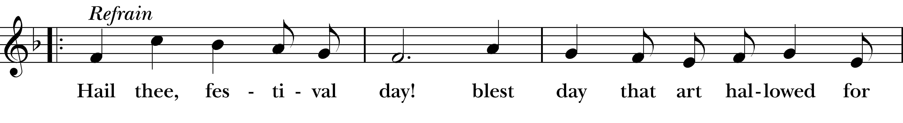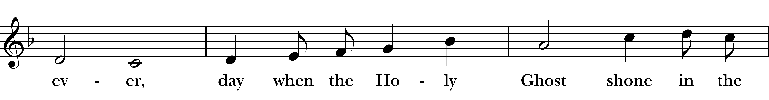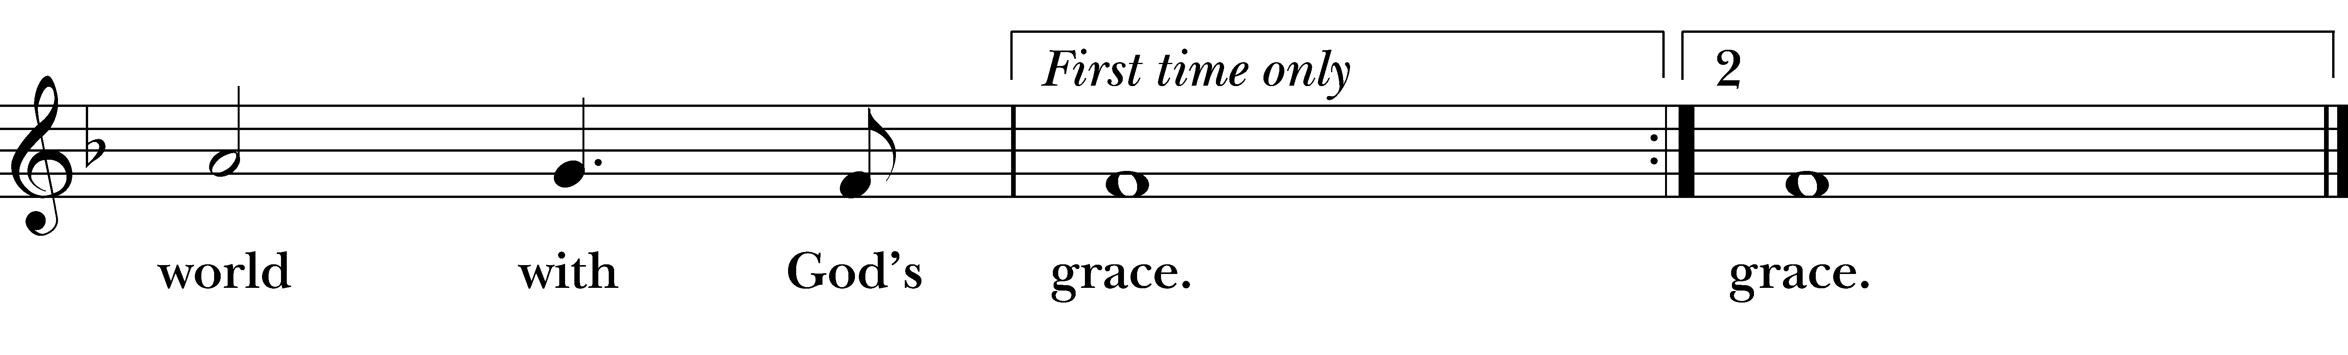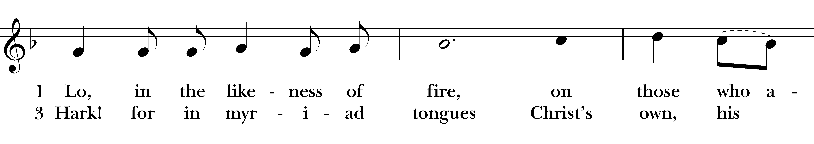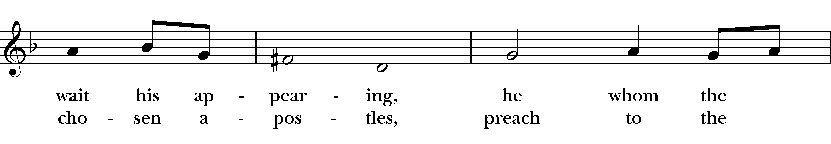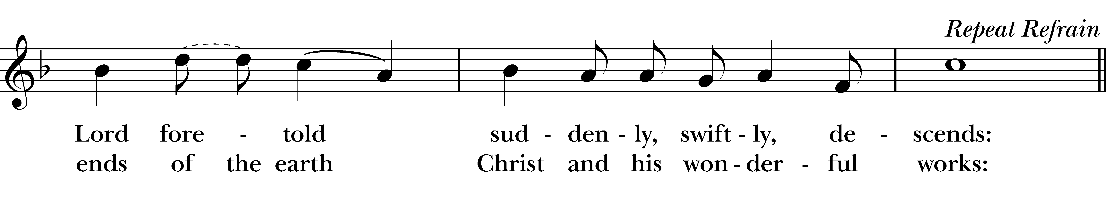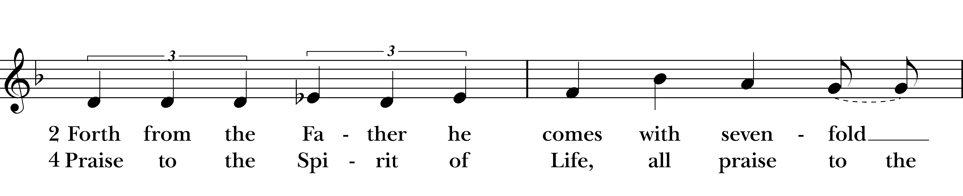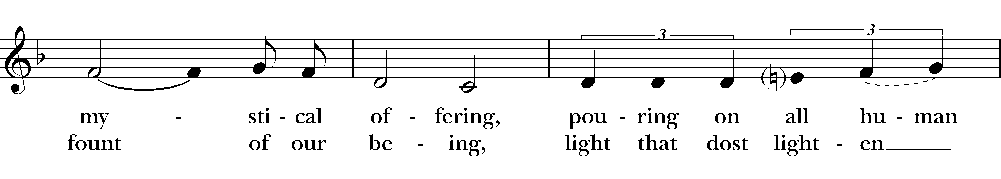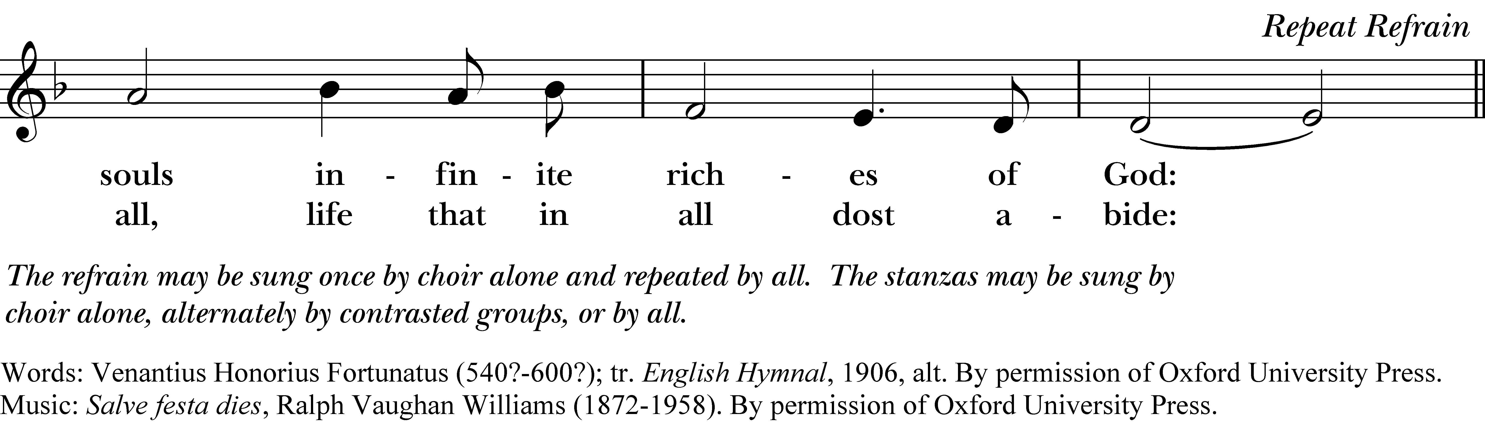

Hail thee, festival day!
blest day that art hallowed for ever,
day when the Holy Ghost
shone in the world with God’s grace.

1 Lo, in the likeness of fire, on those who await his appearing,
he whom the Lord foretold suddenly, swiftly, descends:

Refrain

2 Forth from the Father he comes with sevenfold mystical offering,
pouring on all human so infinite riches of God:

Refrain

3 Hark! for in myriad tongues Christ’s own, his chosen apostles,
preach to the ends of the earth Christ and his wonderful works:

Refrain

4 Praise to the Spirit of Life, all praise to the fount of our being,
light that dost lighten all, life that in all dost abide:

Refrain
Lo, in the likeness of fire, on those who await his appearing, #225 from The Hymnal 1982 — Words: Venantius Honorius Fortunatus (540?-600?); tr. English Hymnal, 1906, alt. By permission of Oxford University Press. Music: Salve festa dies, Ralph Vaughan Williams (1872-1958). By permission of Oxford University Press.
About your RiteSong license
By purchasing this RiteSong license, you, for yourself and on behalf of your organization, agree to comply with the following terms and conditions. RiteSong licenses protect the owner of any underlying copyright included with this RiteSong license and thus you are permitted to use or print a copy of the applicable piece of music included in your RiteSong license for a single service, no matter the type of RiteSong license you have purchased. Any further use will require the purchase of an additional RiteSong license. Note that if you have purchased the annual RiteSong license, you will still need to download each piece of music for each service to ensure proper attribution to the applicable copyright holder.
No permission is granted with this RiteSong license to include any piece of music, in whole or in part, that is included in this RiteSong license, in a hymnal or other permanent or semi-permanent collection of songs. Apart from the written music included with this RiteSong license, no other form of the music, whether for use by a choir, organ or other accompaniments is included with this license and you agree not to modify the written music for such a purpose. Please contact Church Publishing Incorporated at cpirights@cpg.org to secure further materials and applicable use rights.
H225 / H82_225

