O sons and daughters, let us sing
The Hymnal 1982, #206
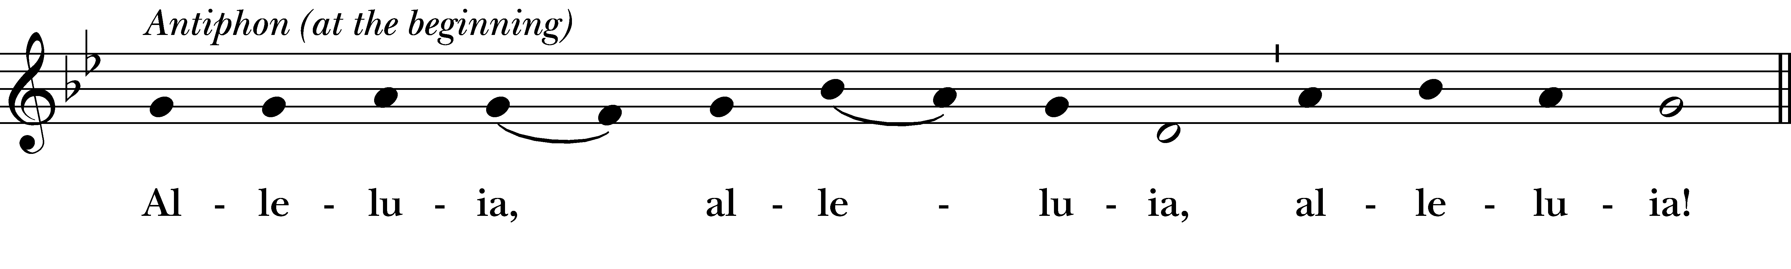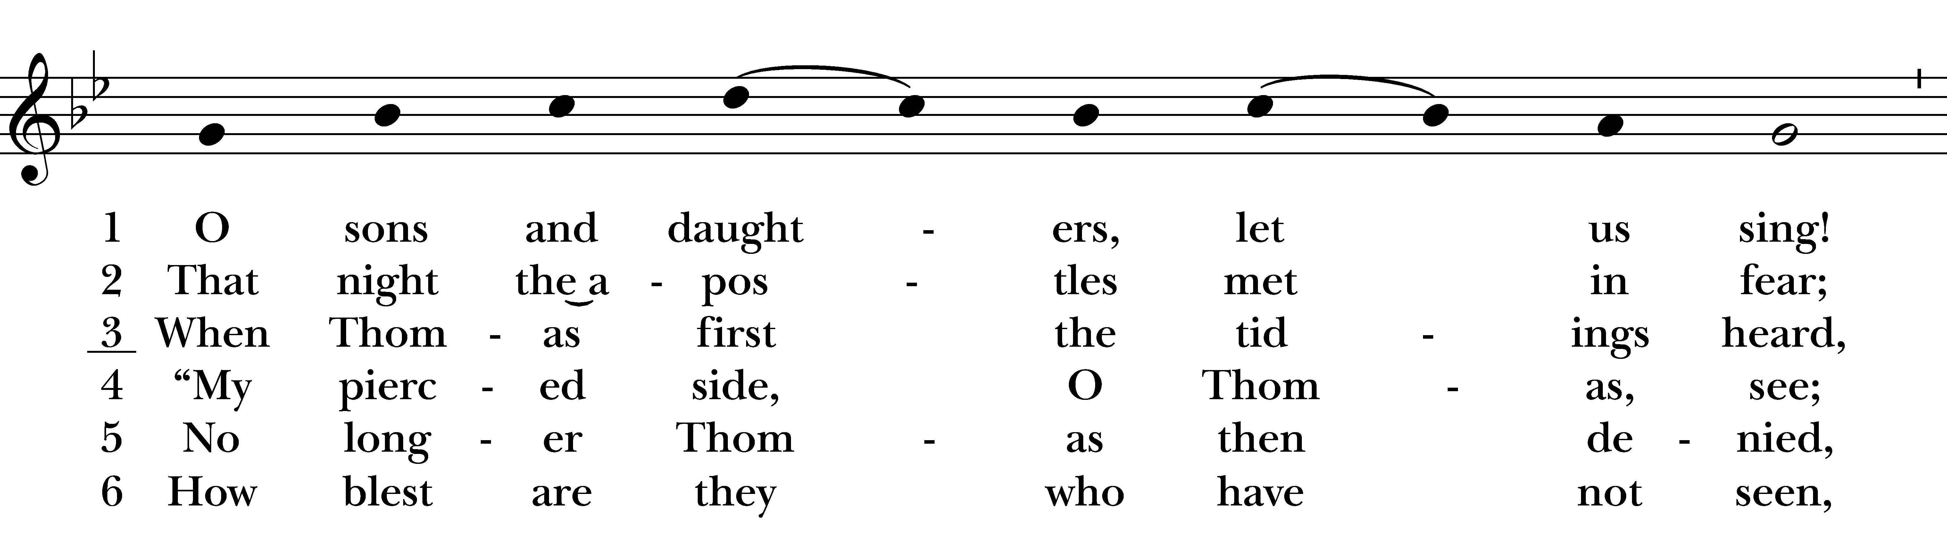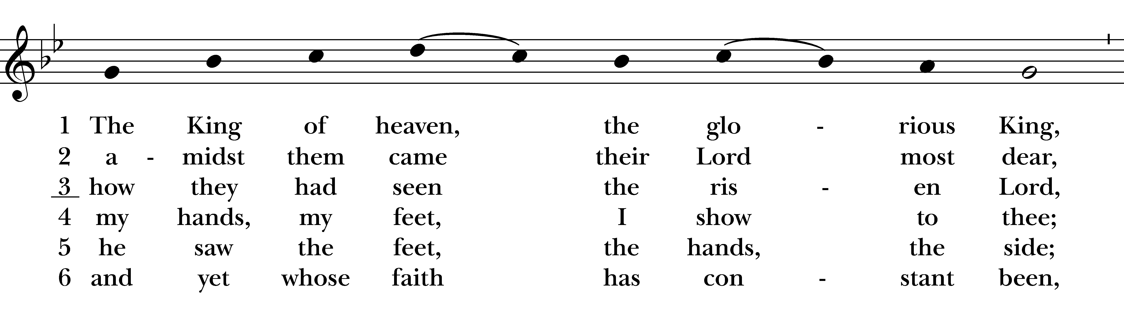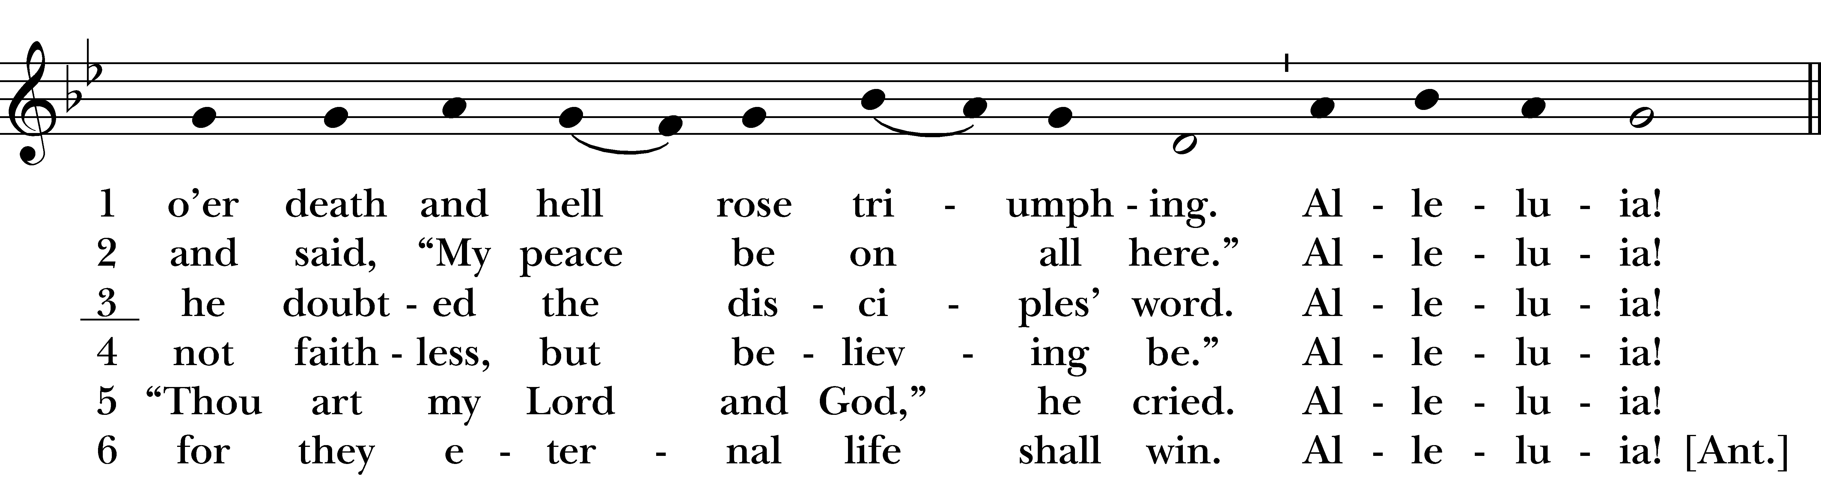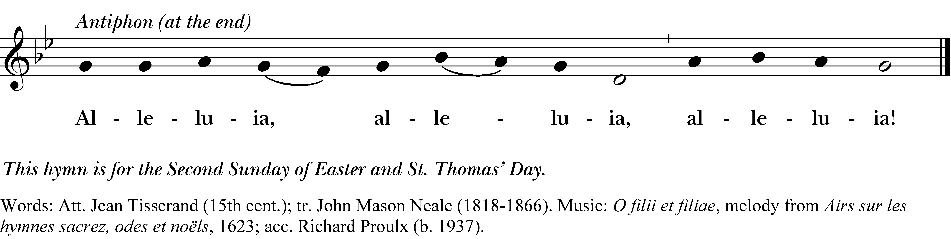

Alleluia, alleluia, alleluia!

1 O sons and daughters, let us sing!
The King of heaven, the glorious King,
o’er death and hell rose triumphing.
Alleluia!

2 That night the apostles met in fear;
amidst them came their Lord most dear,
and said, “My peace be on all here.”
Alleluia!

3 When Thomas first the tidings heard,
how they had seen the risen Lord,
he doubted the disciples’ word.
Alleluia!

4 “My piercèd side, O Thomas, see;
my hands, my feet, I show to thee;
not faithless, but believing be.”
Alleluia!

5 No longer Thomas then denied,
he saw the feet, the hands, the side;
“Thou art my Lord and God,” he cried.
Alleluia!

6 How blest are they who have not seen,
and yet whose faith has constant been,
for they eternal life shall win.
Alleluia!

Alleluia, alleluia, alleluia!
O sons and daughters, let us sing, #206 from The Hymnal 1982 — Words: Att. Jean Tisserand (15th cent.); tr. John Mason Neale (1818-1866). Music: O filii et filiae, melody from Airs sur les hymnes sacrez, odes et noëls, 1623; acc. Richard Proulx (b. 1937).
About your RiteSong license
By purchasing this RiteSong license, you, for yourself and on behalf of your organization, agree to comply with the following terms and conditions. RiteSong licenses protect the owner of any underlying copyright included with this RiteSong license and thus you are permitted to use or print a copy of the applicable piece of music included in your RiteSong license for a single service, no matter the type of RiteSong license you have purchased. Any further use will require the purchase of an additional RiteSong license. Note that if you have purchased the annual RiteSong license, you will still need to download each piece of music for each service to ensure proper attribution to the applicable copyright holder.
No permission is granted with this RiteSong license to include any piece of music, in whole or in part, that is included in this RiteSong license, in a hymnal or other permanent or semi-permanent collection of songs. Apart from the written music included with this RiteSong license, no other form of the music, whether for use by a choir, organ or other accompaniments is included with this license and you agree not to modify the written music for such a purpose. Please contact Church Publishing Incorporated at cpirights@cpg.org to secure further materials and applicable use rights.
H206 / H82_206

