Christ upon the mountain peak
The Hymnal 1982, #129
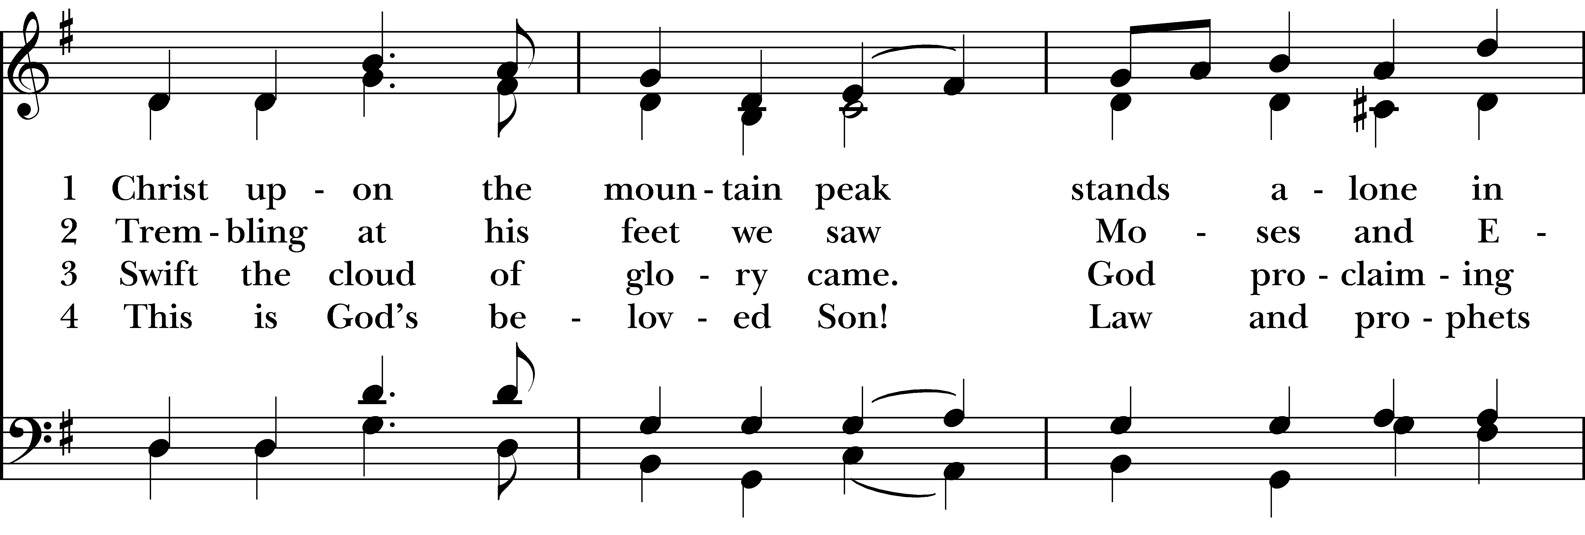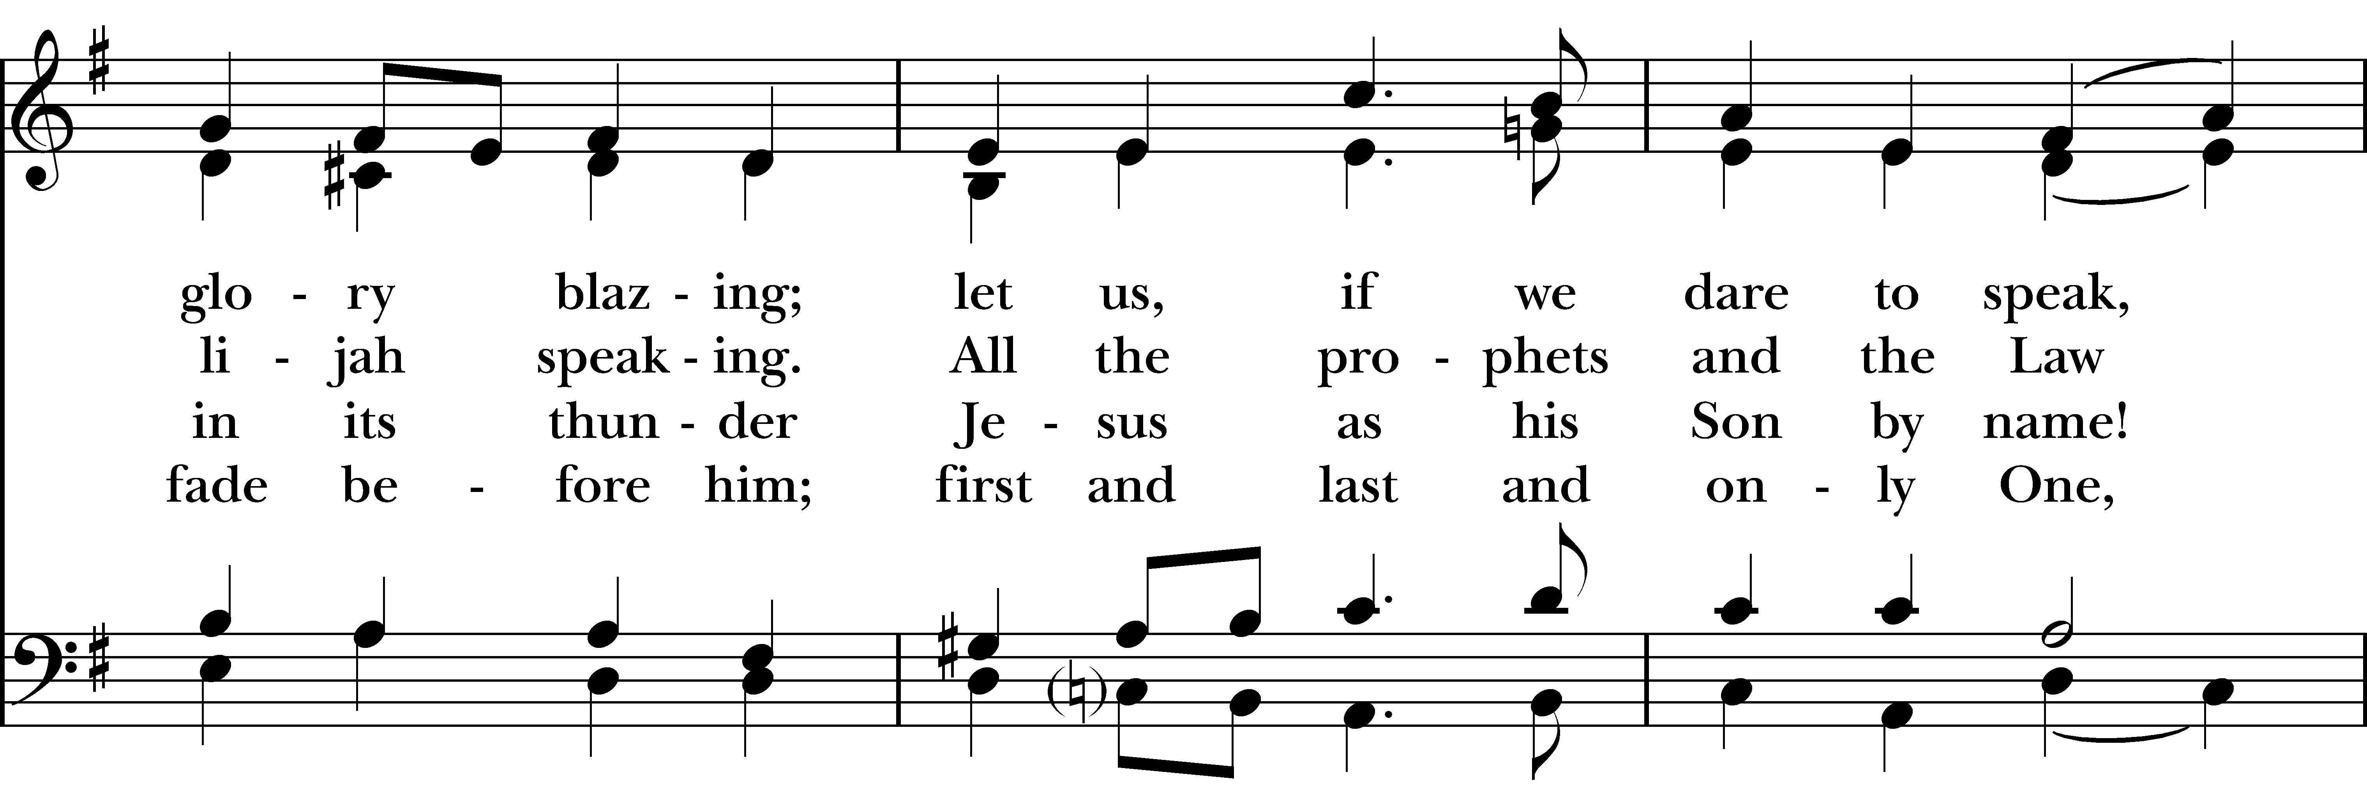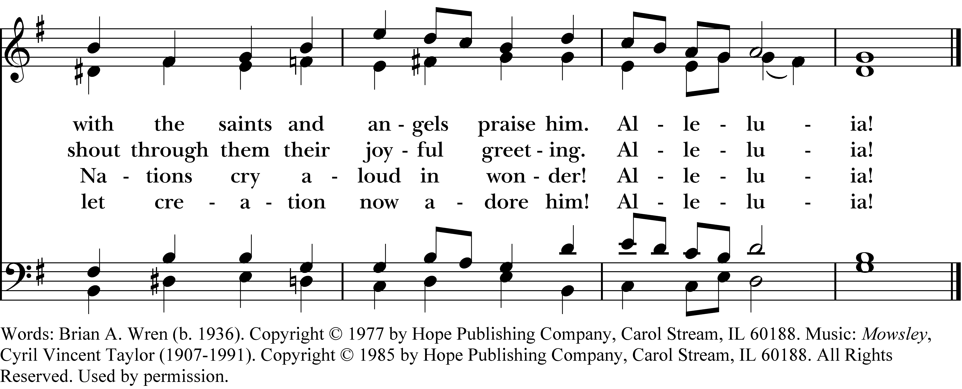

1 Christ upon the mountain peak
stands alone in glory blazing;
let us, if we dare to speak,
with the saints and angels praise him.
Alleluia!

2 Trembling at his feet we saw
Moses and Elijah speaking.
All the prophets and the Law
shout through them their joyful greeting.
Alleluia!

3 Swift the cloud of glory came.
God proclaiming in its thunder
Jesus as his Son by name!
Nations cry aloud in wonder!
Alleluia!

4 This is God’s belovèd Son!
Law and prophets fade before him;
first and last and only One,
let creation now adore him!
Alleluia!
Christ upon the mountain peak, #129 from The Hymnal 1982 — Words: Brian A. Wren (b. 1936). Copyright © 1977 by Hope Publishing Company, Carol Stream, IL 60188. Music: Mowsley, Cyril Vincent Taylor (1907-1991). Copyright © 1985 by Hope Publishing Company, Carol Stream, IL 60188. All Rights Reserved. Used by permission.
About your RiteSong license
By purchasing this RiteSong license, you, for yourself and on behalf of your organization, agree to comply with the following terms and conditions. RiteSong licenses protect the owner of any underlying copyright included with this RiteSong license and thus you are permitted to use or print a copy of the applicable piece of music included in your RiteSong license for a single service, no matter the type of RiteSong license you have purchased. Any further use will require the purchase of an additional RiteSong license. Note that if you have purchased the annual RiteSong license, you will still need to download each piece of music for each service to ensure proper attribution to the applicable copyright holder.
No permission is granted with this RiteSong license to include any piece of music, in whole or in part, that is included in this RiteSong license, in a hymnal or other permanent or semi-permanent collection of songs. Apart from the written music included with this RiteSong license, no other form of the music, whether for use by a choir, organ or other accompaniments is included with this license and you agree not to modify the written music for such a purpose. Please contact Church Publishing Incorporated at cpirights@cpg.org to secure further materials and applicable use rights.
H129 / H82_129

