What child is this, who, laid to rest
The Hymnal 1982, #115
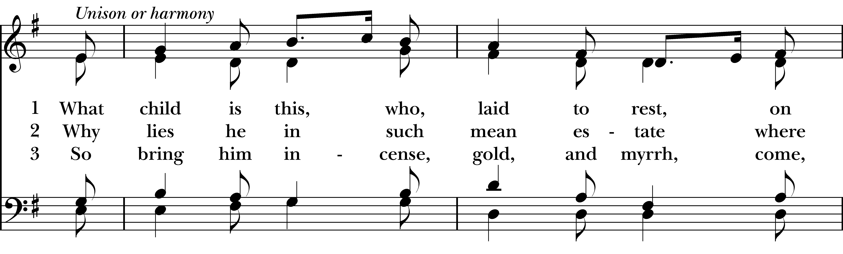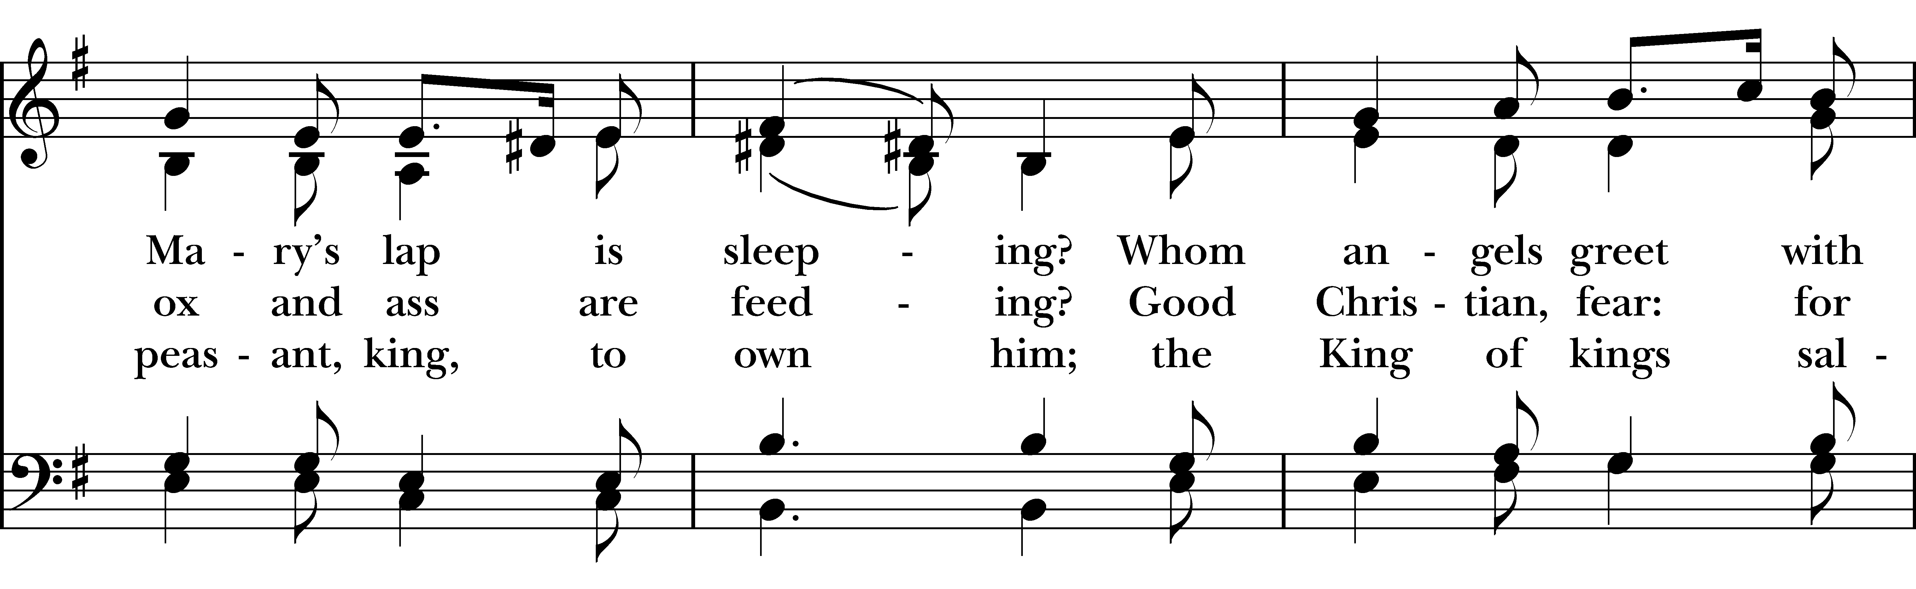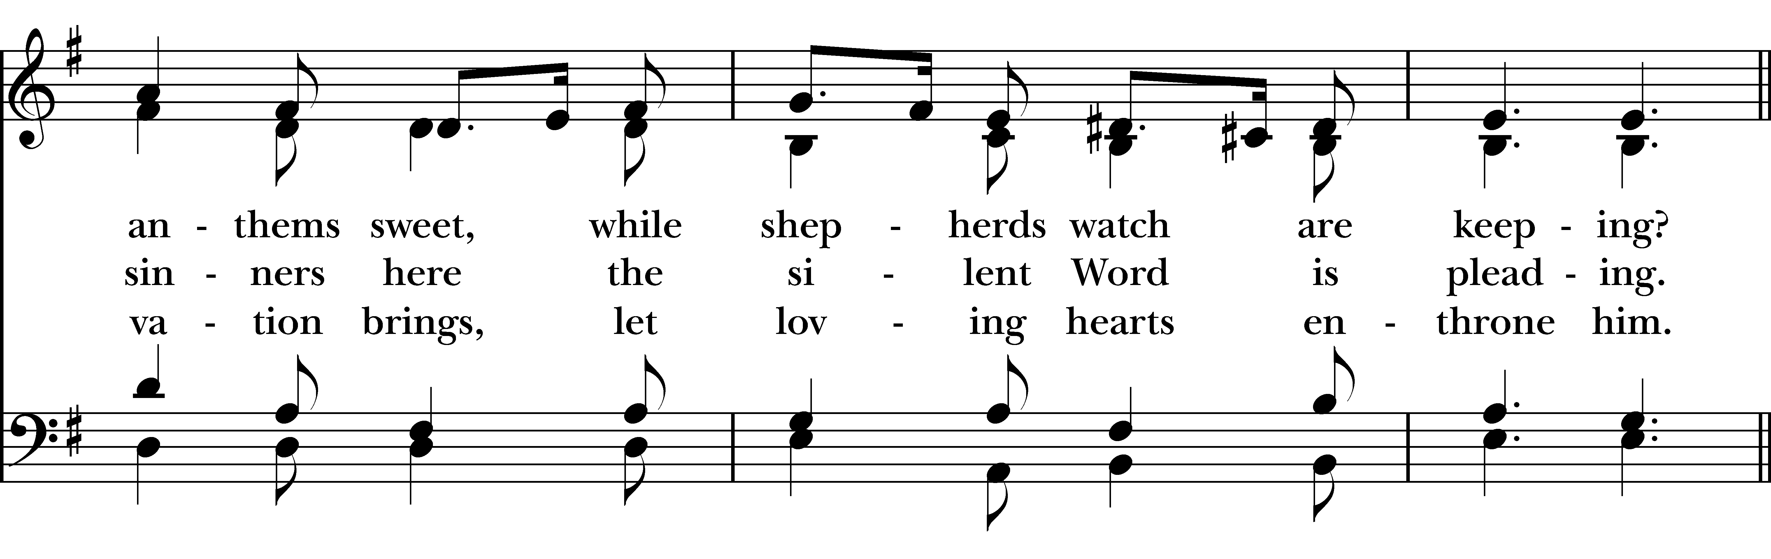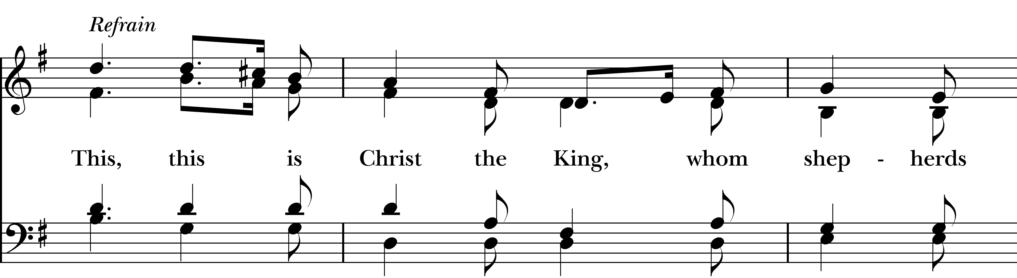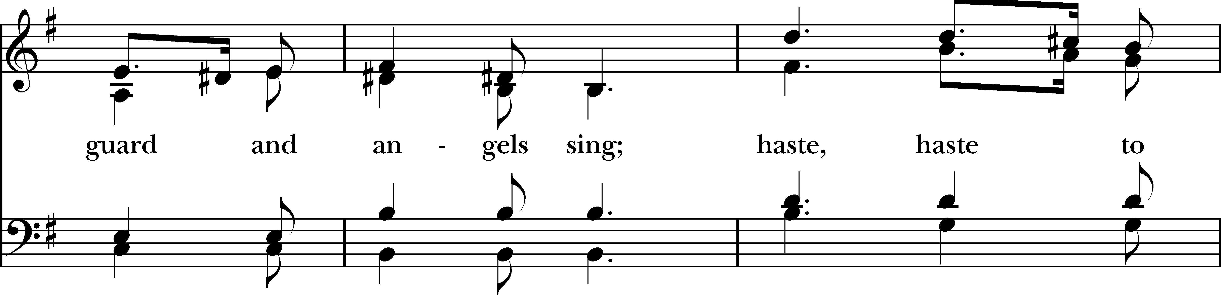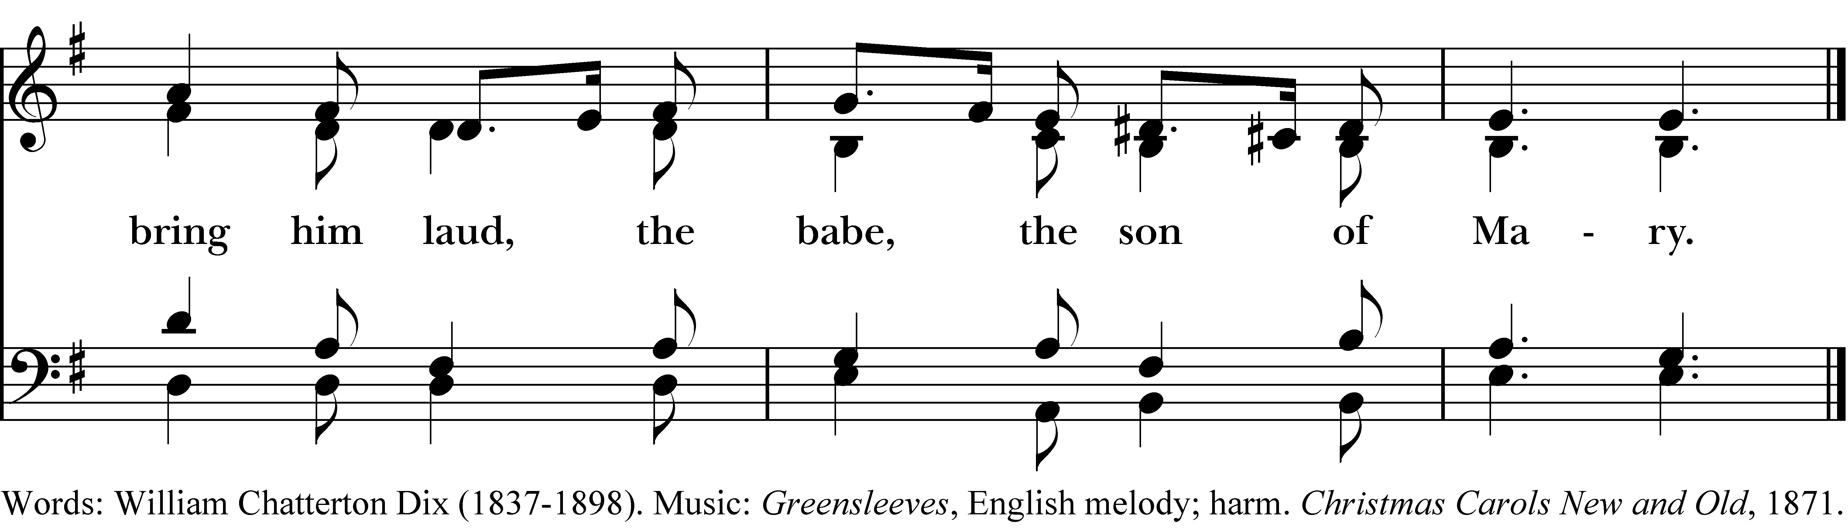

1 What child is this, who, laid to rest,
on Mary’s lap is sleeping?
Whom angels greet with anthems sweet,
while shepherds watch are keeping?

This, this is Christ the King,
whom shepherds guard and angels sing;
haste, haste to bring him laud,
the babe, the son of Mary.

2 Why lies he in such mean estate
where ox and ass are feeding?
Good Christian, fear: for sinners here
the silent Word is pleading.

Refrain

3 So bring him incense, gold, and myrrh,
come, peasant, king, to own him;
the King of kings salvation brings,
let loving hearts enthrone him.

Refrain
What child is this, who, laid to rest, #115 from The Hymnal 1982 — Words: William Chatterton Dix (1837-1898). Music: Greensleeves, English melody; harm. Christmas Carols New and Old, 1871.
About your RiteSong license
By purchasing this RiteSong license, you, for yourself and on behalf of your organization, agree to comply with the following terms and conditions. RiteSong licenses protect the owner of any underlying copyright included with this RiteSong license and thus you are permitted to use or print a copy of the applicable piece of music included in your RiteSong license for a single service, no matter the type of RiteSong license you have purchased. Any further use will require the purchase of an additional RiteSong license. Note that if you have purchased the annual RiteSong license, you will still need to download each piece of music for each service to ensure proper attribution to the applicable copyright holder.
No permission is granted with this RiteSong license to include any piece of music, in whole or in part, that is included in this RiteSong license, in a hymnal or other permanent or semi-permanent collection of songs. Apart from the written music included with this RiteSong license, no other form of the music, whether for use by a choir, organ or other accompaniments is included with this license and you agree not to modify the written music for such a purpose. Please contact Church Publishing Incorporated at cpirights@cpg.org to secure further materials and applicable use rights.
H115 / H82_115

