Not here for high and holy things
The Hymnal 1982, #9
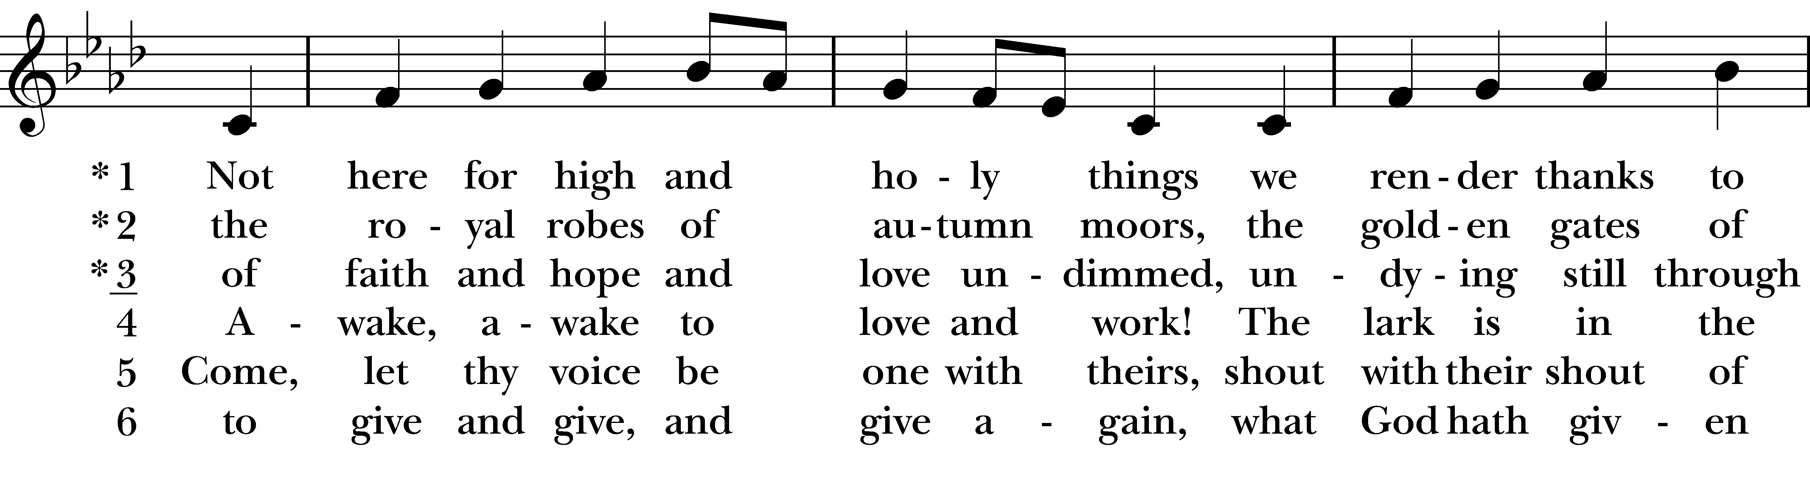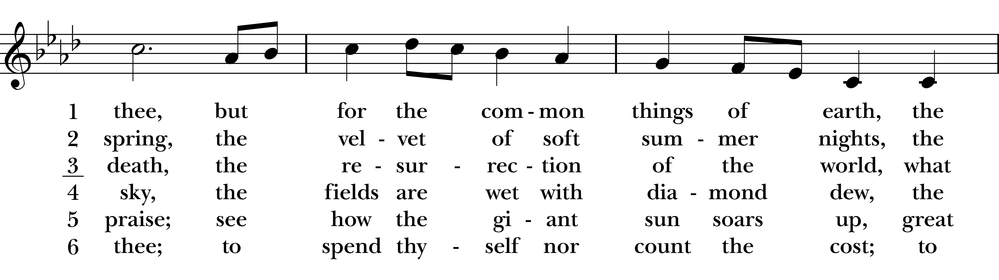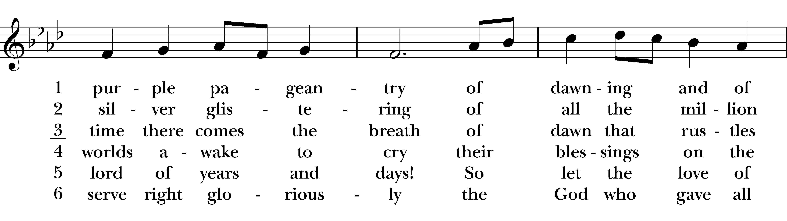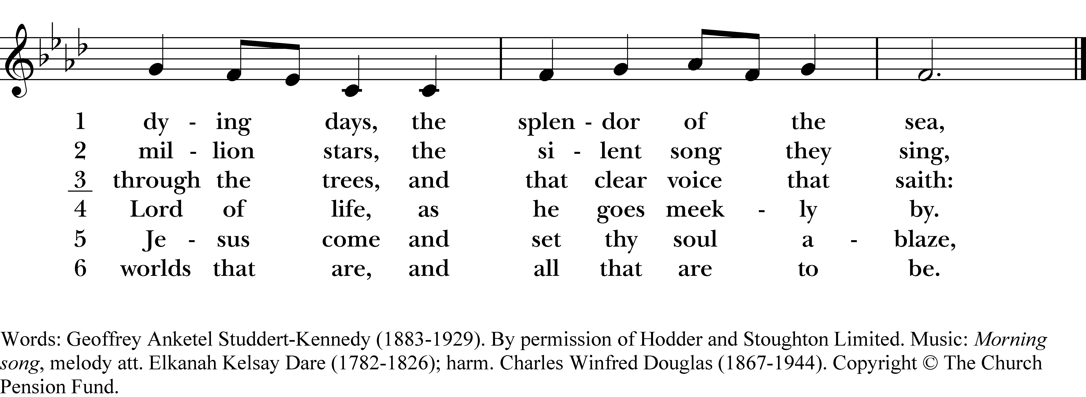

1 Not here for high and holy things
we render thanks to thee,
but for the common things of earth,
the purple pageantry
of dawning and of dying days,
the splendor of the sea,

2 the royal robes of autumn moors,
the golden gates of spring,
the velvet of soft summer nights,
the silver glistering
of all the million million stars,
the silent song they sing,

3 of faith and hope and love undimmed,
undying still through death,
the resurrection of the world,
what time there comes the breath
of dawn that rustles through the trees,
and that clear voice that saith:

4 Awake, awake to love and work!
The lark is in the sky,
the fields are wet with diamond dew,
the worlds awake to cry
their blessings on the Lord of life,
as he goes meekly by.

5 Come, let thy voice be one with theirs,
shout with their shout of praise;
see how the giant sun soars up,
great lord of years and days!
So let the love of Jesus come
and set thy soul ablaze,

6 to give and give, and give again,
what God hath given thee;
to spend thyself nor count the cost;
to serve right gloriously
the God who gave all worlds that are,
and all that are to be.
Not here for high and holy things, #9 from The Hymnal 1982 — Words: Geoffrey Anketel Studdert-Kennedy (1883-1929). By permission of Hodder and Stoughton Limited. Music: Morning song, melody att. Elkanah Kelsay Dare (1782-1826); harm. Charles Winfred Douglas (1867-1944). Copyright © The Church Pension Fund.
About your RiteSong license
By purchasing this RiteSong license, you, for yourself and on behalf of your organization, agree to comply with the following terms and conditions. RiteSong licenses protect the owner of any underlying copyright included with this RiteSong license and thus you are permitted to use or print a copy of the applicable piece of music included in your RiteSong license for a single service, no matter the type of RiteSong license you have purchased. Any further use will require the purchase of an additional RiteSong license. Note that if you have purchased the annual RiteSong license, you will still need to download each piece of music for each service to ensure proper attribution to the applicable copyright holder.
No permission is granted with this RiteSong license to include any piece of music, in whole or in part, that is included in this RiteSong license, in a hymnal or other permanent or semi-permanent collection of songs. Apart from the written music included with this RiteSong license, no other form of the music, whether for use by a choir, organ or other accompaniments is included with this license and you agree not to modify the written music for such a purpose. Please contact Church Publishing Incorporated at cpirights@cpg.org to secure further materials and applicable use rights.
H009 / H82_009

