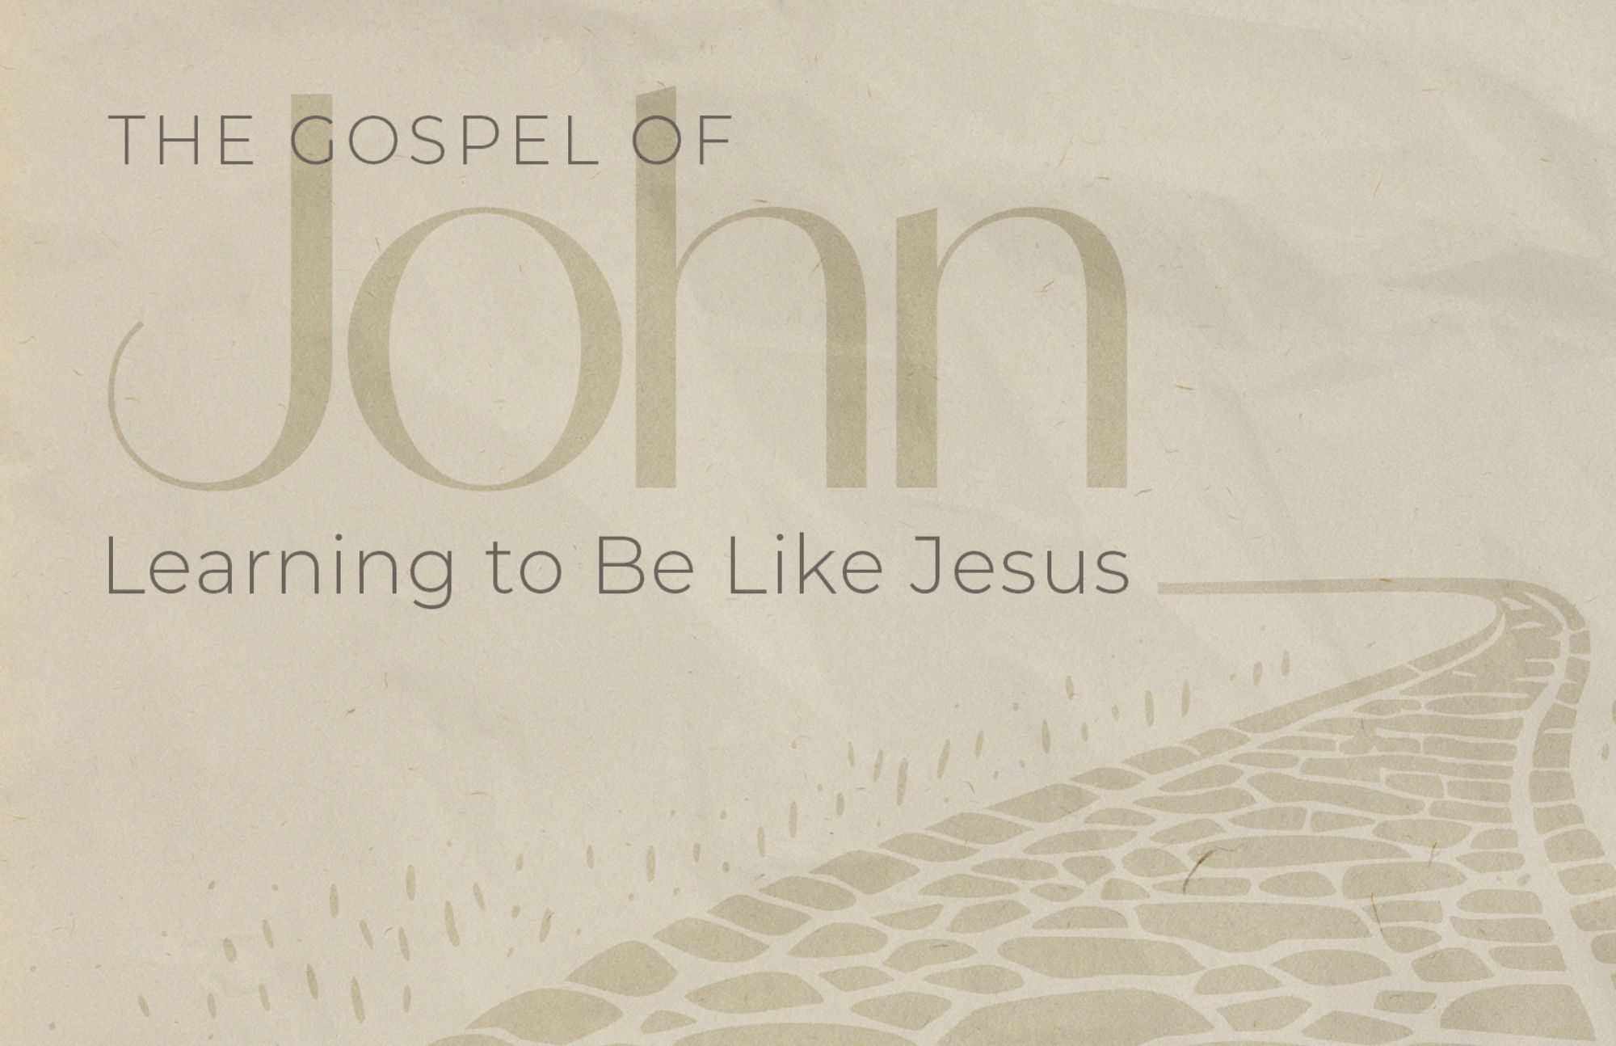

May Memory Verses
^{25 “Who are you?” they asked.}
“Just what I have been telling you from the beginning,” Jesus replied. 26 “I have much to say in judgment of you. But he who sent me is trustworthy, and what I have heard from him I tell the world.”
27 They did not understand that he was telling them about his Father. 28 So Jesus said, “When you have lifted up the Son of Man, then you will know that I am he and that I do nothing on my own but speak just what the Father has taught me. 29 The one who sent me is with me; he has not left me alone, for I always do what pleases him.” 30 Even as he spoke, many believed in him.
31 To the Jews who had believed him, Jesus said, “If you hold to my teaching, you are really my disciples. 32 Then you will know the truth, and the truth will set you free.”
33 They answered him, “We are Abraham’s descendants and have never been slaves of anyone. How can you say that we shall be set free?”
34 Jesus replied, “Very truly I tell you, everyone who sins is a slave to sin. 35 Now a slave has no permanent place in the family, but a son belongs to it forever. 36 So if the Son sets you free, you will be free indeed. 37 I know that you are Abraham’s descendants. Yet you are looking for a way to kill me, because you have no room for my word. 38 I am telling you what I have seen in the Father’s presence, and you are doing what you have heard from your father.” John 8:25-38 Regular verses are in black, extra challenge verses are in brown.

