First Middle Last
Address, City, State, Zip
Email@Email.com, Phone Number

RE: My upcoming international mission trip.

Dear,

May I make an important request of you?

I'm thrilled to announce I get to travel with my church, New Horizon (NewHorizonChurch.org), on an international mission trip to Honduras in November, 2026.

I've been hoping to be a part of an international mission trip for years. I believe God is opening a door for me with this opportunity.

Our church team will be traveling with Common Ground Ministries (cgmok.com) from Broken Arrow, Oklahoma. My pastor, Rev. Mark Jordan, has been working closely with Common Ground for over 35 years, and Common Ground has worked in Honduras for several decades. They’ll be tremendous hosts for our team.

We'll be working out of LaCeiba, Honduras, November 2-9. We'll have many opportunities to serve scores of people during our stay. We’ll be preparing and providing food, distributing medication, visiting maternity wards in hospitals, some light construction and more. And every evening we’ll be hosting outreaches at various churches in the area.

I can’t wait to be a part.

I'm hoping you might help fund my trip. Here's a rundown of our expenses:
- Round trip airfare: $900
- Hotel, breakfast, ground transportation & materials: $700
- Off-site meals: $100
- TOTAL: $1700

I would be grateful for any amount you might choose to contribute. You can make your contribution with cash, check (address above), or online using my Venmo account (QR code below). I will be providing a thorough accounting of all donations and expenditures.

I'm also asking you to pray for me and our team. Please join us in praying for great fruitfulness during our mission, growing relationships with our partner ministries, favor with locals, safety as we travel, good health, and God’s financial provision for our team.

Thank you for considering and for praying. It will be an honor for me to travel and serve with your support.

Please contact me with any questions you might have.


God is good!

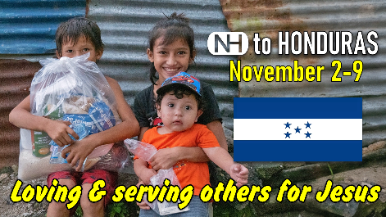

First Last Name

