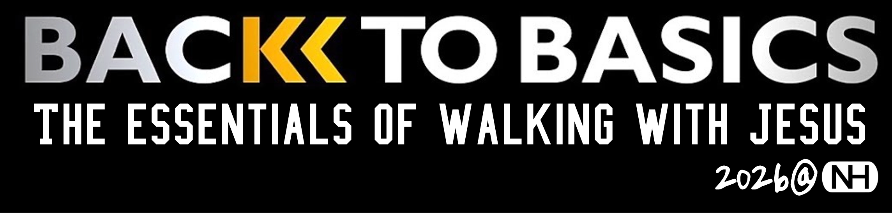
Welcome to NH. NewHorizonChurch.org Feedback@NewH orizonChurch.org
Text “Hello.” New to NH? Text “Hello” to 217-359-8909 for a personal greeting.
Starting Point. FIRST SUNDAYS. Set to know NH after worship in the Alpha Room.
Welcome to 2026
JANUARY: Month of Prayer. January Prayer Exercise: Prayer before each meal.
2026 Theme: Back to Basics. The essentials of walking with Jesus. It’s for everyone.
One Year Bible. Sunday messages & weekly groups from daily readings. QR above.
NH Membership. JANUARY. You may place or renew your membership this month.
NEXT WEEK: NH Stakeholders Gathering. JAN. 25, 4 PM. For all who call NH home.
Kids & Students
Nursery-Pre-K. SUNDAYS, 10:30 AM. Downstairs. Heather@NewHorizonChurch.org.
K-5 Kids. SUNDAYS, 10:30 AM. Upstairs. Deante@NewHorizonChurch.org.
Catalyst Jr. High. WEDNESDAYS, 6:30-8 PM. Café. MikeH@NewHorizonChurch.org.
Axis High School. SUNDAYS, 6 PM. Café. Zach@NewHorizonChurch.org.
Kid’s Outdoor Zone. 2nd SATURDAYS, 8-11 AM. Boys, 8-18. dalero1@hotmail.com.
Growing Big Faith
Choose your group. Groups are up and running. See NH app (QR code below).
Wednesday Nights. 6:30 PM. Groups & opportunities for all ages.
Celebrate Recovery. THURSDAYS, 6:30 PM. Celebrate@NewHorizonChurch.org.
Women’s Bible Study Fellowship. TUESDAYS, 9 AM. Childcare provided.
Opportunities @ NH
THIS WEEK. NH Movie Night. JAN. 21, 6:30 PM. Meet @ Savoy Theater. $8 at the door.
Men’s Mardi Gras Outreach. FEBRUARY 12-18, 2026. Helping others know Jesus.
Info Meeting: 2027 Holy Land Tour. FEB 1., 4 PM, Café. (Tour is 2.23.7 to 3.4.27)
Prayer @ NH
NH Prayer Chapel. SUNDAYS, 10 AM. Also, during & following worship.
NH Prayer Chat Room. SUNDAYS, 8 PM. Dial 217-866-0099.
Giving @ NH. Thanks for your faithfulness. Questions? Sara@NewHorizonChurch.
Give as we pass baskets. Or use website, ChurchCenter app, or drop boxes at exits.
General Giving. January 11: $25,783 YTD 2025: $6,740 surplus.
Worship attendance Januiary 11. In-person: 151 Online: 149
Attendance, Jan. 11. Kids: 32 Jr. High: 6 Sr. High: 16 MDWK: 5 CR: 99





Sunday, January 18, 2025, 10:30 AM

Today’s Message: "Holy Allegiance: Our Covenant God & His People”
It’s a theme running throughout the Scriptures. “Covenant” is more than a promise. It’s our lopsided relationship with God. It’s our allegiance to God as He does all the heavy lifting—and leading…
Today’s Scripture: Genesis 17

MESSAGE NOTES:
“Head, Heart & Hands” What’s God teaching us? Speaking to us? Asking of us?

