***Quote of the Week***

*“At this period of the earth’s history we cannot afford to weaken one another’s influence. The Christian warfare is close and severe. We have to meet and battle with unseen foes, and we must be in harmony with the heavenly agencies, who are seeking to cleanse us from the inclination to criticize our brethren, to pass judgment on them. The Lord desires us to stand under the yoke of Christ....”*

*-Ellen G. White*

**Church Zoom Meeting Information:**

Sabbath School, Main Sanctuary – 9:30 am

Main Worship Service – 11:00 am

Prayer Meeting, Wednesdays – 7:00 pm

Zoom Online Link:

<https://us02web.zoom.us/j/8658631561?pwd=R0NnS0tpVTE0bHErR0FSSkRabXNGUT09>

Meeting ID: 865 863 1561

Passcode: Hesperia

One tap mobile

+16699006833, 8658631561# US (San Jose)

+14086380968, 8658631561# US (San Jose)

Dial by your location

+1 669 900 6833 US (San Jose)

+1 408 638 0968 US (San Jose)

+1 346 248 7799 US (Houston)

+1 253 215 8782 US (Tacoma)

+1 646 876 9923 US (New York)

+1 301 715 8592 US (Washington DC

**Bulletin Information**:

DEADLINE IS WEDNESDAY 7PM

Please contact Lisa Santos:

by text message at: **(442-242-3280)** or

by email at [**sda.hesperia@yahoo.com**](mailto:sda.hesperia@yahoo.com)

Text or email is preferred for accuracy

**Livestream Information**

Please Subscribe to our YouTube Channel for Livestream or share the blessings, go to: <https://www.youtube.com/@sda.hesperia>

*Elder in Charge today: Elder John Colon Next Sabbath: To be announced*

***Sunset today: 6:28 pm Next Friday (10/11/25) 6:19 pm***

***Hesperia Seventh-Day Adventist Church***

*18280 Atlantic St Hesperia, CA 92345*

*www.hesperiasda.com*

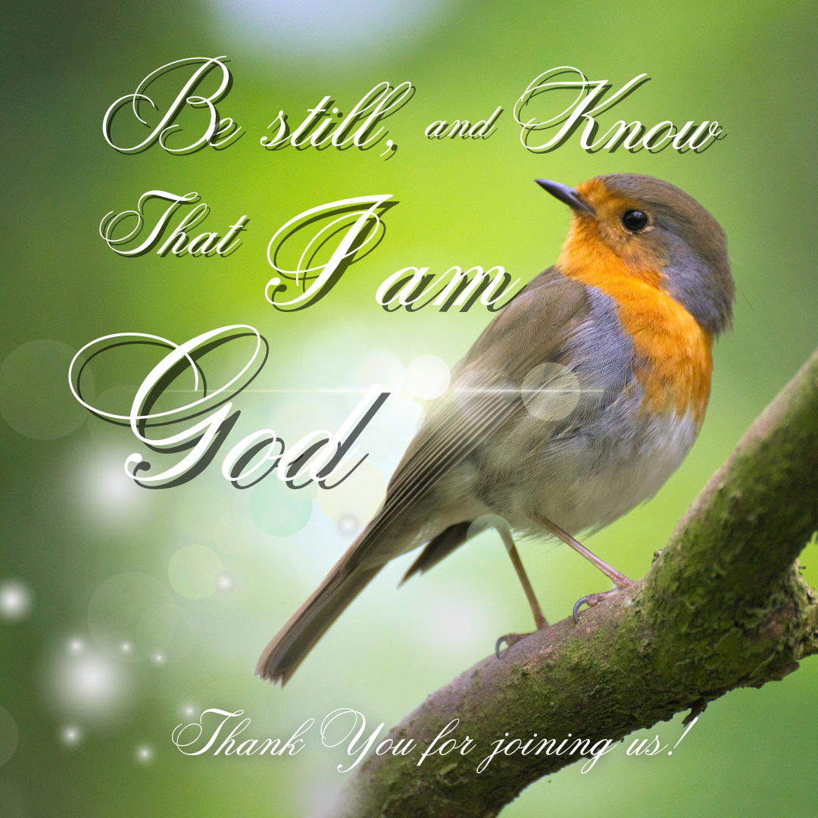

***October 4, 2025***

*Pastor Larry Christoffel*

*(909) 913-7472 /* [*christoffelld@gmail.com*](mailto:christoffelld@gmail.com)

**ANNOUNCEMENTS**

WELCOME TO ALL GUESTS THIS SABBATH

OCTOBER 1 BEGAN THE NEW TERM OF CHURCH OFFICES – Thank you to all who have faithfully served in the past. Please pray for those who have accepted responsibility for the October 1, 2025 through September 30, 2027 term.

FELLOWSHIP DINNER – Next Sabbath following the Worship Service.

FAMILY LIFE FORUM – Next Sabbath at 2:00 P.M. Pastor Adrian Pressley will present on the topic of grief. See Insert.

BIBLE STUDY - Today at 2:00 P.M.

WOMEN’S MINISTRY – Tuesday October 7 at 12:00 P.M. at the Mile High Café in Hesperia, the women will meet for a delicious lunch, fellowship, prayer and praise. We will also finish up Ruth and Boaz.

MEN'S BREAKFAST & BIBLE STUDY – Wednesday 7:30 A.M.at the Mile High Cafe in Hesperia (8632 Orange Street) Daniel 7 is the text we are considering.

PRAYER MEETING – Wednesday, 7:00 P.M. – Pastor Christoffel is leading a study and discussion of Genesis 1. Here is a time for hymns, sharing testimony and prayers as well as getting into the Word of God.

CHURCH CLEANING – We need additional persons or families that will be willing to be responsible for cleaning the church once a month. If you are interested, please call Bob Mosca at 760 880-3897.

UNITED IN PRAYER – Today, United in Prayer will take place immediately after worship service. There will be two prayer session every Sabbath. The 1st session will be at 8:45 A.M., led by Joe Gutierrez. The 2nd session will be after worship service, led by Helen Martinez.

*OFFERINGS FOR TITHE PAYS THE SALARY OF PASTORS BUT DOES NOT GO TOWARD LOCAL CHURCH EXPENSE. PLEASE REMEMBER TO DONATE TO THE LOCAL CHURCH BUDGET SO WE CAN PAY OUR UTILITY BILLS AND OTHER NECESSARY LOCAL COSTS, INCLUDING MINISTRIES.THANK YOU FOR YOUR GENEROSITY! WHEN WRITING YOUR CHECKS PLEASE MAKE THEM TO “SEVENTH-DAY ADVENTIST CHURCH” AND PUT “HESPERIA” IN THE MEMO.*

|  |
| --- |
| ***Prayer Requests*** |
| Please pray for: John Silva’s daughter in law, Sarah Silva for her health and urgent medical care. Continued prayers for Miranda’s grandmother, Carmen Lorenzana, who is still on hospice. |
|  |
| *Kindly send additional prayer requests to Lisa Santos, the bulletin secretary.* |

***Hesperia Seventh-Day Adventist Church***

***Sabbath School Classes***

*9:30am*

Adult – Main Sanctuary

K-Pre-Teen – Hallway Rm 3

Youth & Young Adults – Hallway Rm 1

***Worship Main Sanctuary***

*11:00am*

**Welcome and Announcements** **Elder John Colon**

**Invocational Prayer**  **Praise Team**

**Opening Song *“The Lord in Zion Reigneth”*  #8**

**Offering & Prayer Elder Dennis Mohammed**

**Intercessory Prayer**  **Elder John Colon**

**Storytime Elder Dennis Mohammed**

**Praise in Song Praise Team**

**Special Music Haylie Jaco**

**Scripture Reading** **Miranda Duran**

**Zechariah 14:1-9**

**Sermon  *Pastor Larry Christoffel***

***“The Time of the End in the Old Testament”***

**Closing Song  *“There’ll be No Dark Valley”* #208**

**Benediction  *Pastor Larry Christoffel***

***Postlude Linda Wong***